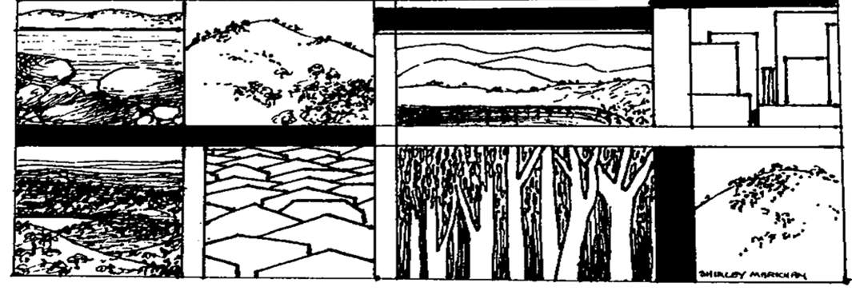

**The Yizraelite – No 2130 Date: 27.10.23**

**Kibbutz Yizrael**

**Edi-torial** We are all in mourning. We mourn the death of our founding father, Dani Harpaz, of blessed memory. His passing is the end of an era.

We mourn the deaths of our civilians and soldiers on the Gaza border. The fate of the kidnapped weighs heavily on our hearts.

Amid all this turmoil, we find the strength to play our part in this war of survival and to be there for one another. Our grandparents overcame the Holocaust. We will overcome this horror and build, together, a better society.

**R.I.P.**

**A deep sadness has prevailed upon our home**

**with the passing of our dear friend and founding member**

**Daniel Harpaz**

**may his memory be blessed**

**“Beit Yizrael"**

**The family will sit Shiva**

**at Dani's house between the hours**

**10:00 - 13:00**

**and**

**17:00 to 20:00.**

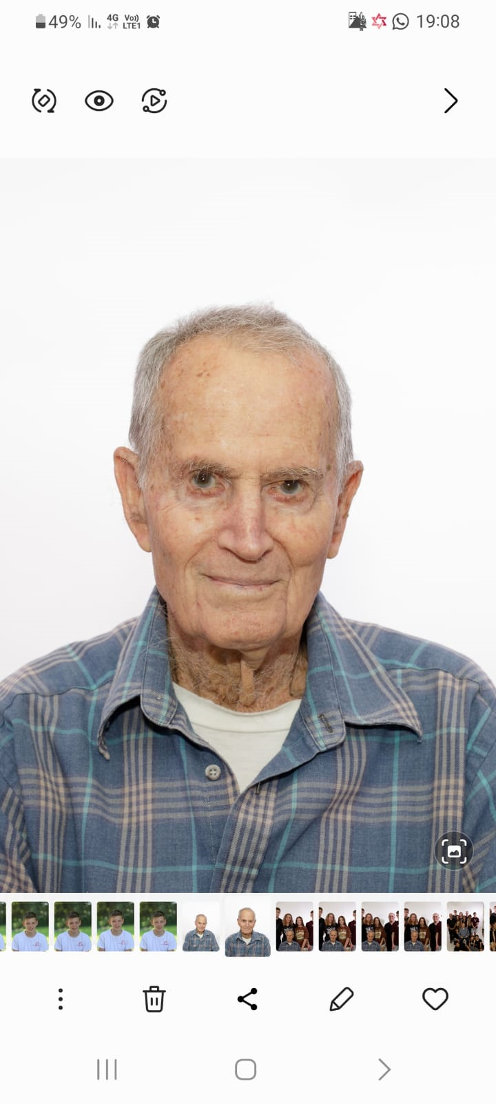

**Dani Harpaz**

**1929 - 2023**

**Kibbutz Eulogy - Yifat Assaf**

In the Negev, the autumn night descends, and the stars twinkle quietly as the wind passes over the threshold, clouds move along the paths...

Danni Harpaz, a veteran of our kibbutz, a man symbolising an era, the founding of YIzrael, the generation of the Palmach, has passed away. Dani was born in Jerusalem on July 10, 1929, to Miriam and Pinchas Harpaz, and was a brother to Ruth and Yigal. He spent his childhood in Jerusalem, attended the Rehavia Gymnasium, was a scout and a youth movement leader in the Scouts. In the years 1945-1947, he studied at the Kadoorie Agricultural School.

At the age of 18, he joined with his friends in the “Hachshara” (Kibbutz training program) at Kibbutz Ramat Yohanan. They belonged to Platoon A in the First Brigade of the Yiftach Division. Dani fought in numerous battles during the War of Independence alongside the members of garin Ramat Yohanan. In August 1948, the garin was discharged from the army to establish a new settlement – "Kibbutz Mishlat" in the deserted village of Zar’in, which became known as Kibbutz Yizrael.

Dani was among the founders of YIzrael, and among the few from the Ramat Yochanan group who remained and made the place his home. In 1952, Dani married Hezi, and together they established their family here. They had five children - Hila, Nira, Omer, Alon, and Lilach, and over the years, 16 grandchildren and 20 great-grandchildren were added to the Harpaz clan.

Dani lived, breathed, built, and dreamed YIzrael. Over the years, he worked in agriculture, construction, and industry. Some of his notable roles included serving multiple terms as the head of the kibbutz settlement (Merakez meshek), as well as treasurer. He served as an emissary (shaliach) of the "Habonim " youth movement in Cape Town, South Africa, between 1960 and 1963, where he went with his family. There he imparted to his many chanichim his love for the land of Israel, its landscapes, and its people.

Dani also worked in the kibbutz movement, in Tnuva (a cooperative in Israel), and in the movement's agricultural committees. Dani had an impressive military career. In 1949, he served in the Home Front Command's YIzrael Regional Command and continued his service as a platoon commander in the first Lebanon War, ending his military service in 1983 as a officer in the reserves.

Throughout the years, Dani invested in expanding his personal and collective knowledge, studied economics at the Faculty of Agriculture in Rehovot, Land of Israel Studies at the University of Haifa, completed a tour guide training course at Beit Berl, and led numerous tours in Israel and abroad. Dani loved the written word, reading countless books on the Hebrew language and the history of the Land of Israel, and was a fountain of knowledge for anyone seeking answers on Hebrew language and the history of Israel.

Dani spent many years in the Maytronics factory, in charge of the transformer division and later the plastics division, and subsequently at "Aubreya."

Dani was a modest and humble man. He was hardworking, industrious, and determined to achieve the goals he set for himself. He left a particularly prominent mark with his project to renovate the original kibbutz dining room, a personal and communal project he led. Over the course of several months, we saw him joining planks, pounding nails, painting, With the help of his two grandchildren and Barry Feldman, he restored the old dining room which was on the brink of collapse into a lovely, useful, and bustling meeting place. Dani left us the “Founders Hut” as a testimony to the person he was and the entire period that ended with his passing.

Dani loved to travel and feel the land beneath his feet. He went on many trips, including the Israel Trail, loved to run through the fields of the Jezreel Valley, and cycle in the Gilboa. Dani has ended his beautiful journey, overlooking the valley alongside his beloved wife, Hezi.

Our country is going through challenging times, changing everything we knew. YIzrael without Dani Harpaz is not the same. May his two great grandchildren, born in recent days, be a sign of hope, a new beginning, continuity, and growth for us and the beloved country.

To the Harpaz clan, we embrace you today, knowing that Dani's legacy is deeply rooted in each one of you, and he will continue to be a part of you and your pride.

"But we shall remember them all, the beauty of the youth and excellence,

For such a friendship will never enable our hearts to forget."

Rest in peace.

We bid you farewell with reverence, gratitude, and love.

The YIzrael community.

Yifat Assaf, October 24, 2023.

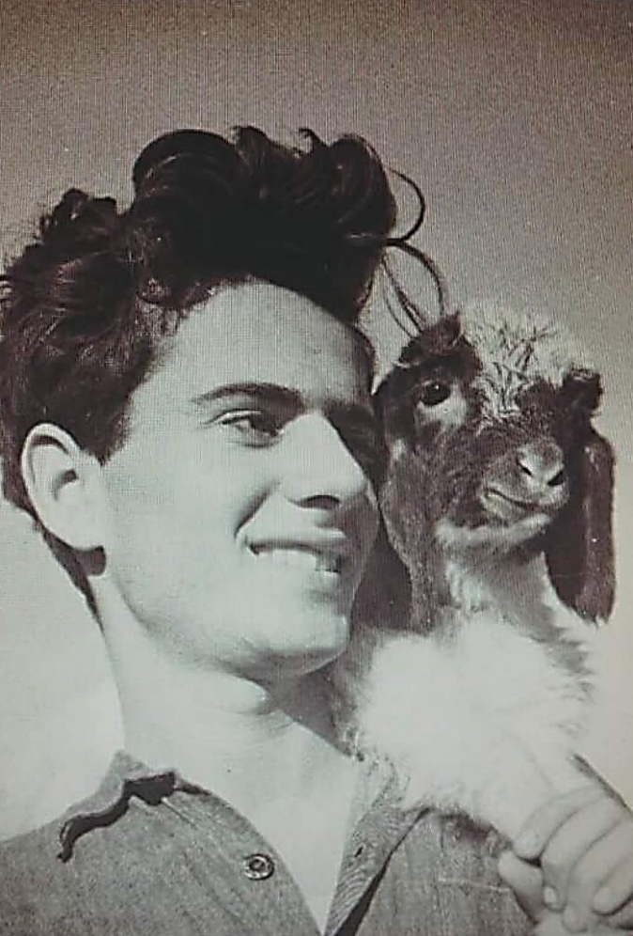

**Omer**

Dad,

Seventy-five years ago, a storm raged on these hills, 800 meters to the east where murderers dwelled. They preyed on Jews who settled here in the valley, attempting to work the land.

A 19-year-old Jerusalem native, a youth movement member, went to study at a military academy and joined the Palmach. That's how true Zionism worked. And that's how all those who believed in the State of Israel, and were willing to sacrifice themselves to establish it, acted.

With a high school diploma and a military title, you headed into battle for Yizrael, Zar'in as was its Arabic name. You had already gained battle experience, throughout the country as a soldier in the Yiftach Brigade of the Palmach.

The battle was tough, but eventually, the Palmach emerged victorious.

Here, you decided to establish your home, along with a few friends. You settled in the village and began to manage a commune, which later became a group and ultimately a kibbutz.

You fought in the War of Independence against all odds and built a flourishing proud kibbutz with thriving families and children.

Dad, the country you've founded is fighting another battle for its existence today, and the heroes are still the same, young men and women. They are fighting today on the hills of Lebanon and the Gaza Strip, cursed land.

Rest easy, knowing that we will also prevail here today, thanks to the same spirit that your generation had instilled in the country.

The real symbol of victory is firstly your two great grandchildren, born last week, one of them just yesterday, and secondly the sound of children's laughter on the paths of Yizrael.

Throughout your life, you contributed, took responsibility, and worked for others with modesty, consideration, and careful thought. You were involved in everything that happened in the kibbutz, taking on various economic and social roles.

You were a good father, an honest and upright man, a man among men, and we will always remember you.

Omer

**Nira**

Dad, Over the last two days, I found myself writing and erasing eulogies in my head. I knew that when the time came, it would be hard for me to write, but I couldn’t do it. I couldn't even find the words to tell you what I wanted to say, when I sat by your side for a few hours before you closed your eyes for the last time. In the past few months, every time we were sure that these were your last hours, you surprised all of us with a burst of renewed life. And you continued...

I didn't have the courage to say to you:

"Dad, go in peace. We release you to a world free of suffering and pain"... Perhaps you would surely hear me and get up and say, "Wait a moment, I'm not going yet"...

But it didn't happen. This time was indeed the last time.

It was a great privilege and pride to be the daughter of Hezi and Dani Harpaz and be a part of the family we called "The Clan Camp Fire."

With deep love and longing, also for Mum, who's by your side,

I love you very much, Goodbye Dad - Nira

**Hila**

Dad,your life was filled with countless events related to the founding of the state and kibbutz. A complete life of endless action, for the sake of a society where cooperation and equality were paramount. That is how you raised us.

You belonged to a group of mission-driven youth, and after the War of Independence, you were among the founders of this wonderful place – Yizrael. The idea became a reality, and even when plans didn't always succeed, you and your friends always believed that the future held good things.

You were a man of action, less talk. Solid and focused, balanced and measured. You saw what the future holds and planned the way to the goal, with composure, calmness, profound seriousness, and yet, a subtle sense of humour.

An inspiration to be admired, for proper and thoughtful conduct, and distinguished by a deep understanding and a vast knowledge in various fields.

Above all, you loved books... Your reading ability was amazing. I remember that before starting your studies (you already had four children), you decided to take a speed-reading course, which was very trendy at the time, so that you could cover a lot of material and increase your reading speed, all in order to have time for kibbutz activities and for us. You loved the written word and insisted on rich, accurate, and precise language.

You loved to travel and explore the land on foot. You thought there was no place in the country you hadn't been... and you always had command of the history of the place. You had extensive knowledge of everything related to the Land of Israel – its history, geography, and local stories.

You wanted to broaden your horizons and began leading tours abroad. Several times you took work trips abroad and there too, you excelled in the planning and execution.

You were a person of dedicated, meticulous work, without shortcuts. Deep commitment to every task and project, you undertook.

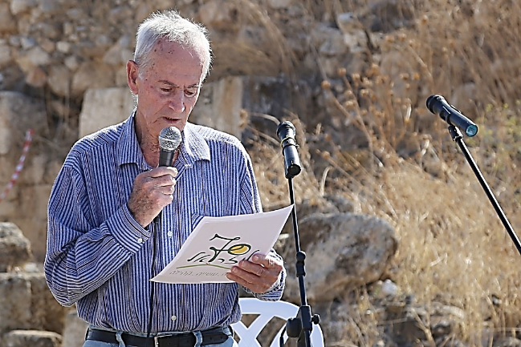Dad, you truly excelled in so many ways.Loved forever, Hila

**Alon**

Dear cherished Dad,

It's hard to believe – the man of eternity has been overcome... In my childhood, liked with the songs of Tirza Aligot, "My dad is the best..." In my innocence, I was convinced it was written just for me... A pioneer, a warrior, a hero in battle, a builder, a leader, an educator... and the list of well-deserved titles goes on. I can't count the praises and honours that resounded throughout the valley and the land whenever your name was mentioned, and the feeling of pride that enveloped me each time anew.

Yesterday, a new hope was born, explaining our essence with clarity.

Dad, Mum, I know that you're enjoying the magnificent work you've created, now even more than ever, together.

With endless love and longing, Alon

**Lilach**

Dad, The wise, the shrewd, the humble, and the modest. Surely, if I were to look up the term "salt of the earth" in Wikipedia, I would find your picture there, with a bag slung over your shoulders. Not the refined salt we use today, but coarse salt, the kind that comes in solid blocks, not easily dissolvable but steadfast and robust, and nothing can overcome it.

Dad, you're the one who ingrained in us, that age is merely a number that shifts, that love for the land and respect for people are more important than anything else. There's nothing you wish to do and can't, you just allocate some time for it.

There are so many things to say in praise of you, but I know how much it doesn't suit your character and how embarrassing it is for you.

So, dad, the clan that you and Mom have left behind is strong and we’re proud of you. In the last two days, while your strength was waning, two new and fresh forces have been added to the clan, and we will all continue to preserve your legacy - defending, building, and strengthening the State of Israel.

With eternal love, Lilach

**Rochele**

Dear Dani,

You loved to hike. There's no path in this land that your feet didn't tread.

We followed in your footsteps on many journeys. When they opened the Israel Trail at the beginning of the 2000s, you came to us with the idea that we should walk the trail. You were over seventy, but we had to move fast to keep up with you. You initiated the idea, planned the routes, and led the way. You built a group, and each time more hikers joined. You provided us with excellent maps for each route. We walked on weekends for four years. We started in the north with day trips and ended in the south with long hikes, including camping and visiting additional interesting sites. You knew how to make the hikes interesting.

You weren't a man of many words, but stories about trips and places you visited were always interresting, both at the locations or around the campfire in the evening. You told us about the battle in Malkiya in which you participated and about your cousin who fell there. During the hike near Arad, you told us how you climbed to Masada when there were still no paths and how you scouted the Negev routes before the state was established. My role was to remind you that you needed to drink from time to time and to rest.

Even when we completed the trail, we kept hiking together - the Golan Trail and other routes. In recent years, when your legs started to fail, we realised how much pain you were in, and that you could no longer hike. Dani, for us, you were and will remain the guiding light that illuminated the way.

With love and deep appreciation,

From the Israel Trail hikers of 2002-2006.



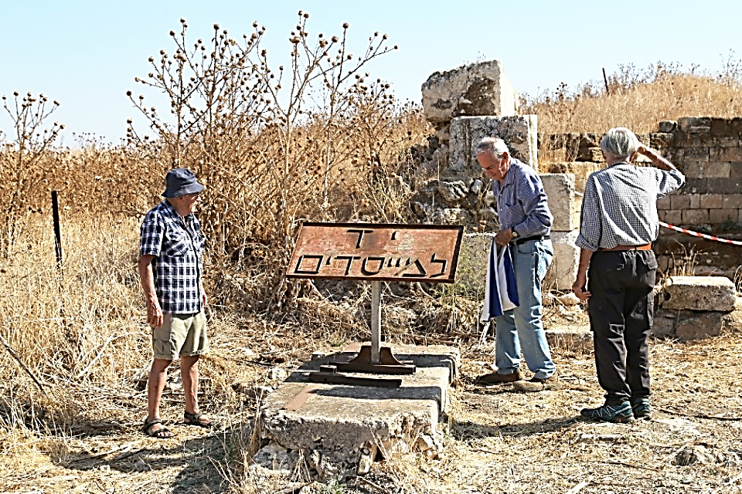

**Written for the 70th Anniversary of the Kibbutz**

**"Moshiko Sinai, Garin Ramat Yohanan, the founders' generation**

In fact, except for **Dani and Hezi**, all of us left the kibbutz, each in their own time, but we never left the 'garin' We are connected by hidden threads of friendship, of absolute mutual trust. We meet often, and for many of us, and I am no exception, this is our only and most important friendship group, despite the decades that have passed. Someone once told me: 'Maybe you left the kibbutz, but it never left you.'

Days passed, and changes came about, and I tried to adapt. We began to build the farm in its new location on a hill east of Zarin. We built chicken coops, erected huts for livestock and dwellings, concrete and iron structures. Gone were the days when we could choose a deserted Arab house in the village for ourselves. We built a spacious dining room and even established a reservoir, into which a pipe from the spring below carried the water, putting an end to the need to transport drinking water in barrels from the spring. After pouring concrete into the molds for the reservoir , a storm broke out. No one bothered to check the condition of the molds until the next morning, and so it happened that after removing the molds, it became clear that the reservoir would remain crooked forever. The valley got its own “Leaning tower of Pisa” ... Gradually, the members moved to the new settlement. The laundry, showers, and warehouses were built. A small group, including myself, remained in the village, serving as guards. In the meantime, changes also occurred in the area.

After signing the ceasefire agreement in Rhodes, borders were moved, including the border next to us, which was shifted about three kilometres south. Wadi Ara became ours, its length extended, Additional plots of land were allocated to kibbutzim and moshavim from the Jezreel Valley and the Galilee, and at our kibbutz, a sort of hostel was created for guests who came to work their fields from other kibbutzim. This, for a certain period, opened new horizons for us."

**From Reut Shaliv’s Editorial:**

In honour of the 70th anniversary of Yizrael, I went to interview Danny Harpaz. I heard from him that he and his friends from the Palmach have been meeting every year (for seventy years!), – I heard about Siko, who was his commander in the Palmach, about life in Zarin, about the first houses that were built on our hill, to which they moved after living for two years in Zarin.

Not surprisingly, Dani found it difficult describing his feelings when he talked about how they lived back then: close to the border of the country, food was scarce, and to bathe, they went down to the spring. I tried to understand how they felt, a group of young people, not yet in their twenties, who came here after fighting in many very difficult battles and losing friends. When I tried to press him about how they felt, I had to settle for the answer:

"Our generation was truly blessed in having writers and poets like Alterman, Haim Gouri, and Haim Hefer who knew how to express this whole period in an ultimate way. They were the spokeman of our generation

During these conversations, , I learned not to take for granted, the beautiful and flourishing Kibbutz Yizrael, with neighbourhoods like "Mizrach," "Tzi’irim," "Horim," "Gilboa," "Tzameret," "Hod," "Nof," and "Sadot," . The recent troubled times, during which Dani Harpaz left this world, just intensify my feelings.

**Summary of 2 H.R. Management Meetings - 15.10.23, 22.10.23**

**Participants:** Eddie Solow, Shlomo Cohen, Irit Shemesh, Rotem Agmon, Yifat Asaf, Erez Peleg, Nir Segal, Noa Armoza, and Kinneret Govrin.

The meetings were conducted in the shadow of the security situation. Many people are volunteering their services to assist in various areas. We commend everyone who steps up during these challenging times.

As part of our resilience efforts, we strive to maintain normalcy and optimal functioning to prepare for the long days ahead and continue to fulfill our roles as best as possible.

1. **Toranut:** A further discussion on the topic of rotations took place. Our dealing with the rotation system issue, continues to make progress. We are focusing on a fair load distribution. Currently, the most significant disparities exist in the Shabbat rotation, and a restructuring of Shabbat rotations is being considered.
   * **Age of rotation duty:** Currently, the age of completing rotation duty is 60. The H.R. management is proposing increasing this age to 65 for both women and men. If ratified, members currently between the ages of 60 and 65 who do not do rotation duties, will receive a letter explaining the change, and they will be invited to participate in rotations until the age of 65.
   * **Exemptions from rotation:** After consulting with members who do not perform rotations and determining the reasons behind their non-participation, approximately 20 members with medical issues preventing rotation duty or participation in the food rotation list, will be asked to provide a valid medical certificate. We are checking out the possibility of bringing an occupational physician to the kibbutz.
   * **Guard duty on Shabbat:** This toranut is problematic. The duty is for 10 hours which is disproportionate compared to the other parallel duties. Some 20 members in this list could bolster the food branch list and make it easier for all. We decided to propose abandoning this duty. (If ratified) Guard duty will be done by a security company on weekends (as is the practice during the week)
   * **Duties of members with permeant medical exemptions receiving National Insurance.** No change in this group. They do what they can, where they can.
   * **Rotation software:** The current software does not meet the kibbutz's needs. A decision will be made on whether to buy a new one.
   * **N.B. Rotation procedure:** **A new procedure for rotations was prepared, which will be published and brought to the kibbutz asefa for approval.**
2. **Tenures:** With the changes in organisational structure by the asefa, some positions have become tenure based. This applies to specific roles where the terms of office have already exceeded four years or had no set limit.
   * **Selection of office Bearers:** The management proposed two alternatives:
     1. All seven positions would be open for re-election via ballot.
     2. Differentiation between those who were elected for specific positions within the last year and a half with the existing system at the time and those who **have completed four or more years in their roles.**

**The decision was made to proceed with the second alternative. Three office bearers, Itzik Shechter (Food Branch Manager), Shlomo Levy (Construction Manager), and Leora Kamilian (Clothing Branch Manager), will come up for re-election via ballot.** Kinneret Govrin

**Synopsis on the Subject of Toranut: October 26, 2023**

Following the decisions of the H.R. Management published above…

(For those, like me, who get confused by long, drawn out, reports - Ed)

**It is important to clarify the ongoing process regarding toranut.**

1. There is currently a significant reorganisation in this matter after it became clear that there are major discrepancies in load distribution.
2. Members who are not currently performing duties and/or not doing duties in the food branch will receive a letter requiring them to provide an up-to-date medical certificate from an occupational physician.
3. Duties for guarding the gate and laundry on weekends will be terminated, and the people on the lists will be reassigned according to need.
4. Moadon duty, driving duty, will transition to retirees. Retirees are invited to contact Tze’ela.
5. All members will be involved in the mid-week serving duties, except for those who have presented a medical exemption.
6. Half-day Friday evening duties (Hetzi Erev) will now become assistant cooks.
7. Efforts will be made to equalise the duty frequency and length among all members, and since there is a shortage of cooks, anyone willing to transition to cooking duties, is welcome to inform Tze’ela.
8. **The Duty Procedure will be published and will be presented for approval at the asefa.**
9. The duty system software will be adapted to the kibbutz's needs. Further updates will follow.

P.S. The new schedule is planned to be released in January 2024. We appreciate the public's cooperation in creating a fair toranut system that operates for the best interests of all.

Kinneret, on behalf of H.R. and all parties involved in this matter.

**Important Update from H.R. re Regional Council Elections**

**The local regional council elections** have been postponed for 3 months. Therefore, the upcoming Tuesday, October 31, 2023, will be a regular workday.

**Regarding work reporting during these troubled days:** All branch managers have been instructed on how to report work of the members and employees. If you have any questions, you can contact me.

In hope of peaceful and safe days ahead - Kinneret



**The Circle of Life**

1. **Mazel tov to Noga and Omer Harpaz** on the birth of their granddaughter, the daughter of Itamar and Dafna, a sister to Eyal, and a great granddaughter to Dani. Congratulations to the entire Harpaz family, including the Alterlevi and Ron families, and to Dafna's family. Wishing you abundance, joy, light, good health, and lots and lots of love.
2. **Congratulations to Noga and Omer** **Harpaz** on the birth of their granddaughter, the daughter of Amit and Gal, and a sister to Eitan, Great Granddaughter to Dani. Congratulations to the entire Harpaz family, Alterlevi and Ron families, and to Gal's family. Wishing you abundance, joy, light, health, and lots and lots of love.



**From the “Tzachi” Home Security Committee**

**The End of Another Week of War:**

Firstly, the committee shares in the grief of Lilach Ron on the passing of her father, the late Dani Harpaz. It is a great loss for Yizrael and, of course, for the family on a personal level.

At the time of writing, Kibbutz Yizrael is still considered a "safe zone." We are in close contact with the regional council and security officials in the area, staying updated on the situation and its implications.

Protective concrete structures have been set up in exposed areas on the kibbutz, the safe rooms have been sealed, equipped, and the Home Front Readiness exercise has been conducted. The kibbutz is being guarded by our local security personnel at the gate and on patrol around the kibbutz. We are also located on a major route, which is manned by the security forces.

We are pleased that we can host many families who have relocated from their homes in the south and north. Some were directed here by the authorities, while others are personal guests of members. All seeking refuge from rocket attacks. Some suffered loss in the war. Keren Kagan and Eyal Tirosh are coordinating all aspects of accommodating the displaced guests and are doing wonderful work. Many of the guests have volunteered for various tasks and are helping in the dining room, and other service branches, Shabbat arrangements, and more.

Thank you to all of you!

Many members of Yizrael are lending a hand in various ways, guarding, patrolling, updating lists, organizing the displaced, lifting and carrying, opening the pool and more. We won't mention names because there are so many. Everyone knows who you are, there is great joy in being able to make a meaningful difference during these troubled days.

The service branches are working at full capacity, taking care of the needs of the visitors. This includes food, clothing, housing, construction, security, and more. The food branch even donates food to the security forces stationed in the area.

We call on everyone to volinteer and contribute where needed, even beyond working hours. We thank those who are already doing so and, in general, thank you all for the great teamwork because only through joint efforts will we succeed in this challenging period and emerge stronger.

We continue to support our soldiers, both regular and reserves, and look forward to their safe return home soon. Thank you for being there for us, far from home, in this complex reality.

May there be peaceful days ahead.

Shabbat Shalom,

Erez and Yifat, on behalf of the emergency committee command centre.

P.S. Please feel free to turn to us, if you need further information or have any questions about this text.

**A Message from the “Hosting” Committee**

Dear friends,

We are presently hosting over 100 guests here in Yizrael,

We would like to express our gratitude to the wonderful Yizrael community for their swift response in welcoming the guests, opening their hearts and homes, helping with accommodating the guests, and preparing rooms for the youth, soldiers, and the younger generation.

A big thank you to our community branches who are working tirelessly to ensure that we, all our guests,, can continue with our regular routine.

Thank you to everyone organising cultural and creative activities for the guests and the kibbutz members during this challenging period.

Beit Yizrael, you are touching. **May we always be on the giving side**, and we will continue to smile and extend a warm welcome to our guests who are in such great need of it.

Hoping for calmer and better days.

Eyal Tirosh, Zohar Assaf, and Keren Shtamper-Kagan

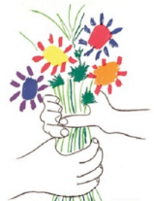

Top of Form

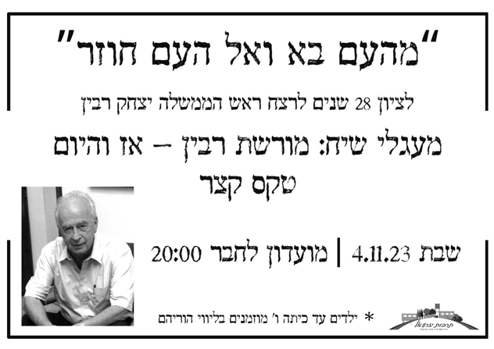

**He Came from the people and returns to the people**

**In commemoration of the assassination of Prime Minister Yitzchak Rabin**

**Discussion groups on the subject:**

**Rabin’s Legacy - Then and Now**

**Shabbat 4.11.23**

**“ - Beit Hamusika” The Music School**

**Music's Secret Charms**

Part 3. Prof. Roni Granot - Lecturer and Researcher in the Department of Musicology at the Hebrew University

The Sense of Time

One of the prominent aspects in all of this is that these are situations where the feeling of coordination and connection among group members is of utmost importance. Music seems to be able to provide excellent responses to creating such feelings. It can be performed in perfect coordination in a large group, even without direct visual or physical contact. This is possible partly due to the way certain types of music allow us to organise and structure time. This organisation is unique to music and is not found in any other medium, making it an effective tool for coordinating group activities that other forms of engagement cannot achieve.

Our sense of time is a very complex concept, and I'll focus on three central points. First, we lack a dedicated sense to perceive time, especially in the immediate or short term. We extract this sense based on information from other senses, like sight and hearing. In music, the sense of time is closely related to the beginnings of events, such as the moment a drum is struck or when the start of a sound is heard.

The second important aspect to understand is that the human auditory system excels in processing time-related information, even more than the visual system. This is because events related to sound, such as natural sounds, environmental sounds, speech, and of course, music, all develop along the timeline. These events demand us to identify minuscule time intervals like those that separate consonants like "b" and "p" or long sentences when we hear spoken words.

Finally, there is a strong functional connection between the auditory system and the motor system. In brain imaging studies conducted while lying still, it's consistently found that when people listen to music, there's activity in brain regions typically active during movement. These brain areas include the cerebellum, basal ganglia, the primary motor cortex, and the anterior cingulate cortex, all responsible for planning and executing motor movements. This neural connection explains why humans often respond to music with synchronised movement like head-nodding, foot-tapping, clapping, or dancing. This response is deeply ingrained in our biology and human development, likely even evolved.

In the majority of cases, this motor response in music is synchronised with a beat. A musical beat is the basic unit of time around which musical time is organised. Like a ticking clock, but one inside our heads, not in the music itself. Music has enough sounds or beats that are organised around it for us to feel the beat and continue it in our minds even when the music has stopped or has moved to longer or shorter sounds.

Furthermore, Western music, for example, often consists of recurring cycles of emphasised beats and less emphasised beats, which are represented in musical notation through barlines. These emphasised beats typically include the first beat of each cycle, which is strongly emphasised. Think about a military march, where the commander often calls out "Left, Right, Left (Pause) Left, Right, Left (Pause)." Here, we have a cycle of four beats in which the word "Left" strongly emphasises the first beat of each cycle. This organisation is called "meter." The combination of beat and meter provides humans with a frame of reference and, interestingly, the capability to coordinate motor movement and even cognitive processing.

In my next segment, I'll discuss rhythm, an essential aspect of our relationship with music, and how our brains perceive and process it.

Coordination for a Sense of Belonging Research conducted over the past two decades has shown that the presence of musical rhythmic stimuli triggers brain activity known as "brain oscillations," and the timing of these oscillations corresponds to the beat. These oscillations can be seen as recurring cycles of ups and downs in the readiness of nerve cells to generate electrical nerve activity. These cycles influence our sensory processing, and they seem to be most prominent at the peak of the oscillation and less so at other points.

These oscillations persist even when skipping a beat within a sequence of beats, indicating that they are not just a response to existing sounds but part of a kind of internal clock that represents the beat in our minds. Using a task where participants are presented with an isolated beat without accents and are asked to imagine an even or odd weight, it can be demonstrated that the brain represents not only the level of the beat but also the level of weight.

Furthermore, the fact that we see similar oscillations in both the auditory system and in motor areas of the brain can explain our ability to synchronise movement with the musical beat. Therefore, we have a mechanism that explains why music is an excellent and unique medium for creating synchronized movement among individuals who are synchronised to the same beat and weight. But what's the connection between synchronised movement and the feeling of belonging and connection between people?

In a broad sense, synchronisation refers to two or more events that maintain a structured relationship in time, creating unity. These relationships can be sequential, simultaneous, or follow any other structured pattern. Professor Ruth Feldman from the University of Haifa, who studies the bonds between parents and infants, describes synchronisation in this context as coordination in behaviour, emotional states, and biological rhythms between the parent and the infant. Such conditions serve as a foundation for moments of communication in which the infant learns the basics of human interaction. Exchanges of glances and smiles, touch, imitation of vocal and motor gestures—all these occur rapidly but in a structured manner over time: sometimes alternately, sometimes simultaneously, and sometimes with partial overlap. This structured pattern allows the infant to learn parental behaviour, develop expectations from the interaction, and participate in the same "dance" where the infant learns and experiences the feeling of being together with someone and forming a connection.

If so, the idea of mutual synchronisation of behaviour and rhythms is deeply embedded in our relationship with others. Studies on both infants and adults have shown that mutual synchronised activities, such as synchronised walking or rocking on a swing to evoke a sense of affiliation with or likeness to another person, can enhance readiness to assist or cooperate with a common goal.

Synchronisation between people, therefore, is a central component of music's charm, and this synchronisation is not only related to music's role in group dynamics but also to its influence on our sense of energy. "Dance music," characterised by a clear and strong beat and a fast tempo, meaning many beats per minute, can drive people to move and feel invigorated, and vice versa. Indeed, when asked, "In what context do you listen to music?" many people speak about changes in their energy level or arousal. This change can be in the direction of increased arousal, for example during sports activities, or conversely, a decrease to relax or prepare for sleep.

In summary, music provides optimal conditions for coordinating movement and vocalisation among people, and such coordination evokes feelings of affiliation, belonging, and even a willingness to help. Thus, mutual coordination is a central element in the charm of music, affecting not only music's role in group dynamics but also its influence on our sense of energy.

**English is Fun - with Rahel**

**DISORDER IN THE COURT**

Great Fractured Moments in Courtroom History

(Contributions from the National Association of Criminal Defense Lawyers)

**WHAT IT IS**

Q. First of all, I need to ask you if you understand what a jury trial is, just as you have had in this case. Do you understand what a jury trial is?

A. Yeah, a jury trial is twelve ignorant people that is illiterate of the law.

**MISSING IN ACTION**

The Court: Who do you have on tap for today?

Prosecutor: Unfortunately, one of the men who was subpoenaed for and supposed to come in today decided to have a vasectomy today, which is an interesting way of getting out of court.

**NO SELECTIVE RECALL**

Q. Are you being selective about what you remember and what you don’t remember as to the details of your previous record?

A. I don’t remember

**PROBATION REPORT (1)**

The defendant reports his future goals are to graduate from high school, and go to college. He states his primary goal was to be a police officer, but he will have to settle for being an attorney due to a felony record resulting from this present matter.

**(2)**

The defendant’s criminal career began over twenty years ago. He committed the present offence less than a week after being released from prison. He has now surrendered to God. God may be able to do more with this defendant than the criminal justice system has been able to do. All we mortals can do is lock him up for the maximum time allowed by the law and give God time to do His work.

**POLICE REPORT: A STUDY IN EUPHEMISM**

I then directed the suspect’s head towards the pavement in order to eliminate his hand from getting under his body via this route because the suspect was resisting by holding his head up even after I attempted to direct it down with little force and I was required to use more force causing his head to impact the pavement.

**MOUTHFUL**

Judge: What made you bite the police officer?

Witness: He stuck his arm in my mouth.

D**EAF DEFENCE ATTORNEY**

DA: Defense Counsel is accountable to you. (The jury)

Counsel: Judge, I object to that. I object to him referring to me as a cannibal, Judge.

The Court: He said accountable.

Counsel: A what?

The Court: He said accountable, not a cannibal.

Counsel: It sounded like cannibal to me and I object.

**NOBODY IS STILL HERE**

The Court: Is everybody here? Nobody is here.

DA: Well, I take exception to that Your Honour.

The Court: Well, I mean nobody who is anybody.

DA: I withdraw my objection.

…………….more next week

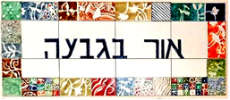

**Daily 08:30 – 12:00 – coffee, cake, chats, board games**

**Sunday 29/10**

09:15 – 12:15 Around the World – Emotion provoking stories with Lieutenant Colonel Dr Moshe Elad (on Zoom)

10:30 Ceramics room open with instruction from Ziv Ben Bassat

16:00 Or B’Givah open for coffee, cake and friendly chats

**Monday 23/10**

08:00 Pedicure with Limor Mualem (by appointment only)

09:30 The Art of Drawing with Chas Broadhurst

16:00 Or B’Givah open for coffee, cake and friendly chats

**Tuesday 24/10**

10:00 Trivia and board games with Galia

14:00 Ceramics room open with instruction from Ziv Ben Bassat

16:00 Or B’Givah open for coffee, cake and friendly chats

**Wednesday 25/10**

09:30 Gathering in the member’s Moadon for a game of Yizre’el monopoly with our guests

16:00 Or B’Givah open for coffee, cake and friendly chats

17:00 Tai-chi (advanced) with Einan Grosser

**Thursday 26/10**

07:00 Pedicure with Na’ama Baum (by appointment only)

10:00 Movie screening with Galia Shemi

17:15 Exercises on chairs with Michal Sha’anan



**Credits:**

Translated and edited by: Eddie Solow

Proofread by: Biff Markham Oren

Printed by: Irit Cohen and Hedva Sharabani

Top of Form