

**The Yizraelite – No 2134 Date: 24.11.23**

**Kibbutz Yizrael**

**Edi-torial**

This week is the week the first hostages are expected home… Who can breathe? **We hope and pray for the safe return of the children, the old people and all our fellow citizens. “There for glory go you or I”.**

On Tuesday 21.11.23, the unveiling of Bernice Kaplan’s tomb stone took place at our cemetery.

This week we’re publishing the eulogies delivered at the anniversary of Gavrush’s passing. May his memory be blessed.

**How to see past copies of “The Yizraelite” on Kehilanet?**

1. Write **“Newsletters”** in the search area

.2. **Press the magnifying glass icon** and bob’s your uncle. They all appear in order. Happy reading. You can binge read “English is Fun” if you need cheering up…and we all need cheering up!

If you need help, catch me in the dining room.

SHABBAT SHALOM - Ed

**Visit to the families of Kibbutz Be’eri at the Dead Sea**

A few days ago, we travelled to the Dead Sea to visit our counterparts from Kibbutz Be’eri, following the tragedy that befell the kibbutz on the seventh of October. The sense of partnership in the journey, the familiarity from meetings between leaderships, and the friendships forged between the kibbutzim led us to visit them as representatives of YIzrael, to convey our of concern for the well-being of our cooperative kibbutz friends, who are similar to us in many ways, and it's impossible to even begin to understand what they went through and continue to endure. We arrived with a car full of cookies and cakes from our own community and found dear people grappling with horrors. There is not a single person in Be’eri who does not know someone closely affected by the many murders and abductions – family, friends, neighbours. They are presently divided between two sites: about 70 members in Ein Gedi and the majority of the kibbutz, about 800 members, filling David's Dead Sea Hotel. They receive care and attention to all their physical needs but are far from their shattered homes, having endured severe trauma. We visited both sites and met with the community manager, Yiftach Zelnikar, secretary Gil Molcho, and former secretary Yaniv Hagai, from the joint headquarters, currently responsible for the group in Ein Gedi. We heard a bit about their experiences and the difficult stories, and most importantly, we embraced and asked how we could help. The answer was that at the moment, it seems they will need financial assistance – people who understand cooperative kibbutz life and can assist in the recovery of various systems. We will meet with them again to delve deeper into their needs, and we are confident that the power of YIzrael has the ability to assist this dear kibbutz. With the box of almonds and cookies, we left them the following letter:

To our friends fron Kibbutz Be’eri,

We have always seen you as a kibbutz similar to ours, in composition, communal way of life, values, and issues at stake. As a result, we have engaged with your leadership in joint meetings, maintained working relationships, friendships, visits, and shared thinking.

Our hearts ache at the thought of what you went through on that fateful day and the immense void it has left in your community since then. We want to embrace you with all our strength, express our heartfelt condolences, and share in the heavy burden that your hearts have been carrying ever since.

We recognise the strength of your community, and we are confident in your ability to rise stronger, united, and better from this tragedy. We will continue to watch over you with respect, concern, and a sense of partnership and friendship.

Our door and our hearts are always open to you.

With you and for you,

**Human Resources Open Meeting – Invitation**

The meeting is open to anyone who wants to submit a proposal for the operation of the duty rotation system.

The meeting will take place on Sunday, November 26, 2023, at 15:00. Proposals must be submitted to Kinneret by next Sunday at 9:00 so that there is time to thoroughly review and understand the implications of each proposal.

Top of Form

**Economic Council plus Asefa**

**Invitation**

**Monday, November 27, 2023**

**Moetza** 19:30

**Asefa** – 20:00

Moadon + Channel 900 + Zoom

**19:30** - Economic Council • Approval of the war budget

**20:00** - Asefa • Audit report - Organisational structure

Auditor: Uri Greenberg

Asefa Committee

** A Candle in Your Ear – Sima Arieli**

**Used in Native American Hopi Medicine**

A common treatment in many cultures around the world. The original use was for soul purification and opening energy blockages; today, it is used to treat ear problems. The hollow candle is made from linen fabric, beeswax, and herbal extracts, with soothing anti-inflammatory oils.

The candle creates local heat and a vacuum on the eardrum's skin, releasing inflammation and pressure from the ear. The treatment involves gently inserting one end of the candle into the ear and lighting it on the other side (20 minutes on each side). The treatment is recommended for relaxation or as a preventive treatment for various ear issues: earwax, hearing impairments, recurring inflammations, sinusitis, chronic headaches, sore throat, and just a good feeling.

A particularly soothing treatment, without side effects, recommended from age 3 to 120. Special price in light of the situation, 99 shekels.

****Feel free to contact me, Sima Arieli, 052-3756193

**Result of the Ballot Following the Asefa held on 6.11.2023 as Published in "Kehilanet" on Monday, 13/11/23**

In the ballot regarding the termination of Zivit Nanikashvili’s membership, the asefa's proposal was accepted according to Article 5(a) of the Kibbutz Regulations - Asefa Proposal: "Termination of Zivit Nanikashvili's membership in the kibbutz in accordance with Article 5(a)(1) in Part B of the kibbutz regulations, after she violated the regulations and asefa decisions and did not cease the violation after being warned by the asefa that membership termination is expected."

242 members voted, which is 81% of eligible voters. According to the voting results, Zivit's membership in the kibbutz has been terminated. The decision was made by a majority of over 60% of eligible voters, as required by the regulations. A message with the voting results has been sent to Zivit

**Zivit and Yuval Nanikashvili**

**Vs.**

**Kibbutz Yizrael, Holdings, Jeremy Perling & Yifat Assaf.**

On Sunday, 19/11/23, a lawsuit was filed in which Yuval and Zivit are suing the kibbutz, Yizrael Holdings, as well as a personal lawsuit against Jeremy Perling and against Yifat Assaf. The main claims include the issue of a restraining order preventing Zivit from being expelled from kibbutz membership, rectification of Zivit's seniority, the reinstatement of Yuval's membership, the retrieval of documents, and the annulment and/or reduction of debts.

All defendants are represented by attorney Omer Cohen.

- Yifat Assaf

(N.B. - Disclaimer – The editor will blame AI for any mistakes in the translation)

**Report from the Asefa 20.11.2023**

Asefa Chairperson: Shlomo Cohen

Asefa Secretary: Uri Gilad

Present: 38 members Agenda:

1. Nominations Committee and Presentation of Nominations - Candidates for committee membership
2. Proposal from the Management of Moshav for the Rotation Policy
3. Preparation for the Cards - Additional Term for Branch Managers, following the Asefa's decision:
   * Liora Kamillian - Clothing Branch Manager
   * Itzik Shechter - Food Branch Manager
   * Shlomo Levi - Building Administration Manager
4. **Elections for Committee Membership**

Yifat Assaf briefly described the role of the Members’ Committee and emphasised the importance of choosing suitable members for this committee. The committee deals with personal matters that cannot or should not be discussed in other forums due to privacy considerations. Additionally, the committee serves as a think tank and consulting team for the secretary in special cases. The committee also proposes candidates for membership. Given that this committee is not obligated to report or work transparently, there is paramount importance in selecting members who will maintain a high level of discretion, sensitivity, adherence to communal values, and individuals who are thoughtful and empathetic.

Nir Segal presented the list of candidates, some of whom volunteered, and some were approached by the committee:

Avner Alterlevi, Eddie Solow, Amir Armoza, Amir Darom, Yaniv Shapira, Yael Epstein, Moran Kuperman, Noga Harpaz, Stas Gavrilov, Sigal Perling, Irit Shemesh, Peter Pezaro, Rochele Matalon, Reut Shalev, Sagit Beutler

The voting will take place in two rounds to ensure a majority vote. The first round will be held on Wednesday and Thursday of this week, and the second round will be on Sunday and Monday of the following week.

**Scoop:** The following names were elected to go through to the final round: Amir Armoza, Amir Darom, Noga Harpaz, Stas Gavrilov, Rochele Matalon

1. **Regulations for Roster Duty Work**

Yifat explained that the pressing nature of the subject is the reason for bringing this subject to the asefa, the war notwithstanding

Kinneret Govrin, H.R. Manager, presented the key points of the policy:

**Opening Remarks:** The current rotation system is not equal in workload distribution. It operates randomly and not all exemptions from rotations are valid. The main goal is to create a fair and equal distribution among all participants, ensuring as many members as possible take part to ease the burden on the entire community participating in rotations. The focus today is on approving the rotation policy. It is essential to distinguish between operational proposals and the essence of the matter. Operational proposals are to be discussed by H.R. management.

The rationale behind transferring people to the food branch is the understanding that the current system, as it stands, cannot be sustained over time and requires pooling resources to preserve it.

**Background:** For the operation of our cooperative kibbutz system, the preservation of service levels, and the unique character of the kibbutz, members are required to participate in the rotation system doing tasks unrelated to their regular work hours. The aim is to operate vital systems only and fairly distribute the burden among participants.

Rotations are an integral part of the communal lifestyle and it is expected of all members, newcomers, and young residents of the kibbutz to play their part. The goal and main principle of the policy is to define and regulate the rotation issue on Yizrael. To define a system that achieves a fair and equal distribution as much as possible among the entire community. Rotations will not be considered work hours. The aim is to regulate exemptions and part and in total. To raise the age limit for rotation duty to 65. To define sanctions if rotation duties are not fulfilled.

**Those obliged to do rotation duties:** Members **up to the age of 65** (Note change - Ed), Candidates within 3 months of their arrival at the kibbutz, young generation members residing in the kibbutz, youth from the beginning of the school year of grade 11, *residents are allowed to volunteer for rotations. *Members over the age of 60 who were exempt by the old decision, are allowed and encouraged to return to or continue doing rotation duties.

**Exempt from rotation duties:** Members and residents who have reached the age of 65, pregnant women from the sixth month until one year after the baby's birth, single parents until the youngest child reaches the age of 6, members who receive an exemption approval from one of the authorised bodies: H.R. Manager, Kibbutz Secretary, or occupational physician.

**Types of rotations:** Each individual will be assigned to 4 types of rotations: mid-week rotation, Friday rotation, Saturday rotation, and holiday eve rotation. *Cultural rotations will be managed separately.

**Member's responsibility:** Swapping out and and informing the authorities, providing advance notice of long vacations, advance notice of reserve duty or specific temporary work needs.

**Rotation Coordinator's responsibility:** Managing the rotation system with fair and equal distribution among the entire community, preparing a semi-annual plan and publishing it to the public. When a member enters the rotation cycle, the rotation coordinator will offer several existing alternatives for rotations according to the Kibbutz’s needs. The coordinator is responsible for continuous monitoring and system updates as needed, monitoring arrivals and departures and returning individuals to the rotation cycle after exemption completion, implementation of the rotation policy.

**Failure to fulfill rotation duties:** If a member/newcomer/young individual does not attend a rotation, they will be reassigned and perform a rotation in place of the one missed. If they fail to perform three rotations during the year, a meeting will be held with the H.R. Manager. If three absences from rotations are unjustified, a fine of 400 NIS per rotation will be levied, and the individual will be reassigned to rotations not completed in the same year. The fine may be levied at any time during the year, regardless. After being fined, make up duties will not enable refund. An appeal can be made to the H.R. Manager.

**Summary of Key Changes**: Each member/newcomer/young individual will be assigned to 4 types of rotations: mid-week, Friday, Saturday, and holiday eve rotations. The age limit for completing rotation duty will rise from 60 to 65. Rotation exemption will be organised systematically and monitored. Definition of ways of dealing with non-compliance. All these will lead to a system that is as equal and as just as possible, cohesive and reliable, stable over time.

Kinneret thanked the H.R. Management Noa Armoza, Irit Cohen, and Tze’ela Baran Shkolnik for their assistance.

**Points mentioned in the discussion:**

* Regarding operational proposals – there will be an open H.R. management meeting dedicated to the topic (Sun 26.11.23 15:00).
* Glad there is a policy. It still does not address everything that is troubling. No mention of coverage. 400 NIS fine is very little, some would prefer not to do it and pay 400 NIS. Prefererence to tie it to the work hours.
* Regarding members aged 60 to 65 – a letter was sent to those members aged 60-65 inviting them to participate in rotations.
* Cultural rotations: It was mentioned that it will be possible to assist in organising them later.
* Praises for the thoroughness and clear presentation. It is a good idea to involve an occupational physician.

**Discussion and Voting on the Rotation Policy:**

* Discussion re the sale of rotations that already exists, with a tariff lower than 400. Asked about single parents, why exempt until the child is 6. In response, it is an arbitrary number that seems reasonable to the H.R. administration.
* Proposalthat exemptions be made by both the H.R. Manager and Secretary together.
* Asked if the policy reduces the frequency of rotations. Kinneret replied that redirecting members to the food branch by cancelling other rotations is aimed at reducing rotations and easing the burden on the community.
* Asked what success will look like in a year. Kinneret replied - a system that is, cohesive, with fair distribution.
* Regarding medical exemptions - a letter has been / will be sent to anyone not fully participating in rotations.
* Efforts are being made to bring an occupational physician to the kibbutz, who will receive an explanation and information about rotations and recommend accordingly.
* Comments on the regulations wording, requesting a change from 'fair distribution' to 'equal distribution.' It is difficult to achieve justice. The policy lacks an ideological foundation. However, it is noted that there is a very clear rationale in the policy, as stated in the introduction.
* It is important that medical exemptions be temporary. Add to the policy that, at the time of granting the exemption, a period will be set for its re-examination.

**A vote was held on the rotation policy, including the requested amendments. By a majority of 52 in favour and 33 against, the rotation policy was accepted.**

3. **Towards Elections by Ballot- Another Term for Branch Managers**

At the kibbutz asefa which dealt with the organisational structure, it was decided that certain managers of large branches in the community services should be elected by ballot. Three managers who completed one or more terms expressed their desire to continue for an additional term. The candidates for election are **Liora Kamilian**, manager of the clothing branch, **Itzik Shechter**, manager of the food branch, and **Shlomo Levi**, manager of the construction administration.

Erez Peleg presented the topic and emphasised that despite the re-election at the same time, the intention is to stagger the end of terms so that three managers of large branches in the community do not finish at the same time. Also, if, God forbid, any of them is not elected, they will continue until a replacement is found, ensuring a smooth and orderly transition.

Here are the statements of the candidates:

* **Itzik Shechter, Manager of the Food Branch:** In May 2019, I took on the role of the food branch manager in the kibbutz. Leaving a workplace after 17 years was not easy. When I decided to leave my previous job and come to the kitchen, I arrived with motivation and a strong will to improve and transform the dining room into something else, something good and pleasant at a high level. In line with this vision, I strive to work consistently. I strongly connect with the statement that "the food branch is the heart of the kibbutz," and I want to continue to see it in the near and the distant future. It is not always easy to integrate and work within the community, and I hope I am up to the task, even if sometimes the wind goes out of the sails... It's a bit hard for me to look back and summarise 4 and a half years full of action, but here are some examples of things that have happened in the branch since I took on the role:
* In March 2020, shortly after I took on the role and at the beginning of my learning period, the corona entered our lives, bringing challenges and goals we did not know before, with daily and frequent changes from lockdown to lockdown. We introduced, and we are still operating, many changes to stabilise the work team and branch employees, while thinking about occupational development in various areas, improving working conditions and wages, and establishing a stable and strong management culture. We renewed very old equipment that was in use, with a constant focus on energy, operational, and environmental efficiency – including dishwashers, smart ovens, hot and cold serving carts, and more. We established a broad advisory infrastructure in the branch - economic, culinary, food safety, and nutritional advice. We are constantly working to improve – culinarily, operationally, and economically, including the introduction of inventory control systems. We entered into detailed planning for the renovation of the entire structure, and in the first stage, the replacement of the dishwashing machine which is already in high gear. Improvement and rejuvenation in the children's sandwich corner, and more. In summary, I would be happy to continue to receive backing from the community to continue on this path in the branch.
* **Liora Kamilian, Manager of the Clothing Branch:** I have been managing the branch for 9 years. Over the years, we have made several changes in the service mentality, efficiency, savings, and income. We investigated what prevents people from bringing their clothes to the kibbutz laundry, and from that, we improved things. There is still work and development to be made in the branch. Yizrael Laundry washes an average of 17 tons of laundry per month, which is over 200 tons per year. For example, when I started working, we washed an average of 12 tons. Last year, we washed an average of 15 tons. The increase is, of course, due to a blessed demographic growth. Yizrael Laundry takes in work from outside the kibbutz, and the goal is to increase the external income. Waiting for business approval. Last and very important - Yizrael Laundry is considered a highly professional laundry, both in materials and in the professionalism of the team. I take this opportunity to thank the team because without their service attitude and professionalism, all this would not have happened. Each member of the team has a different area of responsibility, and we make sure to smile and be happy.
* **Shlomo Levi, Manager of the Construction Administration:** I would be happy to continue doing what I do today. In recent years, we have changed the face of the kibbutz. There is excellent cooperation with the planning committee and the building branch. The kibbutz is facing a very large project - the construction of the northern neighbourhood. We come to it professionally prepared. There are challenges. I love the kibbutz; I care about how the kibbutz looks and the future of the kibbutz. I hope to receive public support to continue the work.

A number of members praised the work of the managers and took the opportunity to express gratitude.

Erez Peleg added his recommendation for each of the three. All three are professionals, worthy, have accumulated knowledge and experience, and this is their "money time":

* **Itzik:** Works very hard on innovation, stability, and advancement of the branch. According to him, 'food is made with love or not made at all,' and this is evident in his work again and again.
* **Liora:** The soul of the branch. The branch is efficient, professional, Liora is service-oriented, has established an efficiently operating team, achieved economic improvement, machine innovation, and business understanding.
* **Shlomo:** The right person at the right place and time. He is the one who gets things moving, with a lot of love and determination. He has learned a great deal. Currently in the middle of a major project, and more big projects are ahead of us. He is ready to continue for another term to promote infrastructure and construction in the next four years.

The ballot election for the three managers for an additional term will take place next Sunday and Monday. Good luck!

Yifat Assaf

Top of Form

**Top of Form**

**Elections – Ballot – 26+27. 11**

**From Sunday, November 26th at 8:00 until Monday, November 27th at 13:00**, the second round of ballot elections for the Members Committee (Va’adat Chaverim) will take place. In this round, each member is requested to choose three candidates from the five who advanced in the first round. The three who receive the most votes will be elected, along with Tamir Blass, who continues for an additional term to maintain the committee's continuity.

Additionally, in the same vote, there will be a vote for an additional term for the central branch managers (as decided by the asefa) -

* Itzik Shechter - Manager of the Food Branch
* Liora Kamilian - Manager of the Clothing Branch
* Shlomo Levi - Manager of the Construction Administration

**Cyber Warning!!!!!!**

Hello everyone,

There is a message circulating on the network from cyberterrorist organisations with threatening content. The message is delivered via email but may appear in various forms and through different channels. **Be cautious and avoid clicking on any unknown links.**

Message by Tal Havshush - Yizrael Computer Dept



**From Erez’s Desk** - November 24, 2023

Since October 7th, it seems that our lives have changed. The events of that Black Saturday necessitated an immediate change in our routine and a transition to an emergency mode. At least until the beginning of November, the routine came to a complete halt, and all attention and efforts were directed towards situation assessments, war results, and enhanced preparation in the kibbutz for the coming days.

The assessment that we are facing a major and widespread wartime event emphasised the need to allocate many resources urgently to improve the kibbutz's readiness in security and defence areas, such as reinforcing the security rooms, enhancing the preparedness of the readiness team, and even giving attention to the redundancy of the bunkers defined by the Home Front Command as unnecessary.

The events of October 7th also highlighted the need to consider our geographical location, only 6 km away from the Jalameh checkpoint. While there are currently many military forces along the border, and the IDF operates with high intensity in the Jenin area, it seems that we may not always be surrounded by military forces, and we need to be prepared to defend ourselves.

Therefore, several investments and immediate actions have been taken, including repairs and use of bunkers, maintenance of shelters, purchase of reinforced shelters and their placement in remote areas, purchase of equipment suitable for the readiness team, and conducting a series of exercises.

Beyond what has already been done, we need to continue to invest and improve our readiness. We are seizing every opportunity for training in security, medicine, welfare, and rescue. We continue to identify and address the gaps against the situation assessments and progress to achieve their closure.

In parallel, the YIzrael community has shown its true nature. Donations of equipment and food were delivered to soldiers and populations in need. Assistance was provided in laundering the uniforms of the soldiers stationed in our area, and the most significant help is hosting about 40 families (120-130 people) evacuated from the southern and northern settlements.

Community members volunteer in every area where help is needed.

Continuing with Full Force in Routine Project Promotion: The war has caused some delays in promoting projects that were supposed to start immediately after the holidays. Also, due to the absence of workers from overseas, there is a noticeable shortage of certain skilled professionals. Nevertheless, we are advancing in the execution of projects that have started or are planned to be executed:

* **Northern Neighborhood:** The infrastructure project is ongoing and is expected to be completed on time. The construction plans for the first row of buildings have been completed and submitted as part of the building permit process.
* **Two-Family Residential Buildings in the Parents' Neighbourhood**: After a delay of about a month, the construction of the building has begun. This week, the floor was cast.
* We are about to start the **path restoration project** in the center of the kibbutz in the coming weeks. The project will be carried out in segments to allow convenient movement without blocking all access roads simultaneously.

**Budget for 2024** In parallel with our activities arising from the war, we continue to prepare for the 2024 budget. The heads of the clusters and branches will present their work plans to the community management during marathon meetings scheduled for December.

The work plan for 2024 will necessarily be influenced by the conclusions arising from new situation assessments and the need for emergency preparedness resulting from the war and the events of October 7th. This is in addition to the budget cut made in the community plan in mid-2023.

Already today, we can identify a significant decline in work income at a rate even greater than the estimates that formed the basis for approving the budget amendment in mid-2023. This shortage creates a very large gap between the community's needs and the ability to finance them.

**Help (Still) Wanted!**

**Tender for Kibbutz YIzrael Security Chief Position** (Rabash).

Additional requirements for the position have been added, and **the position has been upgraded to a full-time role.** We emphasise the importance of filling the position with a kibbutz member, and we would be delighted to receive applications.

Candidates can submit their applications until November 30, 2023.

For details apply to Erez and Kinneret



**Report from the Culture Cluster – Yifat Segel**

Dear Members,

We have proudly passed the 75th year with an abundance of activities that have connected us all. The teams worked hard to ensure that everyone, from the young to the old, enjoyed a variety of events. It is time to express our gratitude to each and every one of them.

The pleasant and enjoyable holidays of Tishrei have also flown by in a whirlwind. Thanks to all the holiday teams who took upon themselves the production responsibilities.

In these challenging times for us all, it is essential to think about our culture. The team responsible for the cultural activities - Gazit, Tal, Keren, and Eyal - along with other wonderful volunteers, is working to adapt a variety of activities to different ages and create a different and positive routine for us and our guests in cultural events, sports clubs, and classes.

The mission is to bring a smile, even a small one, and bring some fresh air and entertainment.

Some updates:

1. The Documentation Team is currently working on the weekly community diaries. Adva and Tzafnat can be seen at every event, filming, interviewing, and producing a high quality and rich diary. If anyone has old films in their private archives, feel free to share them so we can all remember. We also wish Adva a quick and safe return.
2. The Visibility Team completed the kitchen project at the pool and is completing the lobby project. The beautiful furniture gives the lobby an up to date and pleasant look. We ask everyone to use the furniture with consideration for the benefit of all.
3. The Heritage Team (temporary name) aims to preserve our "community memory." Each of us has a meaningful story in the history of YIzrael, and there is a desire to hear, preserve, and present it to the public in an accessible and contemporary way. The team will conduct interviews and documentation with both veterans and young members, starting with the organisation of the first Herzl project, and more.

In the team: Noga Harpaz, Rochele Matalon, Adva Lipshitz, Zohar Assaf, Tzafnat Mor, and Einan Grosser.

Good luck, and we look forward to cooperation.

1. The archive will be closed for activity from December 1, 2023, until further notice. Thanks to Yael Epshtein Cohen for organising and managing the archive over the past year.
2. Looking ahead: Hanukkah is at the door. Despite the difficulties, the holiday team is working hard to organise a holiday that will bring us a small light in the midst of all the darkness around us.

I invite anyone with ideas for community activities or just a desire to participate to contact me or any Committee coordinator.

"When the power of love overcomes the love of power, the world will know peace." - Jimi Hendrix

May we know quieter days ahead.

Yifat Segel



**Our Visitors in this Time of War**Thank you very much to Revital Amit for helping with the column.

**The Elgrabli Family from Moshav Hosen**

**Who are we?** **Roni and Efrat and the children:** Abigail (10), Karmi (7), and Yuvali (9 months). Abigail and Karmi currently study at Gan Ner Hagalboa 1st and 4th grades

**Occupations:** Efrat is the communications manager (for children on the autistic spectrum) at Kfar Vradim, and Roni works at Maytronics. Roni is currently serving our country in the army.

**Where were we before coming to YIzrael?** We arrived in YIzrael on Saturday, October 14.

**What do we miss?** We miss home very much, our corner, extended family, and friends.

**What you like about YIzrael?** We thank our YIzrael friends for their royal hospitality, warm welcome, and smiles at every meeting!

**We appreciate it so much!**

Top of Form

**The Kleiner-Reinhartz Family from Brur-Chail**

**Who are we?** Roni, born in Rehovot, and Eden, born in Netanya, have been living in the Western Negev since 2009. They lived in Kfar Aza and Brur Chail. Parents to Dani, a six-year-old girl, and a four-month-old. Dani started first grade this year at "Sha’ar Hanegev" school, and later, at a school in Haifa, and now she studies at Gan Ner Hagilboa in Gan Ner.

**Occupations:** Roni, owner of "Yam" – a vegan Asian food restaurant that provides excellent and unique food for the entire Sha’ar Hanegev community. Eden works in education and social work.

**Where were we before coming to YIzrael?** In a hotel in Haifa.

**What do we miss?** We miss friends who were killed, those who were abducted, and the kibbutz paths. We miss Mario and Suzanne, our lovely neighbours who never left the kibbutz for a moment and take care of our garden to keep it blooming and growing. We miss Ruti and Yaron, who take care of our cats and also haven't left the kibbutz so far. We really miss our three cats: Shuli, the kibbutz king, Mili, the village darling, and Samdi, the chubby one.

**What you like about Yizrael?** We enjoy being on YIzrael, which provides us with a loving and homely embrace, a feeling of home, and lots of warmth and love.Top of Form

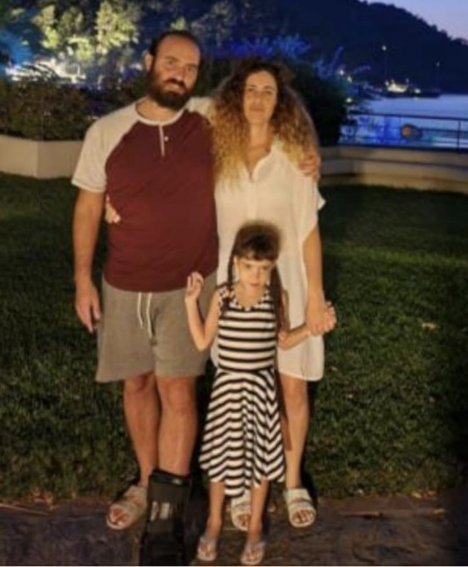

Top of Form

Top of Form

**The Grossman Family from Gvar-am**

**Who are we?** Ortal and Dan, and the children Yogev, 9 years old in 4th grade, Omer, 6 and a half years old in 1st grade, and Neta, 3 and a half years old, who is enrolled in Gan Rimon.

**Occupation:** Dan manages the carpentry shop in Gvar-am and therefore is not on YIzrael most of the week. Ortal teaches movement to young children, teaching in Sha’ar Hanegev, which was greatly affected on October 7th.

**Where were we before coming to YIzrael?** We came straight to YIzrael.

**What do we miss?** We miss our home on the kibbutz, our family, and friends.

**What you like about YIzrael?** We find a lot of help and support here. The children really enjoy the kibbutz and have already connected with children their age, participating in activities and clubs.

**Many thanks to the people of YIzrael who take care of us and welcome us with open hearts!**

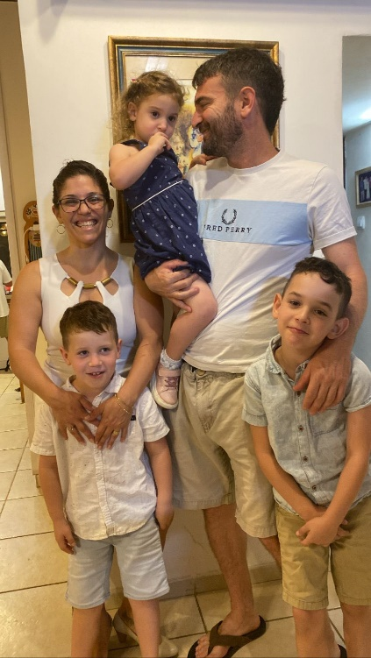

**Notes from Agricultural Volunteering in the Gaza Border - November 16, 2023 – Elad Ilan**

Among the farms seeking assistance, my attention was drawn to the notice about harvesting "lemons, oranges, and avocados near Kissufim." If there is still a functional state, I sincerely hope that it will compensate every farmer for the direct and indirect damages caused to them. We will have to wait and see. In any case, beyond the desire to help farmers, a journey to the region where my life unfolded and the fields where I was in my twenties, drew me northward. I recruited my father for reinforcement, and we hit the road.

On the coastal road, after Nahariya, army and police checkpoints begin. Reinforced concrete shelters, and asphalt-covered military bunkers are scattered about next to armoured personnel carriers, APCs, and tanks. It seems that since the days of “the Night of the Bridges (Leil Hagsharim), there hasn't been so much weaponry in this picturesque place.

At the volunteer gathering point at the Ziv Bridge, we met Moti, the mythical banana branch manager and, at times, the persimmon manager too. Moti said that Sa'id, the avocado manager, needs two or three guys. That's how we ended up in the avocado orchard near the Betzet airstrip. In this place, there was once a British airfield, with warehouses and concrete and stone runways that still stand today. The old landing strip once witnessed the landings of two Syrian MIGs that went off course, helicopters evacuating wounded from Lebanon, and children with and without licenses competing in tractor races. On the asphalt square of the helicopter landing, we flew toy planes and crashed them into the banana palms in the adjacent banana orchard. My grandfather and play partner, Motke, brought a tractor from the kibbutz, and I stood on the elevated scoop. Thus, we brought the toy glider down from the banana palm, stuck the pieces of the blazer wood together, and played again. Today, the expanded neighbourhood of Betzet covers most of the airstrip, and the avocado orchard borders the airstrip.

We picked Hass and Ettinger avocados. An unusual frost in April affected the trees, so the yield was not large. Still, I wish for just one such tree in my garden. In the picking team were Sa'id and three other workers I don't know. A Thai guy, a retired Ph.D. in tissue cultures, and yours truly. Sa'id reminded me about the olive grove, planted in '98. The manager of the orchard wanted to establish rights to the land so that the kibbutz would receive proper compensation when Highway 6 (which then barely reached Nitzanei Oz) passed exactly there, on its way to Lebanon through a tunnel to The New Middle East. Back then, we didn't understand that three bullets were throwing off the course of history. Rabin, in coordination with American interests, planned to make peace agreements with all the neighbouring countries. Syria was supposed to become, like Egypt, an American ally. This would have prevented the civil war there and, more importantly, it would have prevented the continued consolidation of Hezbollah in Lebanon and the Iranian influence beyond Israel's borders. (The three bullets that changed history) Thirty years of strategic blindness, one-sided moves, empty slogans, and arrogance (except for brief attempts by Barak and Olmert) exploded on the seventh morning of October.

Anyway, the olive trees grew, and we are now picking avocados in the section located south of the northern road. North of the road is a closed military area. There, the fruit will dry on the trees until it rots and turns into green butter enjoyed by wild boars and porcupines. The partly scorched ridge reminded me of the Appalachian Mountains in autumn colours. Towards the end of the picking, we heard distant and heavy explosions. In the old watchtower, at the foot of the ridge, in a place where my uncle once raised a pig, you can hear soldiers firing cannons. At the end of the harvest, the truck driver came to take the full fruit bins. Once, I used to tow the long tractor train of wagons along the patrol road of the Palmach's jeeps along the coast to the packing house.

On the southern road, the sea is still blue, and in Haifa Bay, ships are waiting to be unloaded. But as we pass the palm trees and tall trees near Kfar Masarik, I think about families murdered in their homes, and maybe I'm starting (and only barely) to understand my grandfather and his friends who came from far off and built this beautiful land, with memories of their families murdered in the lands of Europe for centuries.

Author: Elad Ilan



**Rugby Tournament**

**and Memorial Ceremony for Staff Sergeant Eli Ginsberg**

Doug Kennedy (former member of Kibbutz YIzrael) once told me that at the end of my first rugby tournament, they could have folded me into four, put me in an envelope, and sent me by airmail. I was a skinny 12-year-old playing with older, stronger, and faster kids. I assume I got tackled several times during that game but in my memory, I only recall one instance when I jumped on a bulky player, tackled him, grabbed the ball, and ran a few metres before someone took me down effortlessly. A strong "phew" was probably enough. Long-term memory is a strange thing. The brain chooses what to remember and what to forget. In the long run, the brain does a good job.

This coming Saturday, we will host a national children and youth rugby tournament with teams from all over the country participating. It's the first tournament of the current season and also the first rugby event in Israel since October 7, 2023.

As in every first tournament of the year, many players seem to be experiencing it for the first time. The excitement in the morning is accompanied by natural concerns (Mom, what should I eat for breakfast?!). The initial shock on the field, until they manage to implement the coach's instructions; all these will gradually fade into a sense of capability, confidence in personal and team abilities, trust in teammates and the coach, and the self-assurance derived from a beautiful rugby move, joy and happiness from the encouragement of the audience—all of these elements will play a role. Each team will play several times and improve from game to game.

Undoubtedly, there will be frustration and anger, victories and losses, joy alongside disappointments, hugs, and tears. Many children will face something new for the first time. More experienced players will also confront new challenges—integration of new players and new coaches in each team, and improving rival teams. This is the sporting experience and educational process that the players go through. It's the beginning of the season, and a long journey awaits everyone.

After each game, they will shake hands, and at the end of the tournament, they will sit with their teammates for a burger. They will return home proud.

**At the beginning of the tournament, we will hold a short ceremony in memory of Staff Sergeant Eli Ginsberg from Kibbutz Dovrat—father of Uri Ginsberg, who plays for the club—who fell on October 7 while fighting terrorists in the Gaza Strip. We pray for the return of all the captives held by Hamas and for the safe return of soldiers and security forces to their homes.**

In this tournament, we will operate for the first time in the new facility established in recent months with funding from the Ministry of Sport. The facility includes new dressing rooms, showers, toilets, a new shop replacing the snack stand, and a gym under construction. Along with the club's staff and youth players, we built a roof for the grandstand, renovated and arranged the entire facility. With the amazing help of residents of YIzrael (Avni Midan and Avi Sharon), we built new benches for the dressing rooms and showers, new counters, covering for the barbecue area, and more. You are invited to explore the facility and be impressed by the amazing work that has been done.

In the near future, we will hold a festive event for the official opening of the facility, along with the new gym.

The tournament will start at 10 AM with a short ceremony. Refreshments, creative drinks, barbecue—according to tradition! The general public is welcome!

**Reported by: Idan Zelas**

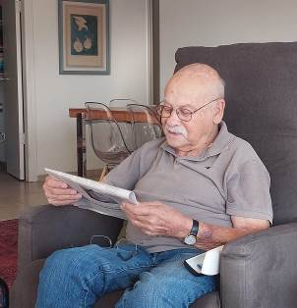**First Anniversary of the passing of Gavrush Nechushtan**

**Ronen Nechushtan**

**In Memory of My Dad - November 11, 2023**

Dear beloved Dad,

It's been a whole year. Our hearts cannot forget. And what a year it has been.

Dear Dad, just as you knew how to live, you also knew when to leave. It's not without reason that we say it's good you didn't experience the ominous year that has passed since your departure. Dad, this was a year where we were governed by the worst government in the history of the country. It was a year where we fought to preserve democracy, to safeguard the Jewish, secular, and democratic state of Israel that you and your generation created here. A model of strength that evil forces sought to extinguish.

In the last month, external enemies also rose against to strike against us. A terrible and dreadful massacre took place, where over 1,000 people were slaughtered. A dark and threatening Saturday that will change us forever. Dad, I am glad you weren't here with us to witness these horrors, to experience the difficult and sad days we are going through. The unbearable tension as your grandchildren fight in the north and south to ensure peace along the borders of the country and for the return of more than 300 hostages from that Black Saturday.

But, Dad, I want to tell you that alongside the bad, there is also much good.

I want to tell you that in this year, an amazing generation has emerged, fighting fearlessly and uncompromisingly for this country. A determined and resolute generation sowing many hopes. Young people who are currently storming courageously against a murderous enemy rising to strike us. An amazing and determined generation that we didn't know existed. I want to tell you that two grandchildren were born to you this year. Or, born to Chen and Nadav, and Jonathan, born a month and a half ago, to Ido and Sapir. Lovely babies that bring so much joy, along with the sweet companion who occasionally reminds us of you.

I want to tell you that Gilad has started publishing beautiful poems that he writes in a burst of creativity, and Keren is advancing towards realising her dream in the enchanting landscapes of Portugal.

Yes, Dad, these are our lives lately. Death and birth. A happy family on one hand and stubborn struggles on the other. You left us with great challenges, and we are committed to them. We will fight to overcome the evil and increase the light. This is the unwritten legacy you left us.

I know you met up there with your good friends who joined you in the past year—Daniel Harpaz and Bernice Kaplan, beloved and dear. I believe you greeted them with a smile and a big hug.

Just as you wished, we continue to maintain the connection between us. We continue to stay connected with Maida and with Yizrael, who you loved so much.

**Maida**

Henry Adams, a 19th-century philosopher and educator, who served as a counsellor to two U.S. presidents, once said:

"A teacher can affect eternity, for he never knows where his influence will stop."

Although Gavrush was a teacher for a certain period at the University of Haifa and other places, he was more than just an educator. He had a grand vision to serve the elderly population, especially in rural areas.

He realized his vision by establishing the 'Sav-Yom' in Mizra, followed by 'Dorot B'Gilboa.' These institutions remain a model for emulation across the country.

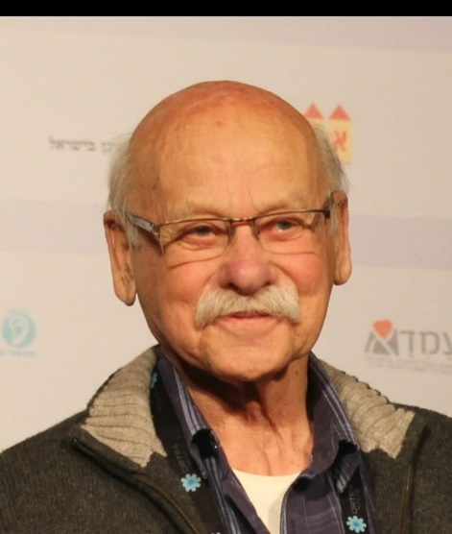I will not enumerate Guvrush’s many activities on the kibbutz and in the community itself – we all know.

I believe that all of us witness today that the legacy of Gavrush has not been forgotten, and thus, his influence did not cease with his death.

May his memory be blessed.

Maida Nechushtan

Top of Form

Top of Form

Top of Form

Top of Form

Top of Form

Top of Form

Top of Form

Top of Form

**Ceremony for the Unveiling of the Tomb Stone of Bernice Kaplan**

**21.11.2023**

Top of Form

Top of Form

Top of Form

**You Just Knew**

I feel I am dry as the desert

The tears have withered

The pain is deep, so deep

The pain is dark like the night

I feel lost

I feel scared

Your touch

Your smile

Your kindness

Your patience

You are home

You are working in the garden

You are doing the crosswords

You are sitting reading with the grandchildren

You are baking for us

You smile at us

You loving us

You said “I will be fine”

I said “it’s just a hiccup in the road”

You smiled

You knew

You were the only one who knew

You never liked goodbyes

You always walked fast, really fast

You knew things wouldn’t improve

You knew the suffering will last

You raced out of our arms, out of our world

You just knew

You knew when your garden will bloom

You knew when the grandchildren will walk through the door

You knew when the first rain will fall

You just knew

You loved the valley

You loved the breeze that rustles through the trees

You loved the sweet smell of the first rain

You loved dancing the night away

We loved dancing with you.

We love you

You left at the right time, mummy

The darkness has fallen on all of us

The world isn’t in a good place

The shock, the tears, the pain

You just knew!

Cigal Kaplan

## **Annabelle’s letter**

Dear Savta,

Me, as a person has changed a lot , all like everyone else in the world.

I am grateful to everyone in this family tree of ours. But for us you are the roots, the most important part of the tree and without roots a tree cannot live. It must start over.

This tree, our tree is heartbroken without you by our side.

You have taught us all a lot of knowledge that we will carry with us for the rest of our wonderful lives.

Bathing Teo and Ariella in a bath together and teaching them how to wash their bodies with soap and helping us read and write in Hebrew. All of these wonderful things have taken us all places.

Your words have made us the proud perfect people we are now.

Everyone knows your name and you are someone nobody will ever forget.

Savta Bernice, you are a wonderful human being everyone loves you so much and we wish that you could stay longer.

The world is full of wonders and the universe has taken you to a better place now, where you will watch over us in pride.

We all hope that you have found a safe place to stay and spend the rest of your happiness on you.

I hope that in another universe we will meet again.

I love you to infinity and beyond and hopefully we will meet again.

Yours sincerely and much much love

Annabelle.

(11 years old)

## **Letter from Sienna**

Dear Savta,

We all love you so much and we all hope you are doing well up there.

It is heartbreaking for all of us to take in. But as long as you are okay, we will all be happy. This whole family loves you dearly in hopes of joy.

Love you forever and ever

Sienna 🥰😍😘

(9 years old)

**From Ray**

As we gather today to unveil the tombstone of our beloved Bernice, we are reminded of a life taken from us too soon at too young an age. Bernice wasn't just a loving mother-in-law; she was a steadfast rock for all her grandchildren.  
  
 Bernice cherished every moment with her family, and I can vividly recall the joy she brought as a loving presence to all the grandchildren Alona, Michael, Annabelle, Sienna, Ariela, Teo, and Keano. Her unwavering support and love were constants in all our lives.  
  
 One of the fondest memories I hold dear is Bernice's love of fish. Bernice was an avid fish lover who enjoyed trying out new recipes. I remember the time she had swordfish; her delight was infectious, but she couldn't help but worry about Charles and Adelle finding out about this culinary escapade.  
  
 In the tapestry of our lives, Bernice has left an indelible mark. Let us remember her with love, cherish the moments we shared, and find solace in the memories that will forever remain etched in our hearts.  
  
 May she rest in peace, and may her spirit continue to bring warmth to our lives.  
  
With deepest sympathy,  
  
 Ray  
( son in law)

**Shoshana Mittelberg**

Bernice, I miss you. I find myself looking for you on the paths of the kibbutz, in the cinema with one or two grandchildren. When we used to meet, we didn't need to talk much - we understood each other without many words.

Bernice and I both grew up in the Jewish community of Perth, Australia. I am a year older than her and remember her as a young girl who came from England with her mom, Ann. Her mom married Jack Lerner, the father of two young boys - Ian and Phil, who became brothers to Bernice. Bernice's dad used to come to the synagogue every Sabbath, when possible, and brought Bernice and the boys with him. That's where we met as children, and we have been friends ever since.

We didn't grow up in the same neighbourhood, nor did we attend the same public school, but we saw each other on weekends. When we were teenagers, Bernice was very involved with the youth movement "Habonim," and later she went to the "Institute for Overseas Youth Leaders"(Machon) in Jerusalem.

We didn't see each other for a few years, and our paths crossed again between the huts (Tsrifim) on Kibbutz Yizrael in the early seventies. Here, Bernice met Milton, and here they got married and raised their three children. On Sabbaths and holidays, our children would meet at the synagogue, which wandered between various children's houses on the kibbutz.

Many things characterised Bernice, but mainly hospitality, care for others, and a lot of joy for life. Everything she did, she did in the most thorough way - family, youth movement, as an emissary in Perth in the eighties, in teaching, in the cultural sphere of Yizrael (Tarbut).

I am sure that Bernice's legacy resides in each and every one of you - Milton, Cigal, Yonatan, Nimrod, and the entire family. I wish you all a long life without further sorrow.

Bernice - you were a true friend to me throughout our lives, and I miss you.

Shoshana Mittelberg

Top of Form

**Small Tips for Big Emotions** *by Gaya Sankar* 

Like Tarzan.

Do you know the feeling that, no matter how hard you try, the air just can't fully enter your lungs? That as you rush from one thing to another, you can feel the tension in your body, the tingling of nerves, as if something is about to burst from within, and you don't know what it is or how to release it? It might sound strange, but gentle taps and beats on our body can help release all that tension.

Remember how Tarzan would beat his chest before swinging from a vine? Like him, we can use these taps to assist our nervous system (and also our immune system, but we'll expand on that another time) and bring resilience to our body.

What to do? With the tips of your fingers, gently tap the centre of your chest, moving up and down while allowing your heart to focus on breathing - deep and conscious breaths entering through the nose and leaving through the mouth. You can move your hands and tap on other body parts - shoulders, back, hands, thighs, anywhere that requires your attention. Then, return to the centre of the chest.

The initially quick beats should now become more rhythmic. You can open your palm and gently tap on the upper chest area (not on the throat, but below it, beneath the collarbone), gentle and stable taps that mimic the rhythm of our heart.

Notice how the breath becomes easier, how the air now fills the lungs completely, and how much calmer we are...

* It is recommended to do this several times a day, for 2-3 minutes each time. You can even set a reminder on your phone for such breaks.
* It can be combined with a few minutes of shaking for added benefit.

Wishing you a peaceful Sabbath. Shabbat Shalom, - Gaya

(Never have I been so in need of your good advice, as I do now. Thank you so much Gaya. And to the rest of our readers, I would like to suggest: go back and read Gaya’s “Small Tips” in the previous editions! – Ed)

Top of Form

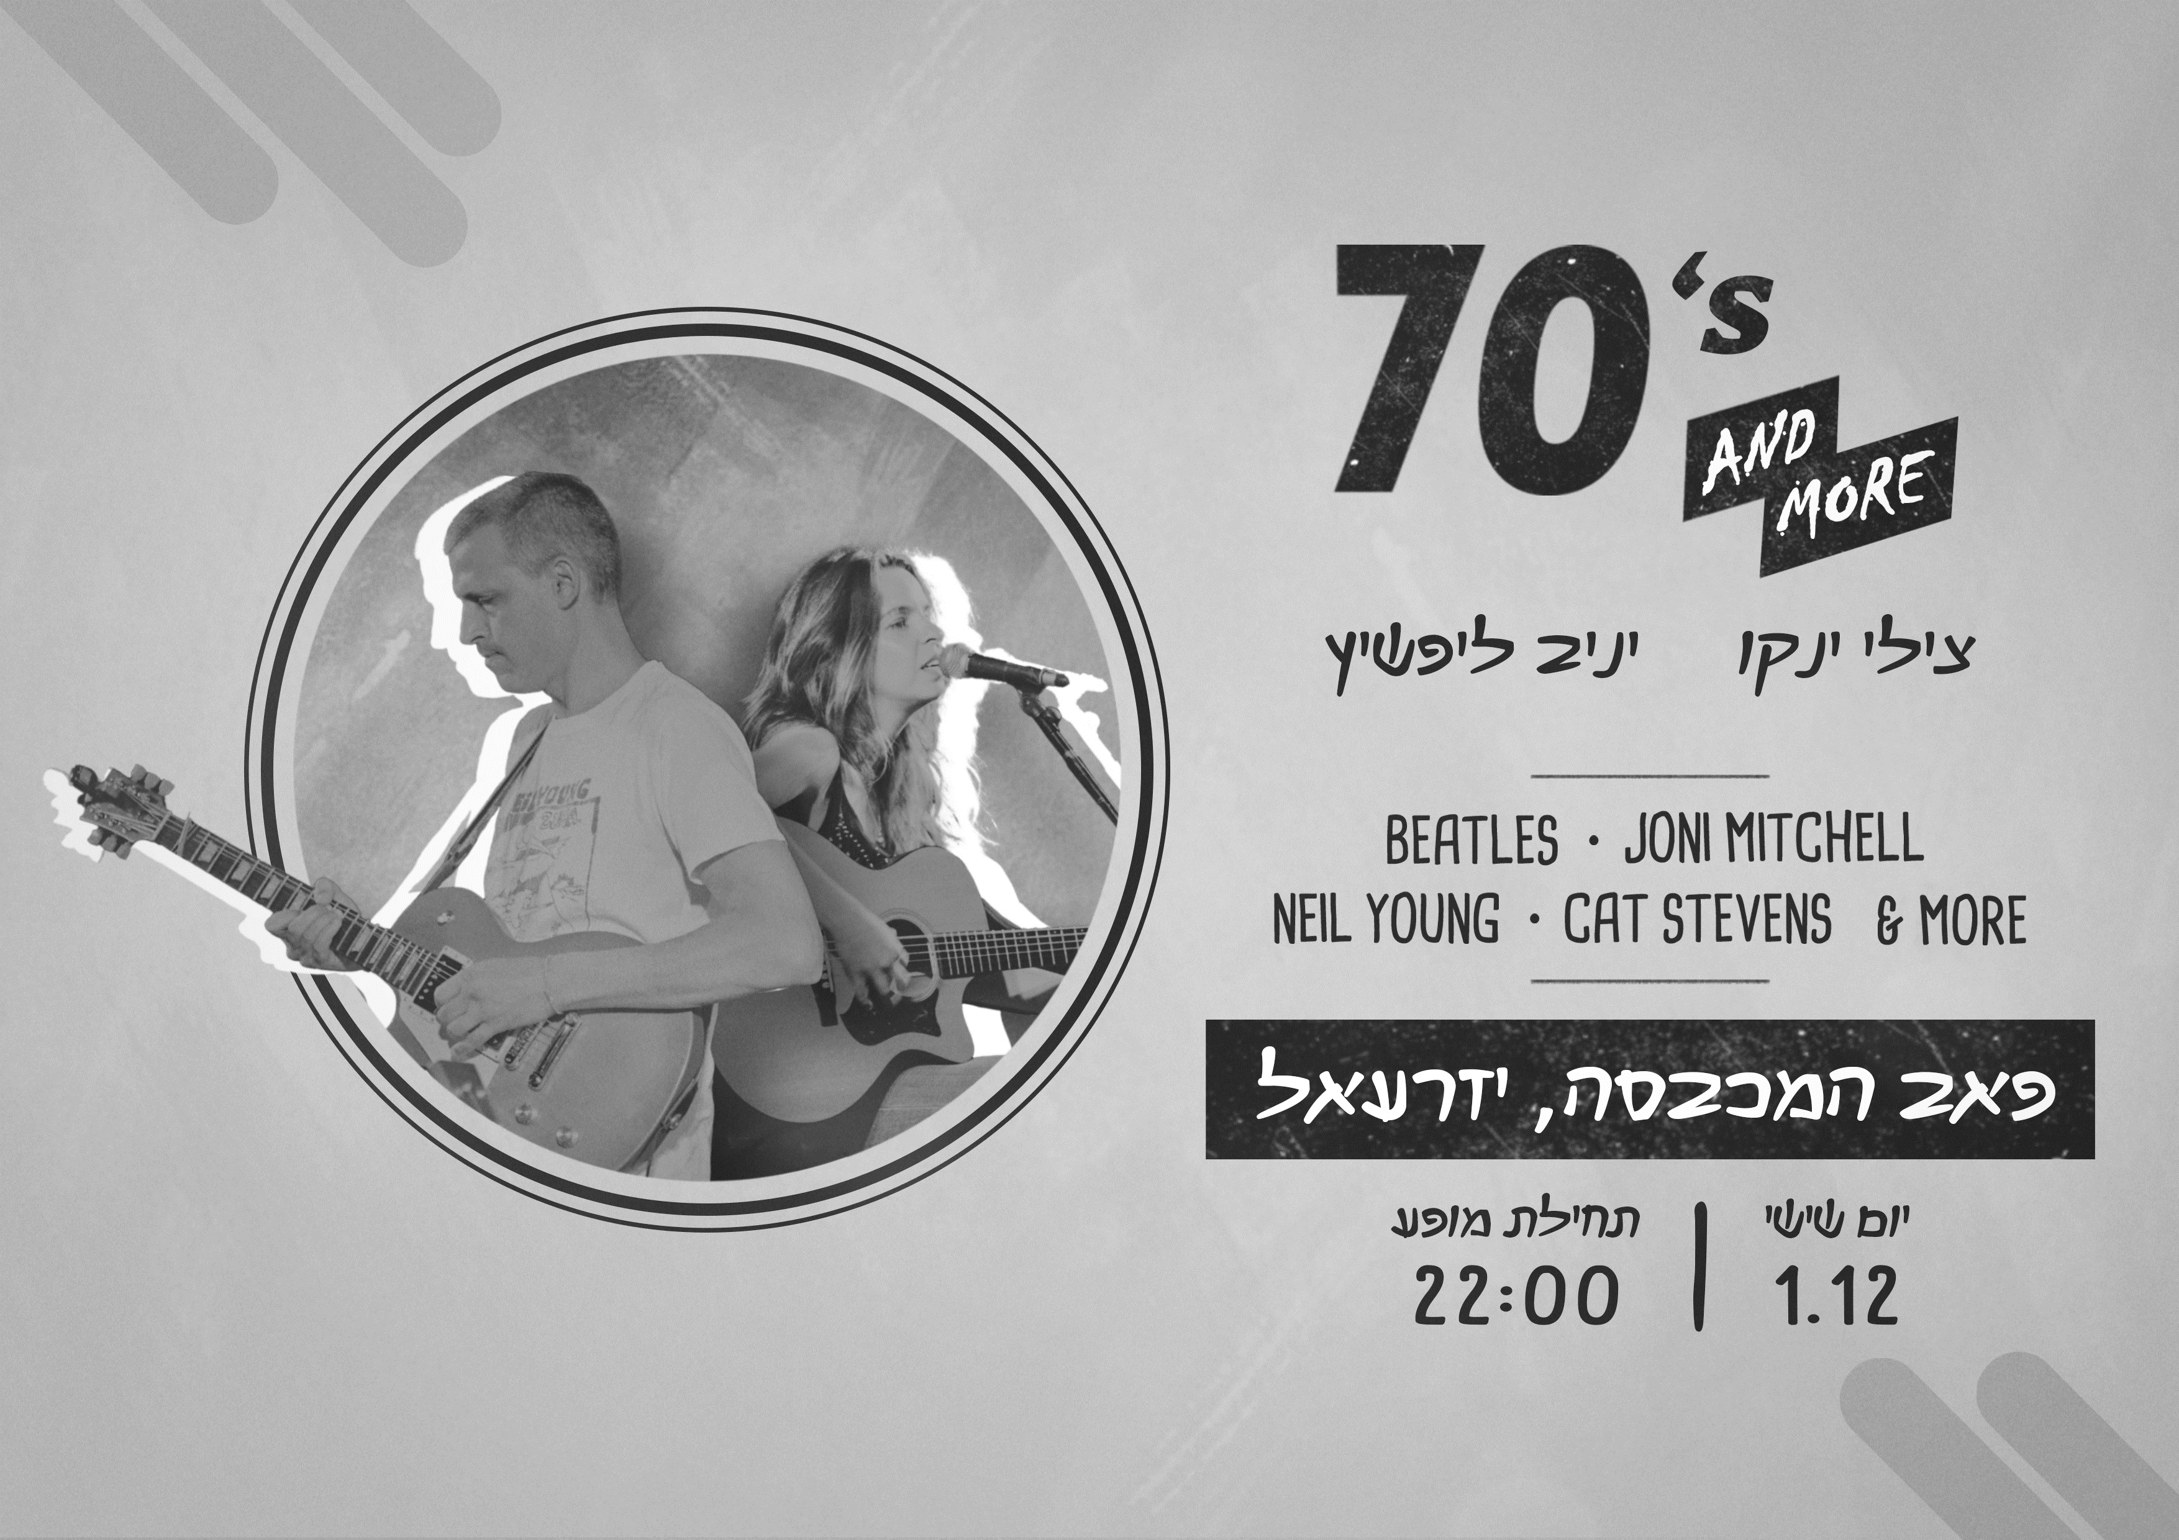

**70s and More**

**Chilly Yanko and Yaniv Lipshitz play:**

**Beatles* Joni Mitchel\***

**Neil Young * Cat Stevens* & More**

**The Laundry Pub**

**Fri 1.12.23 – 22:00**

**Save the Date**

**English is Fun - with Rahel**

More from the Devil’s Dictionary:

BACCHUS: A convenient deity invented by the ancients as an excuse for getting drunk.

BIGOT: One who is obstinately and zealously attached to an opinion that you do not entertain.

CAPITAL: The seat of misgovernment.

CONSERVATIVE: A statesman who is enamored of existing evils, as distinguished from the liberal, who wishes to replace them with others.

DEBAUCHEE: One who has so earnestly pursued pleasure that he has had to misfortune to overtake it.

DENTIST: A prestidigitator who, putting metal in your mouth, pulls coins out of your pocket.

EGOIST: A person of low taste, more interested in himself than me.

FEMALE: One of the opposite or unfair sex.

FRIENDSHIP: A ship big enough to carry two in fair weather, but only one in foul.

HAPPINESS: An agreeable sensation arising from contemplating the misery of another.

HISTORY: An account, mostly false, of events mostly unimportant, which are brought about by rulers mostly knaves and soldiers mostly fools.

LEARNING: The kind of ignorance distinguishing the studious.

MARRIAGE: The state or condition of a community consisting of a master, a mistress, and two slaves, making in all two.

MAUSOLEUM: The final and funniest folly of the rich.

PEACE: In international affairs, a period of cheating between two periods of fighting.

POLITICS: A strife of interests masquerading as a contest of principles. The conduct of public affairs for private advantage.

PRAY: To ask that the laws of the universe be annulled on behalf of a single petitioner confessedly unworthy.

SAINT: A dead sinner revised and edited.

YEAR: A period of three hundred and sixty-five disappointments.

…………. more next week

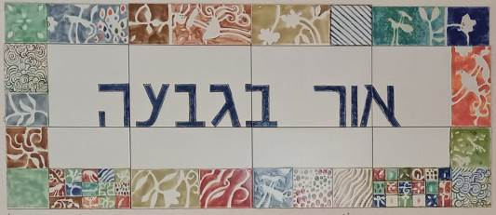

**Programme for 26.11.23 – 30.11.23**

**Daily 08:30 – 12:00 – coffee, cake, chats, board games**

**Sunday 26/11**

Opening the week - baking with Monica.

09:30 Armchair lecture (Zoom) – Moshe Elad – The Fight for Independence – massacre in the Carmel villages

**Monday 27/11**

O8:00 Pedicure with Limor Mualem (by appointment only)

09:30 Art Lecture – Chas Broadhurst

16:00 Open for coffee, cake, and chats

**Tuesday 28/11**

10:00 Trivia and brain games with Galia Shemi

14:00 Ceramics room open with instruction from Ziv Ben Bassat

16:30 Open for coffee, cake, and chats

**Wednesday 29/11**

09:00 Nature is Blooming – Hammutal Assaf

**Thursday 07/09**

07:00 Pedicure with Na’ama Baum (by appointment only)

10:00 Movie screening with Galia Shemi – “A Journal for Jordan” OR “ Koach Mishchit”

17:15 Exercises on chairs with Michal Sha’anan

**Credits:**

Translated and edited by: Eddie Solow

Proofread by: Biff Markham Oren

Printed by: Irit Cohen and Hedva Sharabani

