



**The Yizraelite – No. 2121 Date: 22.9.23**

**Kibbutz Yizrael English Newsletter**

**Edi-torial**

This week marks the 50th anniversary of the Yom Kipper War. At the last minute Barry Feldman kindly shared an article published in a Capetown Jewish Newspaper. We thank Barry for allowing us to reprint the article. I hope you are all following the excellent programs made in the wake of the opening of the archival material from that war.

No Dramas in the Kibbutz committee reports. Very few reports…sorry if I disappointed anyone.

G’mar Chatima Tova. Ed

**New Year greeting from the Sarano family**

**Spoken in the dining room on the holiday evening by David Sarano**

A joyful and sweet New Year to all! Rosh Hashanah brings with it an opportunity for renewal, and we, the Sarano family, have been blessed with a new family: the kibbutz, We received a very warm welcome. We are very happy to be part of the kibbutz. Happy holiday to everyone!

**Following is a translation of the blessing for the new year (Rosh Hashanah) said in the dining room by Yafat Asaf:**

"Today we bid farewell to the year 5783, a year that outside the 'Yellow Gate' was challenging, challenging the very basis of our lives.

Yet, within the despair and difficulty, an immense awakening burst forth, bringing hope to this place, to this people, to humanity.

I bless us at the threshold of a new year:

* With good and stable days of routine, and among them, moments of spark.
* With days of taking a deep breath, and among them, moments when our breath is taken away.
* With days of preserving the familiar, and among them, moments of change and renewal.

May we open our hearts, dream and dare, listen and understand, be patient, and extend a hand and heart to others.

May the days of this new year that begins today be beautiful, good, peaceful, bright, comforting, days of kindness, for us here in Yizrael, and for our beloved country. Shana Tova!"



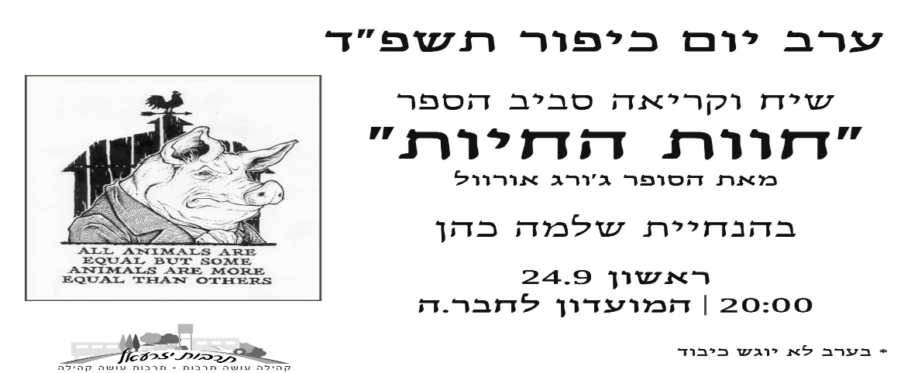

**“Four Legs Good – Two Legs Bad”**

**Yom Kippur Eve - In the Moadon**

**A discussion and reading from the book "Animal Farm"**

**by the author George Orwell,**

**led by Shlomo Cohen**



**Free online Animal Farm ebook Link:**

**(No excuses to come unprepared)**

[**https://www.bing.com/ck/a?!&&p=7fbf8d711bf17561JmltdHM9MTY5NDY0OTYwMCZpZ3VpZD0xM2Y2OGNjOS02YjI2LTY2NWUtMmVkMC05ZWQ5NmE1YjY3ZTkmaW5zaWQ9NTE5NA&ptn=3&hsh=3&fclid=13f68cc9-6b26-665e-2ed0-9ed96a5b67e9&psq=animal+farm+ebook&u=a1aHR0cHM6Ly9ndXRlbmJlcmcubmV0LmF1L2Vib29rczAxLzAxMDAwMTFoLmh0bWw&ntb=1**](https://www.bing.com/ck/a?!&&p=7fbf8d711bf17561JmltdHM9MTY5NDY0OTYwMCZpZ3VpZD0xM2Y2OGNjOS02YjI2LTY2NWUtMmVkMC05ZWQ5NmE1YjY3ZTkmaW5zaWQ9NTE5NA&ptn=3&hsh=3&fclid=13f68cc9-6b26-665e-2ed0-9ed96a5b67e9&psq=animal+farm+ebook&u=a1aHR0cHM6Ly9ndXRlbmJlcmcubmV0LmF1L2Vib29rczAxLzAxMDAwMTFoLmh0bWw&ntb=1)

**Thanks!**

"Dear community,

We would like to thank our entire community and the individuals who contributed personally for the significant and generous donation of food to those in need during the Rosh Hashanah holiday! A big thank you to all involved in this effort – to the Kibbutz team and to Tami Pen in particular, for their dedication and rallying at the last minute. To Gazit Levi for assistance in collecting and organizing the items, to Paul Zelas for contributing the boxes, to Adi Ilan, the Youth counselors, and the youth for packing the baskets and assisting in the distrabution. To Yoni Braunman and Shmulik Hollander for loading, moving, and unloading the packages, and to Navot Asaf for his touching volunteer spirit.

Thank you for the collaborative work in a good atmosphere and with a smile. Thanks to you, 58 families(!) were able to celebrate this holiday season with honor and feel connected during this important holiday period!

From Sandi M., CEO of Aid for Others, as published this week in 'Yediot HaKibbutzim': 'A week ago, we sadly announced to 100 families that due to difficulty finding donations, we won't be able to assist in distributing food baskets for Rosh Hashanah. When Shir Goren approached me and asked that we update the needs for this year to provide assistance, she insisted with all her might that we not remove any families from the list and did everything she could to help and organize the missing baskets. I have no words to describe the action she took and her determination and organization, thanks to her and thanks to the kibbutzim that rallied, more families will receive a full food basket for the holiday from us. Within a few days, about 100 young girls and boys from a local institution mobilized to collect dry food donations. The donations were collected from all the kibbutzim in the area within 3 days, and local businesses also contributed. Concurrently, as part of a joint team effort, 50 food baskets were packed and will be delivered through the generosity of Granot Dairy. Upon hearing the need for an additional 50 food baskets, Kibbutz Yizra'el rallied, gathering donations from members, and an additional 50 baskets were packed together with the kibbutz community and the youth, as part of a social involvement team activity.'

I thank you from the bottom of my heart for the meaningful and blessed action of both kibbutzim, thanks to which 100 families will be able to receive a basket rich in items that will help them celebrate a proper and joyful holiday.

May the spirit of giving always be upon us!

A happy and good year,

The Social Involvement Team of Yizrael, Gazit Levi, Gali Broadhurst, Oren Broadhurst, Dotan Savir, Yoni Brauman, Adi Ilan-Goldstein, Shani Baor, and Limor Keret."

**"More thanks – by Shlomo Cohen**

"'The heart knows its bitterness, and in its joy, no stranger can share.' Proverbs 14:10

In the spirit of Rashi's interpretation of this verse from Proverbs, Rabbi Akiva Keshet explained it as follows: 'The heart knows the bitterness' refers to a person's knowledge of their own toil and efforts. Toil is accompanied by bitterness, hardships, and great effort. Only a person knows, deep inside, the dedication they put into their work. Only they alone, within themselves, know how much effort and commitment they have invested, how much their toil weighs on their life.'

With the conclusion of the Rosh Hashanah holiday, I couldn't help but look back and be impressed by the holiday's production in the kibbutz. The food branch took care of every detail for meals in the home and in the dining hall. It was a wonderful preparation and hard work that we should remember to appreciate. The volunteers invested their time, organized, cooked, served, and gave a sense of unity. You are an example for other volunteers (who left work for tomorrow's volunteer). I saw the mountain of dishes waiting for washing, and I threw in quite a few myself. The Laundry is the most efficient service and saves me a lot of time. I am freer thanks to the clothing department, and for that, I am very thankful.

Thank you to the holiday team, and to our upcoming holiday teams. I also visited the sports fields with the children, which were clean and well-lit, the inviting and luxurious swimming pool that we will soon miss during the winter days. Every area in the kibbutz is inviting and pleasant, and for that, I am very thankful.

I will conclude with a song by Bialik, which tells of the wonderful hospitality that a poet prepares for his friend throughout the year. However, in the autumn, he feels melancholic and wants to remain alone."

"On a summer day, a hot day, when the sun is in the sky,

The firmament blazes like the furnace of the day,

A time when the heart seeks a corner of quiet for a dream –

Come to me, come to me, weary friend!

I have a garden, and in the garden, under the canopy's pleasant shade,

Far, far from the city and the crowds, a hidden hill,

All enveloped in whispers, all revealing a divine secret –

There we will hide, we will rest, my dear friend!

And in bliss and blessing, there in that secret place,

We will sweeten together in the midday dimness,

As it appears to our lips from the horn of plenty,

Bursting forth with the abundance of shades.

And on a winter night, a cold night, in the time of darkness and blackness,

You will wander outside, moving around in the cold,

And when your flesh feels the bite of his frost –

Come to me, come to me, blessed be the Lord!"

**Minutes of the Small Business and Entrepreneurship Committee Meeting September 23, 2023**

Attendees: Kinneret Govrin, Maor Persai, Irit Mor, and Shimon Zelas

Apologies: Momi Cohen, Anna Abramowitz

Agenda:

1. Semi-Annual Summary
2. Establishing a Fund for Investments in Small Businesses
3. Partial Use of Kibbutz Buildings – Need to Include a Partner

1 **Semi-Annual Summary** The committee received a summary of each business's performance. The total income for all 24 businesses amounted to 1,366,000 NIS, which was 280,000 NIS more than the previous year but 220,000 NIS less than the budget. The net profit amounted to 111,000 NIS compared to 290,000 NIS the previous year and 283,000 NIS in the budget. The main reason for the decline in profit is the change in cost-of-living adjustments (COLA) that were adjusted to market prices from the beginning of 2023. The total COLA for the past six months amounted to 638,000 NIS, an increase of 267,000 NIS compared to last year. **The total contribution of all businesses to the kibbutz (including net profit and COLA) amounted to 817,000 NIS compared to 713,000 NIS last year and 1,046 NIS in the budget.**

1. **Establishing a Fund for Investments in Small Businesses Proposal**: A portion of the annual profit of the businesses will be transferred to a fund for investments in small businesses. The remaining profit will continue to go to the community. The Business Committee will decide on the use of the fund's money. There is also a proposal that a business that generates profit can receive a portion of its annual profit to promote the business. It is important to note that the money from the fund is not intended for investments in buildings and infrastructure. Most other investments are in relatively small amounts**. Decision:** No need to establish a fund; a profitable business can request small investments based on its annual profit.
2. **Partial Use of Kibbutz Buildings** – Need to Include a Partner There is a shortage of suitable buildings in the kibbutz for business use. On the other hand, some businesses only use their clinic/workshop part of the week. **Decision:** For any business that uses a building less than 60 hours per month on average, the possibility of including a partner in the building will be considered.
3. Recorded by: Shimon Zelas

Top of Form

**Security Matters**

**Alon Reuven** announced his intention to conclude his role as the current Rabash.

We thank Alon for his service and announce the tender for filling this crucial position.

**Avchai Katz** is no longer the second security officer and therefor our arrangement with Abir Security is terminated**.** We wish Avichai all the best.

Avichai and Alon did a great job in upgrading our security and we thank them both.

**Subject: Tender for the position of Security Chief (Rabash) at Kibbutz Yizre'el**

**Tender for the position: The role of Security chief**

Responsible for the overall security of the kibbutz, its members, and its branches at all hours of the day and to be available for any event occurring within the kibbutz and its fields.

* The SECURITY CHIEF is expected to view the position entrusted to him as a supreme value and to act with utmost seriousness, integrity, and discretion to prevent, deter, and address any type of event while maintaining a high level of security and a commitment to constant improvement in security quality.
* The role consists of defined tasks and ad-hoc, non-routine tasks.

**Additional Information:** Interested parties seeking additional information or having inquiries can contact Kineret Govrin H.R. by the 31.10.23 (the clock is ticking – Ed)

Bottom of Form

**“Forgiveness is not an occasional act, it is a constant attitude.” ― Martin Luther King Jr.**

**Yom Kippur Food Branch Schedule - 5783 (2023):**

**Erev Yom Kippur - Sunday, 24th of September, 2023:**

* Breakfast as usual in the Dining Hall 7:00 to 9:00
* Mini vegetable market: 7:00 to 11:45
* Light lunch served outside the Dining Hall 11:30 to 12:45
* Prefast meal **for fasters only** in the Dining Hall (self-service): 16:30 to 18:00
* Evening meal, self-service at **(for non-fasters only – Ed)** the Dining Hall 18:30

**Yom Kippur - Monday, 25th of September, 2023:**

* Brunch: 9:00 to 12:00
* Break-fast meal (differentiation ceremony) at the Dining Hall 19:15

Wishing you a meaningful conclusion to Yom Kippur and a good year for all!

Top of Form

Yom Kippur Prayers

In the Synogogue

|  |  |  |  |  |
| --- | --- | --- | --- | --- |
| ערב: | כל נדרי | 18:10 |  | Kol Nidrei |
| בוקר: | שחרית | 08:30 |  | Shacharit |
|  | יזכור | 10:00 | בערך | Yizkor |
|  | מנחה | 16:45 |  | Mincha |
|  | נעילה | 18:00 |  | Neilah |
|  | תקיעת שופר, מעריב  וקידוש לבנה  סיום הצום | 18:58  19:09 |  | Shofar Maariv  End of Fast |

G’mar Hatimah Tovah - גמר חתימה טובה

David Mittelberg

**Succot Program**

|  |  |  |  |  |  |
| --- | --- | --- | --- | --- | --- |
| Saturday  7.10.23 | Friday  6.10.23  Simchat Tora | Wednesday  4.10.23 | Mon  2.10.23 | Saturday  30.9.23 | Friday  29.9.23  Erev Succot |
| 9:00 Brunch  Music by Gal Vitelson  12:00-10:00 Kite building in Succah  17:30  Kite  flying on Rugby field | Festive dinner  Salute to Zimra and Ruth Mor on their retirement | Indian Culture  17:30 Activities for children in the Succah  Indian Dances and drawing with Henna    20:00  Captivating India  Colorful and multi sensual evening in the Moadon  Lecture on Indian Indian delicacies and an Indian cultural atmosphere  From class 7 up | 18:00  BBB  BingoBoitler  Burger | 9:00 Brunch  Music by Stas  17:00 “Songs at sunset”  In the Farm with the young generation | 19:00 Kabalat Shabbat and Chag  Coffee in the Succah |

Sukkot Team: Eyal Tirosh, Gaia Sanker, Marnina Gross, Nofar Brin-Dolinko, Omri Sanker, Tamar Sanker

**The Yom Kipper War – 50 Years after**

**The Following article was published in the Capetown “Jewish Report”**

**We thank Barry Feldman for sharing this with us.**

### [ISRAEL](https://www.sajr.co.za/category/israel/)

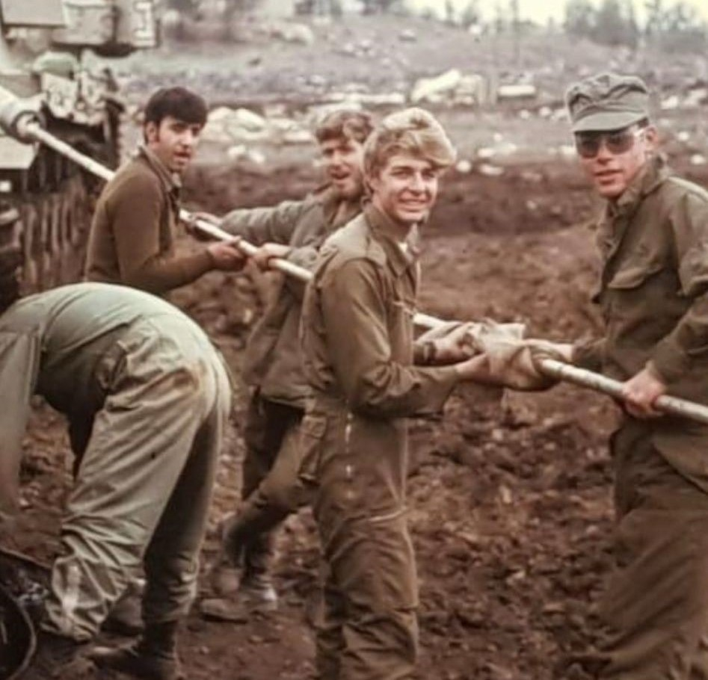

# Yom Kippur War haunts survivors 50 years on

Published

 Sep 21, 2023 By [**Tali Feinberg**](https://www.sajr.co.za/author/3/)

A year after finishing matric, South African Barry Feldman found himself on Israel’s frontline, defending the Jewish state from Syrian forces, which were part of an Arab coalition that launched a surprise attack against Israel on Yom Kippur on 6 October 1973.

He was one of many young people who put their lives on the line 50 years ago.

“We were absolutely ‘green’, although fortunately, our commanders weren’t,” says Feldman. “At 10:00 on Yom Kippur, we were told that we may have to go into action at 18:00 and that there were 1 000 tanks opposite us and we had 110. A few minutes after 14:00, everything started exploding around us and about an hour later, we were on the frontline in the south section of the Golan. In the first 24 hours, my unit lost five of our 11 tanks. When we ran out of ammunition, we took ammunition from damaged tanks.

“When we were completely surrounded, we pulled back through enemy controlled territory, getting back to our lines by morning,” he says. “We hit enemy tanks at a range of 50m during the night. We fought with the six remaining tanks until the sixth day of the war, by which time the Israeli army had retaken all the territory that the Syrian army had occupied.”

Barry Feldman made aliya in January 1972 after finishing matric. Originally from Johannesburg, he now lives on Kibbutz Yizrael in Israel’s north. “I joined the army in May 1972,” he says. “I was in the Nachal infantry unit. In July 1973, I went for advanced training in tanks. We had done the basics, and I was a tank driver in Centurion tanks. We started training as a tank unit only two weeks before the war.”

He says his parents back in Johannesburg had no idea he was fighting in the war. Even his brother, Jules, who was also fighting on the front, assumed that his brother was too inexperienced to fight and was still in training. That’s what he had told their parents back home.

Barry Feldman says that in his own unit many fellow soldiers were wounded or killed. “After five days of nonstop action, we were exhausted. After not enough hours of sleep, we were woken up and told that we were to have the honour of being among the first tanks to break through into Syria. About 10 km into Syria, my tank was hit. We all got into a second tank, which had also been damaged, but was still drivable. That tank was then hit again. We all got out and managed to get into the third tank – now 12 of us in the tank.

“There was no space, so the commander had half his body out of the tank and was hit by a bullet and killed. The tank was then hit by a shell in the turret. The flash of heat was unbelievable. The driver just kept driving because he hadn’t been given a different command.

“I had some burns, shrapnel in my legs, and a piece of shrapnel in my eye. I was taken to the hospital in Safed, and spent three days there. I was treated and sent to a recuperation centre in Nahariya. When we arrived at the hospital, each soldier was allotted a woman soldier to see him through the process. I was in shock and couldn’t stop talking. She’s still probably having nightmares to this day. I told her everything down to the last gory detail!”

After a few days in the recuperation centre, Barry and two others decided it was time to go back to their unit. “We came back to the kibbutz for one night, and then hitchhiked back to the front, which was now about 40km from Damascus. I found my unit, and was there for the next six months. The winter was the coldest that the area had known for many years. The temperature went down to minus 13 degrees centigrade. If you touched the tank without a glove, your hand would stick to it.

“We spent two weeks on the frontline, and then two weeks further back in the villages. At some point [Prime Minister] Golda [Meir] and other members of government visited. On 22 April 1974, [after a prolonged war of attrition in the Syrian bulge], a ceasefire was declared.

Barry Feldman knew South African olim David “Dudi” Silbowitz and Neil Freed, who died in the first few weeks of the war. Silbowitz was born in 1948 in Cape Town, and Freed in 1949 in Johannesburg. In 1971, the close friends made aliya. They settled on Kibbutz Yizrael. Silbowitz was a was an outstanding rugby and cricket player. He represented Israel in cricket at the Maccabi Games. Freed married Jenny Kahn.

Both young men volunteered for the army. After basic training, they did advanced training in the tank corps, and were allocated to reserve units. When the Yom Kippur War broke out, they were sent to the Egyptian front. On 18 October 1973, they were ambushed by Egyptian forces on the Egyptian side of the Suez Canal. The tank that both men were in received a direct hit but continued to move forward, ablaze. The tank took a second hit before blowing up. None of the crew survived.

Both were buried on their beloved Kibbutz Yizrael, where a memorial to them still exists today. Silbowitz was 24 and Freed was 25 years old. Every year, a ceremony is held to remember them.

**English is Fun - with Rahel**

* ONLY ONE
* There is the only nine-letter word in the English language where removing one letter at a time yields another word.
* STARTLING
* STARTING
* STARING
* STRING
* STING
* SING
* SIN
* IN
* I
* SCIENTISTS HAVE GROWN HUMAN VOCAL CORDS I N A
* PETRI DISH
* THE RESULTS SPEAK FOR THEMSELVES
* **WHEN I WAS YOUNG THERE WERE ONLY 25 LETTERS IN THE ALPHABET. NOBODY KNEW Y.**
* WORDS WITH TOTALLY UNEXPECTED MEANINGS:
* Nine modern words and the strange histories that accompany them, also known as etymologies.
* AVOCADO: (noun) A pear shaped fruit with a rough leathery skin, smooth oily edible flesh, and a large stone. The word “avocado” comes from the Aztec word, “ahuacatl”, which means testicle. Aside from the similar shape, avocados also act as aphrodisiacs, foods that stimulate the sex drive.
* JUMBO: (adj.) Very large, unusually for its type. In 1880, P.T. Barnum bought an elephant, named Jumbo, from the Royal Zoological Society in London. By age 7, this pachyderm consumed 200 pounds of hay, one barrel of potatoes, two bushels of oats, 15 loaves of bread, a slew of onions, and several pails of water every day. His caretaker at the zoo also gave him a gallon or two of whiskey every now and then.
* At full size, Jumbo stood at 11-and-a-half feet tall, and weighed six-and-a-half tons. His real name stems from two Swahili words: “jambo” meaning hello, and “jumbe” or chief.
* CLUE: (noun) A fact or idea that serves as a guide or aid in a task or problem. According to Greek mythology, when Theseus entered the Labyrinth to kill the minotaur (a half-man, half-bull), he unraveled a “clew”, a ball of string, behind him so he could find his way back. The word “clue” didn’t even exist until the mid-1500’s when people started to vary the spelling of “clew”.
* ROBOT: (noun) A machine capable of carrying out a complex series of actions automatically, especially one programmable by a computer. The word “robot” comes from the Czech word “robota”, meaning “forced labour” – which sounds strangely like slavery.

…………. more next week

Translated and edited by Eddie Solow

Proofreading: Biff Markham Oren

Printed by Hedva Sharabani and Irit Cohen