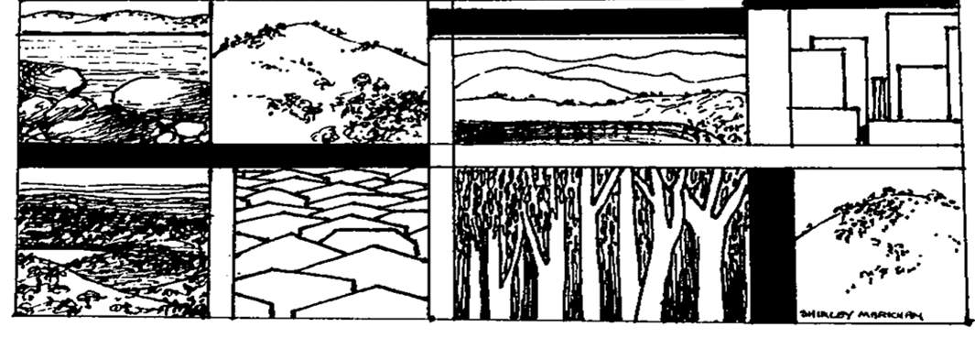

**The Yizraelite – No. 2121 Date: 25.8.23**

**Kibbutz Yizrael English Newsletter**

**Edi-torial**

**“Nice week” again. Fires blazing all over the world, people killed, and homes destroyed. Flood waters complete their work elsewhere. Planes shot out of the skies, The very hills collapse and earth and boulders crash down on innocent passersby. Seething heat and destructive tornedos! Maybe the universe is trying to convey a message? Or maybe we should just watch “Dancing with Stars” and “Wedding at First Sight” and it will all go away…..Thanks to Biff who has agreed to translate while I am on safari in Africa. If I overpower a lion, I will post a picture on my return. If he overpowers me, I enjoyed translating for you guys!**

**Closing ceremony of the Summer Vacation – Limor Griman**

On Tuesday 22.8.23, the closing ceremony of the summer vacation and the opening of the new school year took place. Below is Limor Griman’s address as Chairman of the Education Council:

"Dear children and parents, esteemed educators, friends,

Another summer has come to an end, and a new year is on our doorstep. A year ago, I stood on this stage and expressed a wish for a routine, ordinary, and even mundane year, a year in which we could invest our energy and creativity, without having to deal with external challenges. I believe that all of us, young and old, feel and understand how this year and this period are not normal, and how we are facing challenges.

We have a wonderful kibbutz with an excellent education system, a unique and high-quality “bubble” where the values that were embedded in us from childhood, and which we have chosen to educate our children with, are preserved. Here, our daughters can wear whatever they want and their social destiny is not predetermined. Here, a teenager can choose who to love and who to be, and receive equal treatment regardless. Here, we can express our opinions, dissent, question, whether you are a 40-year-old woman or a 14-year-old boy.

A significant part of our lives takes place within this bubble, and sometimes we feel that it is so secure, strong, and steadfast that nothing can harm it. However, a bubble is still a bubble, and today, the waters outside are raging.

I feel that as parents and as a community investing our best resources in educating our children in the present, we must take a good look at reality and invest our souls' strength in the struggle for the future society in which they will grow.

Throughout the year, I met many members who take part in protests – children, teenagers, parents, and grandparents – who stand strong, not giving up, feeling that they have no choice.

I want to thank our wonderful educational staff who give their hearts to our children, educating them to be wiser and more sensitive, teaching them to find peaceful solutions to problems, to see others equally, helping them discover themselves and live in society, imparting values of self-creation and work, of social engagement, teaching them what democracy truly means.

I want to thank Adi and Yael, the coordinators, who wake up every morning with a great sense of responsibility and do their jobs wholeheartedly and with extra soul, out of a deep commitment to this path and this place.

I wish you all a year of personal, family, communal, and national success and progress." - Limor Griman

**Dear Kibbutz Yizrael - Cigal Kaplan**

Every year, I used to come with my daughters to spend the summer vacation in the kibbutz. After a delightful month and a half, Mom would always say, "Please write a thank-you letter to the kibbutz."

In the past year, my daughters and I spent a whole year in the kibbutz, and I know that Mom would have asked me to do the same thing.

But this time, I don't have Mom to check my spelling and grammatical errors or remind me of the important moments I need to be thankful for.

Summing up the past year is difficult, but I'll start from the beginning.

The decision to return to Israel and the kibbutz, wasn't easy. This transition took years of thinking and planning. I always waited for the "right time." Moving from one country to another requires a lot of effort and planning, and sometimes the stars need to align correctly for things to work out as planned.

Finally, I took the step. My older daughter, Annabel, was very excited about the move, but my younger daughter, Sienna, wasn't interested at all in moving to a new country or embarking on a new adventure.

The first half of the year was challenging, as expected. Getting used to a new language, a new culture, and new friends wasn't easy. The girls managed to catch every illness that circulated in the valley, and they even managed to twist their ankles. We got used to spending Saturday evenings at Kupat Cholim.

Grandpa Milton and I took the girls to horseback riding lessons, swimming lessons, and art workshops. We encouraged them to build friendships outside the kibbutz as well, so we spent a lot of time driving them to their friends' places during the week, while Mom taught at the language centre every evening.

Slowly, things settled down, and we entered a routine. We began to learn how to live together. Mom always used to say, "Three generations under one roof." Oh, how happy and excited she was that her girls were living with her.

And then a tsunami hit our family.

We all know the ending.

Our world collapsed around us in an instant.

The "plan" didn't end up as we wove and dreamed it.

Now we live with memories.

My daughters returned to London to their old friends, and I'm leaving at the end of the week to be with them.

I'm leaving Dad alone in an empty house.

My request is, please take care of Dad for us.

The list of thanks is long, so in random order, I want to thank: the education system personnel for their great effort and the love they gave to my daughters, the medical team who helped and supported all of us, and all our friends who helped us take care of Mom to the best of our abilities.

I'm leaving you with a broken heart and tears in my eyes.

See you soon, I promise.

With much love,

Cigal, Annabel, and Sienna - Bernice and Milton’s daughters

**Message from the Community Leadership Regarding the Decision on Budget Cuts in the Food Branch**

Following the publication of the report in the previous newsletter, regarding the community leadership's decision to make budget cuts in the food sector, numerous inquiries have reached the community leadership, requesting a re-evaluation of the decision.

The community leadership is re-examining the issue, and until the re-evaluation is completed, things in the food sector will continue as usual. Erez and Yifat

**Message from the Education Cluster**

In the academic year 2023-2024, the entire education system will be closed on the following dates:

* Friday, September 15, 2023 - Erev Rosh Hashanah
* Sunday, September 24, 2023 - Erev Yom Kippur
* Monday, April 22, 2024 - Erev Passover

Additionally, staff team-building days will be held on different days:

* Early Childhood Education System - Monday, July 1, 2024
* Social Education System - Thursday, June 13, 2024

On the staff team-building day, the education system will not operate.

Staff preparation days: August 21-27, 2024.

**Public Update Regarding the Conclusion of the Community Manager's Term - Kinneret Govrin**

As we approach the conclusion of **Erez Peleg’s** term as the Community Manager in November, the assessment team has begun the process of evaluating a second term.

The process will involve meetings with colleagues, community managers, and members. The team will gather feedback and analyse it, to formulate a recommendation by the end of October

The voting will take place by ballot

We invite interested members to engage in a discussion with us. Please contact one of the assessment team members to schedule a meeting: Hila Alterlevi, Amir Darom, Irit Shemesh, Ofra Shelef, and Kinneret Govrin.

Kinneret – Human Resources

**Business and Entrepreneurship Committee Meeting Minutes**

**July 4th, 2023**

**Present:** Shimon, Maor, Kinneret, Irit, Anna, Momi

**Agenda:** Addition of employees expenses to labour costs – continuation of discussion from the previous meeting

The committee presented calculations regarding the addition of employee expenses to labour costs and the potential impact of the increased labour costs on business profitability.

**Decisions Made:**

1. It was decided to add employee expenses of 30% of the gross salary to the labour costs.
2. In order to ease the burden on the small businesses, the implementation will occur in two phases: starting from January 1st, 2024, an additional 15% of the monthly salary will be added, and from July 1st, 2024, an additional 15% of the monthly salary will be added. For example, for a salary of 50 NIS per hour, an additional 7.50 NIS will be added from January 1st, 2024, and an additional 7.50 NIS will be added from July 1st, 2024, totalling 15 NIS.
3. The budget for the year 2024 will be adjusted accordingly.

Reported by: Shimon Zelas

**Community Leadership Meeting Report**

**August 20, 2023**

Present: Erez Peleg, Maor Parsai, Talia Arad, Shlomo Levi, Limor Griman, Ilana Peleg, Ishai Levi, Yifat Segal, Kinneret Govrin, Yifat Assaf

Absent: Stas Gavrilov, Tamir Blass, Inbal Adler

1. **Bringing Parents to the Kibbutz - continued discussion**

For this item, members interested in joining or participating in the discussion were invited. New attendee: Ella Cohen.

Ella noted that while demographic and absorption considerations are relevant, it's a great privilege and act of kindness to allow members to support their parents by bringing them to the kibbutz. She acknowledged that there are limitations but expressed hope that the option would continue.

**Decision:** From a demographic perspective and considering the kibbutz's needs, the community leadership recommends to the asefa not to accept parents of members as new residents from this point forward. Special cases for fixed periods will be discussed and decided on.

**Vote:** In favour - 8, Against - 1, Abstentions – 1

1. **Work bonus Project**

(Invited: Members of the Communal Project Team - Amir Armoza (Coordinator), Nitzan R-F, Shlomo Cohen, Shahar Levi)

Amir Armoza, the team coordinator, presented the team's operating approach. Amir presented the framework as approved by the community leadership on April 2, 2023:

Top of Form

**Points discussed in the meeting:** There are large projects that lack alternative sources and are proposed year after year. Only through the communal project can we realize them, by accumulating funds over several years. For example, covering the swimming pool.

The process of a communal project allows members to decide on the use of funds, distinguishing it from the ongoing budget of the community, which is determined by the management.

If the community has been in a budget deficit for several years, it's absurd that in one place we are reducing what will be allocated to members, while simultaneously considering what to do with a large sum in our possession. On one hand, we are minimising expenditures on food, and on the other hand, we are discussing tree planting, playgrounds, etc.

Efforts should be made to eliminate any surplus funds, and if they exist, they should be returned to the community fund.

One proposal is a joint trip for all kibbutz members abroad. Does it meet the criterion that 75% of kibbutz members can participate in the project? What about members who have mobility issues or work commitments... and is there a willingness to travel together? It was proposed to conduct a deeper assessment before proceeding to see if at least 75% of members could participate, to review survey results indicating general interest in such an idea, and to ensure there's no financial risk in initiating such a project when the economic future is uncertain. The community leadership views the proposal for the overseas trip as a "game changer" and suggests examining it thoroughly.

The team presented three different project proposals, all within budget, and recommends one of them.

* After the meeting, it was announced that the proposal for the overseas trip was put on hold by the proposer.

**One decision was reached: to bringone proposal to the asefa: The proposal is presented below.**

|  |  |  |  |
| --- | --- | --- | --- |
| **Name** | **Proposal** | **Cost** | **Team Recommendation** |
| Eviatar Asaf | Placement of tractor & implements at entrance of kibbutz | IS 5000 | ₪ 5,000 |
| Eviatar Asaf | Paint and fix “The Rocket Playground” | ₪ 20,000 | ₪ 20,000 |
| Idan Zelas | Lighting and shade in rugby stands | ₪ 420,791 | ₪ 100,000 |
| Tal Darom/  Yifat Segel | 76th anniversary | ₪ 70,000 | ₪ 30,000 |
| Ori Ayalon | Restoration of “Gan Claudio” | ₪ 17,169 | ₪ 17,169 |
| Hedva Sharabani | Accessibility for the “Stone Playground” (Gan Ha’even) and additional amenities | ₪ 380,530 | ₪ 380,530 |
| Hedva Sharabani | Lighting for “Stone Playground” | ₪ 60,000 | ₪ 60,000 |
| Yitzchak Peleg | Turbi-not protest / struggle | ₪ 40,000 | ₪ 20,000 |
| Oded Fink | Citrus Avenue | ₪ 45,000 | ₪ 45,000 |
| Gil Hillel | Gas Barbeque at pool | ₪ 40,000 | ₪ 40,000 |
| Slush Fund |  | ₪ 25,000 | ₪ 25,000 |
|  | Total | 1,123,490 ₪ | ₪ 742,699.00 |
|  | Accrued monies |  | ₪ 268,780.70 |
|  | 30% to members | 433,491₪ | ₪ 1,313.61 |

Each Item will be voted on separately

In Addition, during the upcoming year, there will be a principle discussion on the subject of utilising the work bonus from Maytronics and outside workers.

An appeal was lodged by Omri Fink, regarding pruning; however, due to time constraints, this subject was postponed until the next meeting.

Summarised by: Yifat Asaf

**Economic Council Meeting August 21, 2023**

Present: 26 members

Absent: Barry Feldman, Nir Segal, Rotem Agmon, Peter Pezaro, Natalie Zinenko, Yitzhak Peleg

Council Chairman: Uri Gilad

**Agenda:** Approval of the annual budget for the Northern Neighbourhood

Discussion Highlights: Yifat opened the discussion with a social perspective on the council's decision regarding the project duration for the northern neighbourhood. She emphasized the need to consider societal implications before delving into financial details.

**Key Points:**

1. The project was initiated in December 2019 with approval for planning phase A of the northern neighbourhood project, consisting of 16 units.
2. In April 2021, the secretariat presented a principal guideline for the construction of 30 units.
3. In August 2022, preliminary approval was granted for building 30 units in phase A of the northern neighbourhood.
4. This project is a flagship endeavor for the kibbutz in recent years, having garnered public attention for over 5 years.
5. The public was informed that the neighbourhood would be established by 2022, and members made their decisions accordingly.
6. A phased approach to construction over an extended period could negatively affect members waiting for suitable housing.
7. The opportunity to regain public trust by addressing housing needs and concerns is now available.
8. The question arises whether extending the project to reduce financial risk justifies social consequences.

Discussion on Budget:

* Maor initiated the budget discussion, highlighting the significance of the Rugby Neighbourhood project.
* The project is of strategic societal importance and should be prioritised.
* The pace of construction influences the kibbutz's ability to fulfill demographic and growth objectives.
* Balancing societal goals with financial constraints is a challenge.
* The council will be asked to approve a comprehensive budget for the project and allocate it annually.
* The project's funding sources include an annual deposit to the fund, minus funds for renovations and apartment transitions.
* Construction costs include housing units, infrastructure, at a total cost of 55 million ILS.
* Alternative A's budgetary framework suggests distributing funding over an extended period.
* The extended timeframe of construction has significant economic implications.
* Uri emphasized the importance of considering both economic and social aspects.

Final Decision:

* The council approved the construction project for the Rugby Neighbourhood with a budget of 55 million ILS, plus associated funding costs.
* The project will be executed over a 5-year budgetary framework, starting from 2023.
* Annual budget controls will be implemented and approved each year.

Summarized by: Uri Gilad and Yifat Assaf (And chatgpt – Ed)

Top of Form

**Education Committee Report - August 15, 2023**

**Present:** Philippa Segall, Peter Pezaro, Kinneret Govrin, Revital Zelas, Rotem Agmon, and Momi Cohen

**Absent:** Shlomo Kamilian and Danit Kirshberg

Agenda:

1. **Principle discussion on approving study days for non-regular students**

After the discussion and opinions presented, it was decided to adhere to the existing regulations and not deviate - meaning not to allow study days for students who are not on the 2023 enrolment list.

1. **Approval of the student study agreement** Part of the student's commitments is to sign a study agreement. This agreement obligates the student to adhere to a number of conditions such as tuition, study days, workdays, and various obligations within the framework of studies. The agreement was adapted to the new organisational structure of the kibbutz, but there were no significant changes. Committee members reviewed the agreement and approved it.
2. **Committee student support.** Part of the committee members' duties is to support the students during their studies. The support list will be given to the students soon.
3. Shlomo Kamilian decided to end his membership in the higher education committee. The committee acknowledges Shlomo for his many years of membership in the committee and his significant contribution to promoting education in the kibbutz.
4. Reported by: Momi

**Demography Cluster Report - Ishai Levi**

**Incoming Families:** We are pleased to update you about two families who will be joining us in the coming week. Both families will enter the integration stage (equivalent to residency) prior to their official candidacy.

**The Greenshpon Family – Ya’ara (Havshush), Noam and Amit (2).**

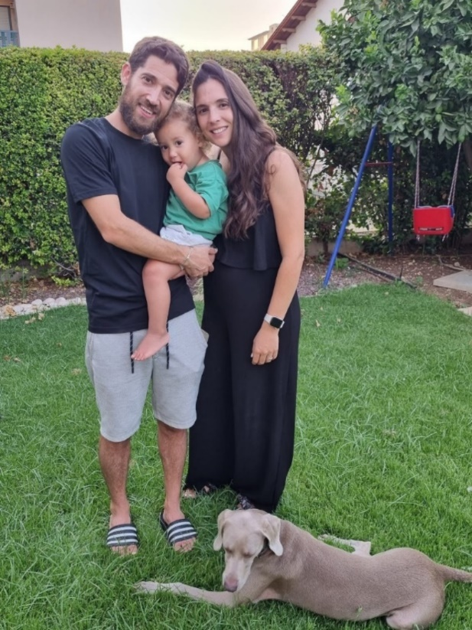

**And… The Serano Family - David, Dekel, Yuval (3), and Omer (1).**



We are delighted to welcomeboth families to the Yizrael community and wish you a successful and pleasant integration process. Best of luck!

**Young Generation Update:**

* Congratulations to **Aharon Amerik** who has been released from the IDF, and we wish him success in his new path.
* **Yonatan Assaf** has completed his community service and has returned to the kibbutz. He will be enlisting in the IDF's Paratroopers Unit in December, and until then, he will be working in the agriculture sector. Best of luck!
* Last Friday, on August 18th, we held the **annual gathering of the young generation**. This time, we went to a location near Kibbutz Adi, where we ate, drank, played laser tag, and had a great time. We also welcomed the members of the Dor leadership group and bid farewell to Noga Har-Paz, who will be finishing in October two terms of managing the committee.

**Housing Update:**

* **The Reuven family** has returned to their home in Nof neighbourhood after completing renovations. Thank you to Alon and Yana who swiftly respondeded to our request and ensured that the house was clean and ready for the next family.
* **The Kirshberg family**, Ben, Danit, and their daughters, will be moving to the that house.
* **The Sereno family,** arriving next week, will be moving into the same residence that the Kirshberg family will vacate, above Eddie and Dani Solow in the Gilboa neighbourhood.
* **The Greenshpon family,** arriving tomorrow (Saturday, August 26th), will be moving into the apartment above Dani Harpaz in the Lower Tzameret neighbourhood.

Reported by: Ishai Levi

Top of Form

**H.R. Committee Meeting Summary August 20th, 2023**

**Kinneret Govrin**

Participants: Phillipa Segall, Peter Pezaro, Kinneret Govrin, Rotem Agmon, Yifat Assaf, Erez Peleg, Nir Segal, and Shlomo Cohen.

Absent: Eddi Solow, Noa Armoza.

**Work Welfare in the Kibbutz Branches.** Currently, there is no consistent policy addressing various life events and issues related to work completion. Each branch handles these matters differently. The guiding principles of the management are based on:

* Implementing a unified and fair policy in workplaces and among all kibbutz workers.
* Providing individual, team, and workplace-related solutions.
* Addressing the personal and organisational life cycle of workers to strengthen commitment and identification with the workplace and the kibbutz.
* Strengthening social bonds in the workplace through team gatherings during different events throughout the year.

**Key Points Raised in the Discussion:**

* Currently, there is no uniformity re the conduct of significant events when finishing work, and it is desirable to clarify when a significant event should be held.
* Some individuals receive multiple gifts.
* It is more appropriate to celebrate occasions with a festive toast and not necessarily with an extra gift.
* There are additional costs for secondary gifts that are added to the main gift, and it's uncertain whether it's necessary. (I guess they are talking about ribbons and bows and other useless decorations – Ed)
* It is suggested to include clothing in the policy. Currently, all members, including pensioners, receive clothing supplements. It will be more logical to establish a consistent policy where workers in branches requiring attire and footwear will receive them from the workplace.

**In conclusion**, the Management Committee of H.R. approves the proposed welfare policy with the addition of addressing attire and footwear, as well as expanding the recipients of gifts during holidays. The new policy will come into effect starting January 1st, 2024, in the new budget year, unless there is an appeal within two weeks of the publication.

**(Note**- the sums budgeted for members are in most cases the same as for hired workers… with the exception of weddings - IL 750 for hired workers as compared to IL 150 for a kibbutzniks and in the case of the birth of a child IL 300 for hired workers verse IL 150 for kibbutzniks – Ed) (Considering that we double our property when we get divorced and outside workers halve theirs, it seems only fair – Ed)

**Job Opportunity:**

**International Marketing and Sales Manager**

**at Teldor Cables and Systems Ltd. in Kibbutz Ein Dor**

**Responsibilities:**

* Managing marketing and sales activities
* Identifying, developing, and capitalising on business opportunities.
* Maximizing the company's product sales over time.
* Providing customer service.
* Identifying existing and potential customer needs and relevant information.
* Identifying products with trading potential, including e-commerce.

**Application:** Please send your resume to: [Jobs@teldor.com](mailto:Jobs@teldor.com)

**Job Opportunity:**

**Teldor Cables and Systems Ltd. at Kibbutz Ein Dor** **Position: Local Market Customer Portfolio Manager**

**Job Description:**

* Maximizing the sales of the company's products over time.
* Identifying existing and potential customer needs and relevant information.
* Providing customer service and representing them within the company until payment is received.
* Identifying products with trading potential, including e-commerce.

**Application:** Please send your resume to: [Jobs@teldor.com](mailto:Jobs@teldor.com)

Top of Form

**Updates from the Garden Branch 23/8 - Shachar Levi**

"July and August heat was intense," I feel like there are no words that describe our current summer experience. I hope the intense heat will soon subside, allowing us to continue the summer with slightly fewer extreme temperatures.

Due to the heavy heat, the plants appear thirstier, and we are adjusting our irrigation schedules accordingly to assist them as much as possible. I recommend that garden owners extend their watering times in gardens and lawns, at least until the heat subsides. After that, we can return to regular watering schedules. I want to thank everyone who reports leaks; your help is greatly appreciated!

Summer season is also evident in the growth of shrubs and trees, often we see those branches intruding onto public paths. Part of our responsibility in the Noi is to ensure a smooth, pleasant, and safe passage for path users. This is why we trim branches that might cause an obstruction. We also trim shrubs located in members' gardens when they encroach upon the paths. We usually use pruning shears or saws to trim branches rather than excessive trimming, as it's better for the plants and the environment. Pruned plants and trees can manage their energy flow, and if we trim them properly, they will grow in more desirable directions. This approach might take longer, but it's better for all of us in the long run. Of course, there are members who prefer to trim their own shrubs in their gardens, and we, the noi, even encourage that. However, please don't get upset with us while we are working. If you'd like us to stop trimming, just talk to me (Shachar), and we'll sort it out. Those members who choose to trim their shrubs themselves take on the responsibility to ensure the work is done properly.

This season is quite challenging for lawns, especially those under direct sunlight all day. It's crucial not to drive or park vehicles of any kind on the lawns. Any kind of vehicular activity damages the grass and hinders its recovery. One solution to protect the lawns is to provide shade, allowing the grass to enjoy hours without direct sun exposure. Of course, shade also benefits us – the residents.

In general, shading the entire kibbutz area is one of the main objectives of the noi. **It has been proven that tree shade reduces temperatures underneath them by about 5 degrees (!),** which is extremely important for us, especially during our extreme summer season. Trees serve us in many ways, but this is a broad subject that we will address in the future.

Finally, I want to thank the Noi staff who, despite the oppressive heat, continue to work and do their best for the kibbutz's benefit. Thanks to Einan for stepping in as the head of the branch, allowing me to take a short vacation.

**Philosophia**

**Try Again**

**Sadly, I attended a funeral last week in Bat Yam.** As you would expect, I was dressed respectfully– black jeans, white shirt, black socks (in truth one was green because I dressed in the dark), black sandals and black kippa.

I heard about the funeral at the last minute (no time to trim my beard). There was no car available so with a song in my heart (Everybody Hurts by REM) I hitched a ride to Afula and went down on the train – quite enjoyed it. The only problem was operating my Moovit app but luckily for me there was a three-year-old in the queue who was happy to help me.

After the funeral one of my Russian relatives kindly offered to take me back to the station so I could return home to my loving family. The place seemed to be really busy but Nikolai didn’t seem to know why (my Russian is very poor) but I thanked him and disappeared into the crowd. I admit I didn’t really pay attention to what was going on around me because I was very nervous about reactivating my app and I thought it would be a bit weird if I was seen trying to make contact with young children.

The place was crowded and I was really struggling to make my way toward the platform. Out of nowhere two men (roughly the size of one of those new double door refrigerators) grabbed me by the armpits and propelled me through the crowd – with all the noise and the hearing deficit in my left ear I struggled to hear what they were saying. They seemed to be calling me Moshav Geffen. It had been a long day so I just went along with them grateful for the help. At some point they hung what I assumed was my ticket around my neck and pushed me gently into the waiting carriage.

My ticket was checked by what appeared to be a clown with too much makeup (Tali according to her name tag) and I was ushered to my seat. It took me a little while to get my bearings – it had been a pretty hectic morning so I sat quietly doing my yoga breathing. Slowly things began to come in to focus. I found myself sitting next to a rather large pensioner with a magnificent grey beard and a sprinkling of dandruff on his broad shoulders. He asked me in Yiddish if I was comfortable and I told him ya zeyer (very). He too called me Moshav and he said I could remove the "ticket" from around my neck.

It turned out to be name tag and it said Moshe Gafni (whoever he is). I didn’t say anything because I didn’t want to get anyone in trouble. My new friend babbled on about not understanding anything about housing policy and I nodded in sympathy.

He started complaining that someone called Miri (his Thai cleaner I assumed) had forced him into this trip and that he had better things to do than travelling on a train that was only going to Petach Tikva. It slowly dawned on me that I was on the wrong train (I think all those tunnels was my first clue). I said to my new friend "excuse me Mr. Goldfinger, is this train going to Afula? He looked a little indignantly and replied " Knoff ... Goldknoff and no, not to Afula."

It was about then then that Benjamin button I mean Goldknoff asked me about the proposed enlistment law. **I told him I thought it was a disgrace and it was about time you thieving penguins started to pull your weight.**

The headline in the papers next morning read " Fist fight on new light rail line -irreparable rift between Agudat Yisrael and United Torah"

**Zimra’s Column - Maneshe Kadishman and Amnon Becker:**

**Artists and Kibbutz Members**

Maneshe Kadishman and Amnon Becker were members of the youth movement "United Movement" ("Gordonia"). In 1950, they enlisted in the Nahal Brigade and were stationed at Kibbutz Ma'ayan Baruch, where Kadishman worked as a shepherd. When several garin members moved to Kibbutz Yizrael, Kadishman continued to work as a shepherd, and his depictions of sheep became his signature motif. The Bible inspired both friends – Amnon Becker and Maneshe Kadishman. In 1978, Kadishman presented an exhibit at the Venice Biennale, featuring a sculpture of 18 sheep with blue paint on their backs, titled "The Sheep Project: Nature as Art and Art as Nature."

Kadishman often used iron and other materials to create environmental art in his sculptures. He often employed an abstract style but also created sculptures that were less abstract, such as "Binding of

Isaac." One of his well-known pieces is a steel curtain sculpture called "The Upthrust," standing 15

metres tall. This sculpture is located near the Habima Theater in Tel Aviv.

**Amnon Becker**, as described by journalist Eli Alon, was the first editor of the "Kibbutz Yizrael" newspaper. Over the years, he wrote dozens of poems and songs that were recorded, including "Eli B’telem Bo’a," "Ballad for Navot," and "Light on the Hill." In addition to writing songs, Amnon Becker also directed and adapted numerous plays, many of which were performed in kibbutz settings.

Maneshe Kadishman and Amnon Becker lived together in a room in Kibbutz Yizrael during the early 1950s, making their mark in the beginning stages of the kibbutz.

**Kadishman** was a member of Kibbutz Yizrael for a number of years but had to leave due to financial constraints related to his academic studies. However, the friendship between Amnon Becker and Maneshe Kadishman endured over the years.

Their close relationship was evident when Kadishman attended the opening of Amnon Becker's painting exhibition at the municipal gallery in Afula.

In 1958, Amnon Bar married Ruth Olami, and their wedding was held on the kibbutz's lawn at a joint ceremony with another couple from the kibbutz. Several of Kadishman's paintings decorate our members' moadon, celebrating his fascinating life story, which is preserved in the archive.

With great affection,

Zimra

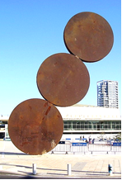

**From the Library – New English books!!!!!**

New additions include:

* "Squeeze Me" by Carl Hiaasen
* "Beautiful World, Where Are You" by Sally Rooney
* "Into the Fire" by Gregg Hurwitz
* "The Liar" by Steve Cavanagh
* **The new “Return Box” will undergo finishing touches by the “Library Knight” – Barry Feldman upon his return from vacation.** However, we already extend our gratitude to Agie who built it – and we want to take this opportunity to wish him a pleasant and successful national service. We are certain that your skills and ideas will contribute significantly!
* At the end of September, the "Libraries Forever" exhibition will be taken down (Those who haven't had a chance to visit are recommended to do so asap!

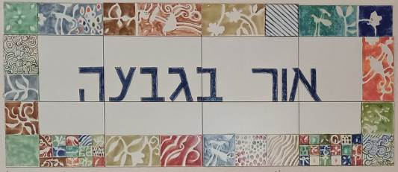

**Programme for 27.08.23 – 31.08.23**

**Daily 08:30 – 12:00 – coffee, cake, chats, board games**

**Sunday 27/8**

Opening the week - baking with Monica.

09:30 “Handicrafts or Armchair”

17:00 Tai-chi (advanced) with Einan Grosser

**Monday 28/8**

O8:00 Pedicure with Limor Mualem (by appointment only)

09:30 Art lecture with Chas Broadhurst

11:00 Pool exercises with Eyal Tirosh

16:00 Open for coffee, cake, and chats

**Tuesday 29/8**

10:00 Matan Freiman will talk to us about UNIFER, a virtual club for senior citizens

**Wednesday 30/8**

08:00 Pool exercises with Eyal Tirosh

10:00 Brain games and trivia with Galia Shemi

17:00 Tai-chi (advanced) with Einan Grosser

**Thursday 31/8**

07:00 Pedicure with Na’ama Baum (by appointment only)

10:00 Movie screening with Galia Shemi “Colours of Love”

17:15 Exercises on chairs with Michal Sha’anan

**English is Fun - with Rahel**

THE SAYINGS OF THE JEWISH BUDDHA

If there is no self, whose arthritis is this?

Be here now. Be someplace else later. Is that so complicated?

Drink tea and nourish life; with the first sip, joy; with the second sip, satisfaction; with the third sip, peace; with the fourth, a Danish.

Wherever you go, there you are…

Your luggage is another matter.

Accept misfortune as a blessing. Do not wish for perfect health, or a life without problems. What would you talk about?

The journey of a thousand miles begins with a single Oy.

There is no escaping karma. In a previous life, you never called, you never wrote, you never visited.

And whose fault was that?

Zen is not easy. It takes effort to attain nothingness. And then, what do you have? Bupkis.

The Tao does not speak. The Tao does not blame. The Tao does not take sides. The Tao has no expectations. The Tao demands nothing of others. The Tao is not Jewish.

Breathe in. Breathe out. Breathe in. Breathe out. Forget this and attaining Enlightenment will be the least of your problems.

Let your mind be as a floating cloud. Let your stillness be as a wooden glen. And sit up straight. You’ll never meet the Buddha with such rounded shoulders.

Deep inside you are ten thousand flowers. Each flower blossoms ten thousand times. Each blossom has ten thousand petals.

You might want to see a specialist.

Be aware of your body. Be aware of your perceptions. Keep in mind that not every physical sensation is a symptom of a terminal illness.

The Torah says, Love your Neighbour as Yourself… the Buddha says, There is no self.

So….maybe we’re off the hook!………………….more next week

Top of Form

Translated and edited by Eddie Solow

Proofread by: Biff Markham Oren

Printed by Hedva Sharabani and Irit Cohen