**The Yizraelite - No 20 Date: 20.1.2022**

**Kibbutz Yizrael**

**Translated and edited by Eddie Solow**

**Edi-torial**. The people have spoken. 61% to the most cooperative alternative for the dining room. Now we have at least one year before the next round. More, I hope. My nerves can't take it. Lots of humour this week. Just what the Dr. ordered.

New in the Yizraelite. Chaz Broadhurst has generously contributed his Limerick collection for printing. See the last page. If you like bawdy humour, then this is for you. If not, you can always reread the committee reports instead. There's something for everyone in The Yizraelite.

**Asefa + Moatza**

**Monday 23.1.2023**

Moatza – Community Budget

Asefa – 1) Changes to the Higher studies procedure

2) Establishment of a Statuary committee for "special Needs"

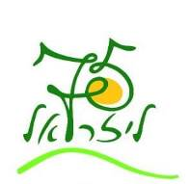**75th Anniversary PLAY**

 After a stiff selection process - Ido Dagani was chosen. He was the producer in the 60th year celebrations.

 The play will be written in the wake of Ido's meetings with us as a community.

 In the near future we will be invited to meetings

 Commitment to the process is important to us - the more the attendance at the meetings, the more the show will be about us and the special diversity of our community

 It is important that this period of our small community, together with the disputes - we know how to keep our humour and good relationships together.

 We guarantee a quality encounter with humour and a view of the past, present and future.

 Every meeting will be announced in Kehilanet, on the bulletin boards and by personal invitation

We start with two first meetings

**The veteran group** - on Sunday - 22.1.2023

At 16:00 - at "Or Begiva" - for veterans over the age of 75

At 19:00 - in the Rishonim Hut - for veterans 60 - 75 years old

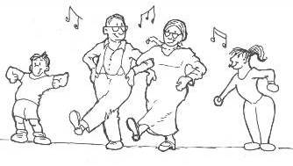Come in droves and have fun and leave your mark!!!

The Chag HaMeshek Team



**We donated blood:**

**At the blood donation that took place last Sunday**

**people contributed36**

**A big thank you to all the donors!**

**See you in six months.**

**Maor Cohen in Concert - on Yizrael!**

**27.1.23**

**Outside the pub**

**22:00**

**Rock Concert**

**From the Manpower Desk**

To all members, residents and employees - for the last time before the end of my term of office.

I wish to thank all the community workers wherever they are - members, candidates, young generation, entrepreneurs and employees who protect and work hard for the community, admire and serve the entire population throughout the year in better moments and in less good moments.

I believe that all employees want to succeed and give the best they can. They don't always hit the mark, but it is always possible to improve. It is important to know how to communicate, how to criticize for the success of the other. A critical discourse that does not reach the workers and is only carried out on the sidewalks will not benefit anyone. Constructive criticism will result in improvement and respectful discourse will also provide motivation for improvement. No employee/manager has the intention of harming anyone, sometimes you have to listen to the other person in order to understand.

The community workers, the members among them, reduce the community's expenses, by maintaining a workplace and save the need to pay a salary, and the more this path is maintained, the more the community will benefit from every member who works within the community.

To the many outside workers in Yizrael - thank you for your great contribution to the community's resources. There is no doubt that everyone who chose to work outside realises their profession, and their ambitions in the world of work and yet gives up the comfort of working at home. I wish you every success.

To the members who work at Maytronics - every member who works in Maytronics brings pride to the kibbutz, each of you maintains the company's belonging to the kibbutz, preserves the connection between the kibbutz and the factory, and I hope that more members will join the work circle at Maytronics.

To the agricultural and holdings workers - thank you for still believing in manual labour, and not being afraid of hard work, in such an important and valuable field, not only for the kibbutz, but for the entire country, which unfortunately makes it difficult instead of encouraging and supporting agriculture. The kibbutz sees you as true messengers for all of us.

And to all Beit Yizrael - everyone is recruited to work for the kibbutz, everyone contributes according to their ability; I'm sure that even those who contribute less at a given moment in theirlives, do so not selfishly or out of a lack of care, but because there are moments in life when a person can't find himself and wants to recalculate a course.

His is not in a place of comfort, he's in a dilemma and he is trying to find his future. Not everyone succeeds in doing this at a given moment, there are people for whom the search for a job/profession in life takes time and the elements of the dilemmas are many and different from one to another. We cannot judge a person whose sufferings we do not understand; It should be remembered that living in a small community can cause mental damage to a person and bring him to a moment when he thinks that he can no longer continue... I, personally, see a cooperative kibbutz particularly as having the ability to give others the support and help in moments of weakness... and not to judge.

I wish Yizrael all the best in the world as you continue on your path and that you should know how to create a respectful dialogue, that you know how to listen to those who think differently, to remember that if someone thinks differently from me, this does not mean that he is an enemy. He is part of the whole that wants to be just as good as the other, just in a different way. I wish you to make decisions based on broad consensus, and from a place of strength both economically and socially.

Many, many thanks to every member who put their trust in me, who shared with me their plight, their thoughts, who let me help and support; To many members who knew how to give a good word and to those who also knew how to give constructive criticism and to those who knew how to ask questions. To those members who pitched in to help when I asked.... again, many thanks

An optimistic attitude, and accepting life as it is, with humour and understanding of the other, is the way to a good life. A pessimistic and gloomy attitude is good in some situations, but an optimistic attitude is good for any situation. May you always look for the way to a better life.

Racheli Arava - Human Resources

**Planning Committee Meeting Summary**

**(Very abridged translation – Ed)**

**Date: 3.1.2023**

**Present: Yotam Assaf, Vicky Hollander, Tomer Hayun, Shahar Levy, Shlomo Levy, Benny Segal, Erez Peleg, Axel Levin**

**Recorded by: Axel Levin**

**1) Open spaces on the Maytronics campus**

Invited to the meeting: Rinat Greenberg and Amir Binyamini on behalf of Maytronics, and Ron Cohen and Shimon Zelas on behalf of Yizrael Holdings

Maytronics representatives presented a short presentation on different standards of execution and maintenance in some industrial areas in Israel as examples of what they want.

Different ideas were discussed and what could be appropriate for a Maytronics campus

It was agreed that the planning committee in collaboration with representatives of Yizrael Holdings will write guidelines regarding open spaces on the campus. The guidelines will take into account (among other things) Maytronics representatives' request for landscape planning at the level of the existing entrance to the offices.

**Maytronics' Requests:**

That the investment and maintenance are at the expense of Yizrael Holdings.

That the campus is indeed industrial, but with a rural collective atmosphere.

There is a desire to emphasize the headquarters area.

That there is a desire to plant a significantly large number of trees.

That there is a need for sitting areas and shaded walking areas.

is preferred. Use of local materials that can be easily maintained and replaced,

To maintain the sense of openness of the campus.

**2) The decoration of the kibbutz by the bar mitzvah year children**

Joining the meeting: Tamar Sankar, on behalf of the kibbutz decoration project by Bar Mitzvah children, and on behalf of the Environment Committee. This is a project in which Bar Mitzvah children will make environmental sculpture from scraps. Pictures of examples of sculptures were shown - bicycle scraps and colorful chairs with flower boxes

Tamar requests 19 places to erect such statue throughout the kibbutz. The project is scheduled is for the month of February. Location options, the lifespan of the scrap sculptures, the possibility of establishing an "exhibition" area and the possibility of reducing the number of sculptures were all discussed.

The planning committee thought of a number of places where the statues could possibly be erected, but does not think it is appropriate to erect 19 statues in the public area of the kibbutz. Since Tamar does not want a specific area for the exhibition - the planning committee will send a list of possible places to erect individual sculptures and requests:

Tamar will talk to the directors or coordinators responsible for each area and get consent for erecting the statues.

Tamar must check with the gardening branch that in the desired location, the statue will not interfere with the maintenance of the area and that a watering system can be added to the pot.

The children may build up to 9 statues

After a year, they must take down the statues

The construction, maintenance and removal of the statues is their responsibility at the project's expense. (It seems like the planning committee is not enamoured with this project - Ed)

**(3) Power storage**

**The planning committee now concludes that it is not worthwhile to place electricity storage containers on the ground in a place intended for (special) residences in the kibbutz.**

**(4) Benches**

The planning committee and the gardening branch received a budget from the social bonus for a bench project in the communal public area of the kibbutz. Options were examined and several criteria were prepared for appropriate benches in terms of material and maintenance, number of connections to the ground, backrest, width/number of seats, and quality. A market survey was prepared and quotes were received. The models that meet the budget were presented. The options were discussed and it was decided:

- A model with arm rests is better

- To request completion of price offers accordingly

- To try to get better discounts

**5) Security cameras in the public area of the kibbutz**

Security cameras were set up in public spaces in the kibbutz, with some of the cameras with communication and electrical connections hanging between light poles

In all new projects, the planning committee insists on electrical and communication connections underground. It is not acceptable to connect new electrical cables overhead. The instruction will be sent (again) to the kibbutz branches. Erez is asked to check that projects are planned and budgeted accordingly

**Updates from the Housing Committee**

Renovation work started this week in the rooms of the younger generation 9-12 in an old parents' residence. During the works, three rooms will be converted into two apartments, one of them for Inbal Pezaro, where accessibility and suitability will be improved for her, and the other for a young couple.

During the renovation, Inbal has moved, temporarily, to live in an apartment near Orit Sloman in Shikun Mizrach

In this bulletin the list of kibbutz members entitled to permanent housing is published, it should be noted that the list is correct as of January 1, 2023 and is valid for the entire year - until December 31, 2023. Also, the list does not contain veteran families interested in housing improvement.

Families, who are interested in moving to the new northern neighbourhood, must contact the Housing Committee in writing by Friday 2/3/23 and declare their desire to move. According to the decision of the community management, four apartments in the new neighbourhood are allocated for these families.

Definition of "housing improvers" from the housing procedure:

Housing improvers - moving from a permanent apartment to another permanent apartment.

A) Moving from a permanent apartment to another permanent apartment will only be possible after a period of 15 years from the date of completion of the extension/entry into the apartment by the date of the allocation of the apartments to tenants.

(See Alon for points chart - Ed.)

**Outside Workers Branch - Update**

(In the Hebrew Alon is an updated list of all **94** outside workers of the kibbutz. We tried not to miss any, but if we missed someone, sorry! This list is the first part of several end of year documents, which we will continue to publish in the coming weeks. Any correction/error is solely the responsibility of the Human Resources.

Peter

Sorry - The translation of the table was too complicated for me Ed)

**From the Nominations Committee Desk**

The Nominations committee proposes Alon Reuven for the position of coordinator of the security committee.

The committee reminds you once again that we are still looking for another economic council chairman, together with Sigal Hadar. You can contact any of the members of the committee on the matter.

Members of the staffing committee:

Racheli Arava, Albert Rosilio, Liran Penn, Anat Friedman, Uri Ayalon, Tzach Sassi and Nir Segal

**All-comers Band**

As part of the 75th year for Yizrael, the idea of forming a folk orchestra came up. A band composed of beginners and professionals alike!

We got a first taste at the evening of the "launch" of this 75th anniversary year’s activities. 22 musicians sat/stood on stage. Stas the maestro, did the arrangements, and found a role for each and every one.

Not to worry. We have several more performances ahead, so that if you were unable to participate this time, do not worry. We are waiting for you.

And if there is someone who plays (or played in the past and wants to shake off the dust) - and we didn't know - feel free to call! We have a "Yizra-Band" and "Gilbo-Band" and a "Klezmer-Band"... why not Kolmisheba-Band?

There is room for everyone!

**The Premiere Concerts**

There's nothing like the first time! The joy... the excitement... the "butterflies" in the stomach...

Three premiere concerts, one after the other, took place in one week. For all the students who started their studies this year, this was their debut! Dressed in their best clothes, trained to take a slight bow before, and after playing - the various musicians took the stage, and played light and flowing melodies.

Whoever has not seen the joy of a novice (and heard the sigh of well-being after it is over) - has never really seen joy at all.

The Music School welcomes everyone. "Even a journey of a thousand miles begins with first steps."

And this is our promise and calling.

**New English Books in the Library**

If I Told You Once – Judy Bunitz

The Emperor of Scent – Chandler Burr

Freshwater – Akwaeke Emezi

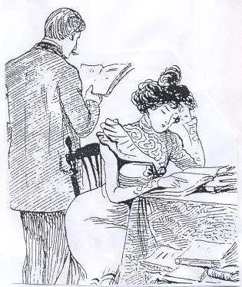The Death of Vivek Oji – Awaeke Emezi

Transcendent Kingdom – Yaa Gyasi

Firefly Lane – Kristen Hannah

People Love Dead Jews – Dara Horn

The Book of Longings – Sue Monk Kidd

Small Island /Andrea Levy

Lost Children Archive /Valeria Luiselli

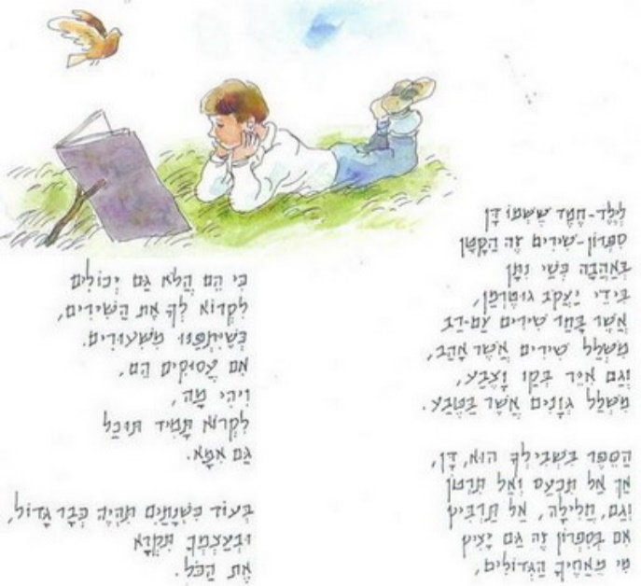Lessons /Ian McEwan

Circe /Madeline Miller (also in Hebrew)

The Memory Police /Yoko Ogawa

The Tulip – Anna Pavord

Stone Diaries /carol Shields

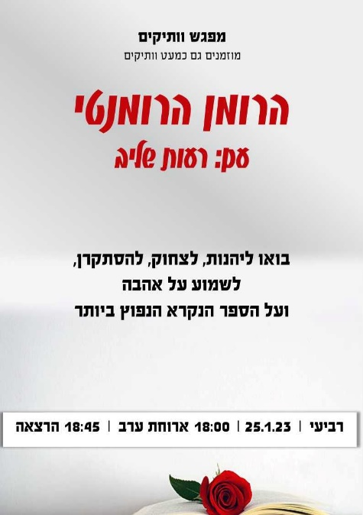

[**Haaretz**](https://www.haaretz.com/) | [**Israel News**](https://www.haaretz.com/israel-news)

Opinion |

**For Israel, There is No Way Back from Netanyahu’s Chaos - David Grossman**

**Under the guise of democracy, Netanyahu is warping the character of Israel itself, sowing the seeds of anarchic chaos, hatred and violence which cannot be tamed**

Everything that has happened in Israel since the election is ostensibly legal and democratic. But under its cover – as has happened more than once in history – the seeds of chaos, emptiness and disorder have been sown in Israel’s most vital institutions.

I am not talking merely about the enactment of [new laws](https://www.haaretz.com/world-news/wires/2022-12-27/ty-article/.premium/israels-netanyahu-closer-to-hard-right-government-with-new-legislation/00000185-52d1-d334-a9cd-57f7fc930000), extreme and outrageous though they are, but about a deeper, more fateful change, a change in our identity, a change in the character of the state. And the election wasn’t fought over this change; this isn’t what Israelis went to the polls to vote on.

Throughout the negotiations to [form a new government](https://www.haaretz.com/israel-news/2022-12-27/ty-article/.premium/netanyahu-begins-appointing-likud-members-ministerial-posts-for-new-government/00000185-54a2-d878-a995-54ba708f0000), a verse from the book of Isaiah has been constantly running through my head – “Woe unto them that call evil good, and good evil; that change darkness into light, and light into darkness; that change bitter into sweet, and sweet into bitter!”

In the background, like a Chinese water torture, I constantly hear MK [Moshe Gafni](https://www.haaretz.com/israel-news/2022-12-11/ty-article/.premium/israels-far-right-is-dragging-the-ultra-orthodox-into-a-dangerous-culture-war/00000185-01c9-d615-a38f-65ff72920000)proclaiming, “Half the people will study Torah and half will serve in the army.” And each time, my brain is charred, this time in part for completely personal reasons.

ראש הטופס

תחתית הטופס

The negotiations, which more closely resembled a looting spree, have flickered before our eyes in rapid pictures, in flashes of an alien, provocative logic – “the [override clause](https://www.haaretz.com/opinion/editorial/2022-11-07/ty-article/.premium/no-to-an-override-clause-no-to-an-empty-democracy/00000184-4e97-df34-a9b6-6e9f0f9b0000),” “the discrimination law,” “Smotrich will be the ultimate arbiter on construction in the West Bank,” “[Ben-Gvir](https://www.haaretz.com/israel-news/2022-12-27/ty-article/.premium/netanyahu-lies-down-with-dogs-and-acts-surprised-when-he-wakes-up-with-fleas/00000185-5051-d122-a5cd-595184db0000) will be able to set up a private militia in the West Bank,” “The serial criminal Dery will be able...” In the blink of an eye, with increasing freneticism, with the sleight of hand of a street side card sharp.

We know that someone is deceiving us at this very moment. That someone is pocketing not just our money, but our future and that of our children, the existence we wanted to create here – a state where, despite all its flaws and shortcomings and blind spots, the possibility of becoming a civilized, egalitarian country, one that has the power to absorb contradictions and differences, one that in time will even manage to free itself of the cursed occupation, occasionally shines through. A country that could be Jewish and believing and secular, a high-tech power and traditional and democratic, and also a good home for its minorities. An Israeli state where the multiplicity of societal and human dialects won’t necessarily create fears and mutual threats

Now, after the dust storm has settled, after the dimensions of the catastrophe have been revealed, Benjamin Netanyahu may be telling himself that after his sowing of chaos has achieved its goals – destroying the legal system, the police, education and anything that emits a whiff of “leftism” – he will be able to turn back the clock, erase or at least moderate the crazy, dishonest worldview he himself created and go back to leading us in a proper, legal, rational fashion. Back to being the responsible adult in a well-run country.

But at that point, he may well discover that from the place to which he has brought us, there is no return. It will be impossible to eliminate or even tame the chaos he has created. His years of chaos have already etched something tangible and frightening into reality, into the souls of the people who have lived through it.

They are here. The chaos is here, with all its suctioning force. Internal hatreds are here. Mutual loathing is here; as is the cruel violence in our streets, on our highways, in our schools and hospitals. The people who call good evil and evil good are also already here.

The occupation also evidently won’t end in the foreseeable future; it is already stronger than all the forces now active in the political arena. What began and was honed with great efficiency there is now seeping into here. Anarchy’s gaping maw has bared its fangs at the most fragile democracy in the Middle East.

**Phil-osophia**

**1981**

Back in 1981 the Springboks toured New Zealand. For those lacking a proper education, I am talking about the South African rugby team – fifteen optimists hoping to win a game or two. Their biggest hope being against the Hamilton Blind School on 25 July.

History records that the game was cancelled – due to a pitch invasion by hundreds of anti-apartheid protestors. This had never before happened in New Zealand and sent shock waves throughout the country, that still linger – there is still great bitterness in the blind community to this day. It is something we don’t talk about, if my older brother is in the room.

The tour split many families apart. Louts like me believed that sport and politics should remain separate while the other half stood by the belief that apartheid was indefensible so there should be a total ban on contact with South Africa. There was even talk about a civil war. The tour dragged on for weeks – protests everyday – wild accusations for and against the government for allowing it to go ahead and it was a good idea to keep your opinion to yourself.

My friend was a very clean-cut type – neatly groomed hair, sharp clothes and softly spoken. I on the other hand, I sported an unkempt beard long curly hair and jeans that should have been in a rubbish bin a long time ago. At first sight I looked like a protestor and he looked a member of the establishment.

I went to the games and he protested outside the stadium. While I was enjoying a meat pie and a beer inside, he was being beaten by the police outside. One evening as he sat on my couch, I put forward a radical but incredibly logical idea. I suggested that instead of messing around with the police he should come and protest outside my flat.

I had a fence that with a good imagination could double as a police barrier – he could come over with a placard in one hand and with the other rattle the fence for a half an hour or so and yell out things like "free Mandela" or "our bodies our abortions" or "Dumbledore wouldn't let this happen" or even "Crime Minister". At some stage I would come out dressed in blue – beat him up and then invite him in for a cup of tea and some first aid. I pointed out the advantages – no need to travel long distances, shorter protest time, no time spent in a police cell and my blueberry muffins went great with a hot cup of tea (or coffee). Believe it or not he never took me up on my generous offer.

The way things are, it looks like we are heading back into an era of civil unrest and many of us are going to find ourselves being tasered, beaten, cuffed, soaked by water cannons, spat on and generally abused.

Come to my place instead (think, ok, of the travelling costs you'll save (unless you have a work car), you won't need a baby sitter and you can request a protest timetable that suits you.

I have an App (DIY Riot) that you can download – simply choose from the list of options offered – you can even add some of your own – all for free! For example, me and my team (dressed in Yariv Levin masks) will spray you with the garden hose or if you prefer, I will set my vicious French bulldog on you – you choose**! Let's keep things in proportion (and in house). Contact me as soon as you can. Places are filling fast.**

**English is Fun - with Rahel**

THE STRANGE CASE OF THE ENGLISH LANGUAGE

English is a crazy language, continued:

Sometimes you have to believe that all English speakers should be committed to an asylum for the verbally insane. In what other language to people drive in a park and park in a drive? In what other language do people recite in a play and play in a recital?

In what other language do privates eat in the general mess and generals eat in the private mess? In what other language do people ship by truck and send cargo by ship? In what other language can your nose run and your feet smell?

How can a *slim chance* and a *fat chance* be the same and a *bad* *licking* and a *good licking be the same while a wise man and a wise guy by opposites? How* can *sharp* speech and *blunt* speech be the same and *quite a lot* and *quite a few* the same, *while overlook* an*d oversee* are *opposites?*

If *button* and *unbutton* and *tie* and *untie* are opposites, why are *loosen* and *unloosen* and *ravel* and *unravel* the same. If *bad* is the opposite of *goo*d, *hard* the opposite of *sof*t, and *up* the opposite of *down*, why *are badly* and *goodly*, *hardly* and *softly*, and *upright* and *downright* not opposing pairs.

Why is it that when the sun or the moon or the stars are out, they are visible, but when the lights are out, they are invisible, and when I wind up my watch, I start it, but when I wind up this essay, I shall end it?

English is a crazy language!

How can expressions like “I’m mad about my flat; “No football coaches allowed” and “I’ll comeby in the morning and knock you up” convey such different messages in two countries that purport to speak English?

How can it be easier to assent than to dissent but harder to ascend than to descend? And if you decide to be bad forever, you choose to be bad for good, and that if you choose to wear only your left shoe, then your left one is right and your right one is left? Right?

If *uplift* is the same as *lift up,* why are *upse*t and *set up* opposite in meaning? Why are *pertinent* and *impertinent, canny* and *uncanny,* and *famous* and *infamous* neither opposites nor the same?

English is a crazy language! More next week

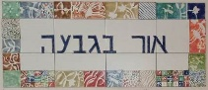

**BEACON ON THE HILL – 22.1.23– 26.1.23**

|  |  |
| --- | --- |
| **SUN**  **22.1** | 7:00 Feldenkrais with Illana Lahav  09:10 – 12:15 World View on Zoom  *To be an Elephant with Galia* |
| **Mon**  **23.1** | 9:00 Coffee, cake, chats, and games  9:00 A trip without walking  9:30 Art with Chas  16:00 – 18:00 Coffee, cakes, chats and games |
| **Tue**  **2**4**.1** | 9:00 Board Games  10:00 Creativity with Pnina Habshush  17:00 Exercise with Irit Bahir  16:00 – 17:45 Ceramics with Miki Touz |
| **Wed**  **25.1** | 9:00 Games  09:30 Blooming Nature with Hamutal  117:00 Tai Chi with Einan Grosser  18:00 Seniors' get-together |
| **Thursday 26.1** | 9:00 Coffee, cake, chats, and games  9:30 Movie – Mr. Harrigan's Phone – with Monika  7:00 Pedicure with Na’ama Baum  17:15 Exercise on chairs with Michal Sha’anan |

Weekly Limerick - Chas

A chartered accountant called Clyde

stared out of the window and sighed;

with no time for perversions

with Greeks or with Persians,

he withered away and he died.

I guess you can call it a work/life balance thing.....

Chas

