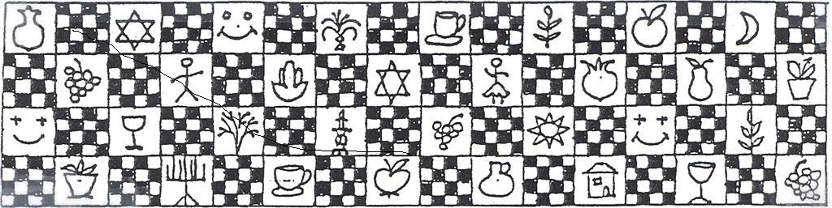

**No: 2098 17.3.2023**

**Kibbutz Yizrael**

Translated and edited by Eddie Solow

**Edi-torial.** This week, I want to draw your attention to a very nostalgic interview with Chas Broadhurst, on the occasion of the opening of an exhibition in the library complex. The exhibition tells the story of the wandering libraries of Yizrael over the years. It’s undoubtedly worth visiting the exhibit and very worth reading the interview. Three pages of sheer nostalgia. Longing for people who are no longer with us and days gone by when our pockets were empty and our hearts full.

**Many thanks to everyone who helped with our Purim celebrations**

**Children's Purim:**

 To Yuval Agmon, Shlomo Cohen and Ishai Levy – who took on the responsibility so that this year our children could enjoy the traditional joyous ADLO-YADA parade

 To Esti Mittelberg and Ori Ayalon - you made us all so happy, children and adults alike.

 “Jezebel Productions" - our new photography team - to Einan Grosser for taking the beautiful photos and Tsofnat Mor for editing them into a video.



**Purim "protest" for adults … Thank You**

 To the party team: Or Nanikashvili, Anna Abramovich, Ariel Dolinko, Gal Perling, Doron Kagan, Tal Levi Freiman

Yuval Agmon, Ranit Levy, Niv Edelstein, Rotem Kamilian, Shira Levy and the 4 shinshins.

Assaf Arieli, Yuval Agmon, Yarden Griman, Niv Edelstein, Niv Segal,

Eden Zinenko, Ofri Sharoni and the shinshins: Boaz Kaplan, Gil Nachmias, Tal Weinhaber, Yoav Hadani, Lee Inbal, Noga Kamilian, Ron Aviv, Shani Wiseman and Shaked Meirovich - who worked day and night for 3 weeks.

 To the pub staff - for the treats at the bar

 For the participants of the "Holiday Tract": producer - Tamar Agmon, dances -shinshins, Ohad Ziv, Amir Darom

Doron Kagan, Niv Edelstein, Eran Shkolnik and Tzachi Tzfadiya, choreography for boys' dance - Sarit Laviv and Danit Duvdevani Kirshberg. Video - "Dror" group (12th grade); judges of the costumes contest - Eviatar Assaf, Karen Brustein Eylon, Artzi Sankar, Keren Stamper Kagan, and Shlomo Levy

 Many thanks to all and sundry, we were happy beyond measure!

On behalf of the Yizrael community - Tal Wolfson-Darom, cultural director



**Rainfall**

Rainfall from the beginning of the 2023 - 2022 season: 333 mm

Multi-year average to date: 384 mm

A

**Rainfall Table**

|  |  |  |  |  |  |  |  |  |  |
| --- | --- | --- | --- | --- | --- | --- | --- | --- | --- |
| Month | Sep | Oct | Nov | Dec | Jan | Feb | March | Apr | May |
| Total | 0 | 18 | 2 | 44 | 105 | 93 | **19** |  |  |
| Average | 0.38 | 16 | 51 | 99 | 111 | 80 | 52 | 19 | 5 |

Daniel Rosenfeld – Manager of Agriculture

**Invitation to all members!**

**Summing up the financial year in terms that the layman can understand.**

**Yizrael Holdings invites you to the Economic Council** to hear the summaries of all the various activities of Yizrael Holdings and the outlook for the coming year.

This year, for the first time, we will try to adapt the various reports so they will be understandable, both to the kibbutz members without a financial background as well as to the members of the council, who are schooled in the subject.

We recently learned from a number of visits to various kibbutzim with levels of economic activity similar to ours, about holding an annual summary “celebration”, which takes place once a year, **on a Friday morning**, when the majority of the public is free, alert and a little less stressed.

**On Friday, 4/14/23, at 09:00 - 12:30 – save the date!**

The meeting will replace the two meetings of the Economic Council that were customary until now.

**In addition**, on the afternoon of the Sunday 23/4/23, there will be a meeting "over a cup of coffee" with Sharon Goldenberg and Jonathan Bassi in the same format, exactly on these topics, relating to Maytronics. (Save this date too!)

A formal message with a schedule and details will be issued before the meeting itself.

All members are invited to participate, listen, ask questions and feel proud! (And a little anxious – Ed)

Ron Cohen, Manager of Yizrael Holdings

**Education Committee Meeting Minutes 08/03/2023**

Participants: Peter Pezaro, Shlomo Kamilian, Philippa Segal, Rotem Agmon, Revital Zelas and Danit Kirschberg

Agenda

1) Momi presented the list of this year's students and Peter elaborated in a few words about each one. A significant number of students are continuing their studies in the 2023 academic year therefore we asked the community management and received an increase in the budget, which will allow the committee to add new students.

At the next meeting, after reviewing this year's applications, we will select committee representatives who will approach each applicant, to hear them and obtain from them additional information that will help the committee sort and rank the applications.

**As previously published, the submission of applications for studies for 2023 ends on 31.3.23**

On the occasion of the first gathering of the new committee, we wanted to thank and congratulate the members who were on the previous committee and chose not to continue: Avishag Sharoni, who was the "living archives" of the previous committee and contributed much over many, many years, Limor Griman, who was on the committee for only one term until she was appointed director of education cluster. She contributed her wisdom to the discussions, Rotem Hillel, she also had only one term, but she went out to study this year, Tamar Sadur, who resigned from the committee a few months ago due to overloads in other areas

* Congratulations to Mor Broadhurst, who won a scholarship for excellence

Momi

**Candidates for the Position of Public Representative on the Executive Committee**

After collecting the names, and checking the candidates' willingness to run for office, the following is the final list of candidates.

The vote was delayed to enable the candidates to publish their manifestos in the Alon.

To ensure broad participation, the vote will take place from Monday 20/03/2023 at 8:00 a.m. until Wednesday, 22/03/2023 at 13:00.

You must choose 4 candidates from the list. The four candidates who receive the most votes will be elected. (There will not be a second round – Ed)

In the event of a tie between 4th and 5th place - a lottery will be held with the consent of both candidates

In the case of spouses who are both elected - the person who receives fewer votes will give way to candidate number 5 (since it is forbidden for spouses to sit together on the board of directors)

We need a wide participation in the vote - 60% of all members must vote or we will have a constitutional crisis. (One constitutional crisis at a time is enough ... Ed)

**Below is the List of Candidates (in random order)**

**Choose 4 names from the list.**

**Eviatar Assaf; Oscar Groysman; Ofir HaLevi; Anna Abramowitz; Esther Epshtein; Biff Markham-Oren; Barry Feldman; Brent Abramowitz; Dima Tchernikovsky; Dana Alster; Zivit Nankishvili; Meir Mashali; Momi Cohen; Matan Elul; Natalie Zinenko; Netta Broadhurst; Nitzan Rivlin-Feldman; Sigal Hadar; Adi Goldstein- Ilan; Adi Laviv; Phil Adler; Tzachi Tsafdia; Rafi Baum; Rotem Agmon**

**The Manifestos of the Candidates**

** Eviatar Asaf:** It is a great privilege to be a candidate for public representation in the executive committee. It is important for me to be a part of the decisions made in the kibbutz. I would be happy to continue to keep Kibbutz Yizrael as a cooperative kibbutz, but I am always open to hearing a variety of opinions. My occupation at the moment is in agricultural research at the Volcani Centre of the Ministry of Agriculture. I am a member of the Economic Council and an observer on the Agriculture Directorate.

Thanks for the opportunity. I would love to be a public representative on the committee.

** Oscar Groisman:** I intend to contribute the knowledge I have acquired throughout my life, and my experience as a rank-and-file member of the kibbutz for many years.

** Anna Abramowitz:** I believe in cooperative values of the community while maintaining the way we decided to live. It is important to me to meet the expectations of a public that has trusted me to represent them on the committee.

** Esther Epshtein**: candidate for the board of directors - "I believe in myself": I have lived on Yizrael for 55 years and have experienced upheavals that have happened to the kibbutz and its members. During my life I was very involved in education, culture and community life. The Yizrael community and its members are important to me. Important too is the social fabric, especially in these troubled days of divisive legislation and our mobilisation as a community to protest.

I want to be present at important junctures of the kibbutz and its management - to hear and voice my opinion and the opinions of many other members, who sometimes feel that their opinion is not heard or considered. I am confident that my years as a member will enable me to influence the quality of life of all of us - young and old, so we may march forward, not only economically, but especially socially.

 **Biff Markham Oren:** I summarise my "I believe" in a few words by which I try to lead my life... Integrity, Transparency, Justice,

Collaboration, Accountability

** Barry Feldman:** I arrived to Yizrael 51 years ago. I believe in a cooperative kibbutz with equal rights and responsibilities for everyone. A kibbutz with mutual help and opportunities for all ages to reach their potential. I would love to sit on the board of directors. Thank you.

** Brent Abramowitz:** I believe in a cooperative kibbutz and in action for the good of the people in accordance with the community rules and regulations, procedures and values. I believe in not hiding anything from the public.

** Dana Penn Alster:** I appreciate, cherish and share the principles and values of the kibbutz where I was born and lived most of my life, and where I chose to raise my children. I think there are many amazing things in our kibbutz, in the surrounding community, the people who live here and in our special way of life. All these need to be preserved, nurtured and strengthened. And yet, we need to know how to observe, criticise and adapt ourselves to the changing times. Needs and ways of life change from time to time and we must be realistic and know how to look at ourselves without fear and provide a better response to the variety of different needs in our diverse community. I am sure that people who feel that their needs are taken into account, will be happier and contribute more economically and socially. I believe that the different age groups should be given appropriate solutions according to their needs - the veterans should be looked after and feel they belong and be secure about their future and that of their children. The middle age group should accept the responsibilities and lead the kibbutz forward, with responsibility and confidence. The young should feel that this is their home now and in the future. I believe in including all views, in transparency and in integrity. I believe that as a community, we must be open, attentive, daring, proactive and flexible in order to promote, develop and lead the kibbutz to success and enduring economic and social prosperity.

** Zivit Nankishvili**: Dear members of my kibbutz,

First of all, I thank the members who supported me and saw me as a worthy candidate to run as a public representative on the executive committee. As a daughter and as a someone who has lived all her years on the kibbutz, I know the kibbutz very well and over the years I have also worked in service branches in the kibbutz, the kolbo, laundry, early childhood education at various ages and even in a management position as well as outside work. Over the years, I participated in various committees, specialised in professional courses and recently even completed a directors' course. I am confident that I have the knowledge, experience, tools, abilities and skills to work faithfully for the preservation of the fabric of the community, and the preservation of the dignity of the entire population of our dear kibbutz. I believe that it is important for the executive committee to have a diverse range of people and opinions and I would be more than happy to serve the kibbutz that I love the most and I will do it to the best of my ability. I will conclude by saying that everyone knows that my family and I are going through a difficult time that makes us feel distanced and ostracised, therefore it is extremely important for me to take an active part in the kibbutz and prove to everyone who the real Zivit is. I think you don't know and it's a shame. I have a lot of skills that can help me in this position and I would be more than happy to prove myself. Thank you, in anticipation.

** Natalie Zinenko**

I have been a member of Kibbutz Yizrael since 1997. Yizrael is home for me and my family. For quite a few years I was active in the life of the community: I have been a public representative in the Mazkirut, a member of the Mazkirut as the coordinator of the Higher Education Committee, a member of several committees (education, absorption, higher education, culture and more). In the last decade, I focused and developed my career in teaching English at the 'Emek Harod High School', where I developed professionally and personally. Here I held various positions, such as, junior high and high school class teacher, English coordinator, and more. Today, along with teaching English, I fulfill the role of pedagogical coordinator of the school. I feel that now I can and want to return to being active and contributing my abilities to the community. Therefore, I am keen on joining the executive committee as a public representative, in order to learn the processes that take place on the kibbutz and to voice my opinions and the opinions of the public and influence leadership and decision-making. I hope to bring with me the life wisdom I have gained, sensitivity and the unique viewpoint of a woman.

** Nitzan Rivlin Feldman:** What can I bring with me to the position of public representative on the board of directors:

- Love for Yizrael and its members and a desire for us to continue to exist as a cooperative kibbutz. A community that is a good place to live in and be together.

- It is important to me that there is a constant process of conceptual and social clarification in our society.

- In my opinion, the Management Committee should act in a pro-active manner, engage in vision and planning for the future and lead the way and not let its idiosyncrasies manage our lives.

- Planning the future is a kind of act of dreaming and, as you know, I love dreams, from which a better reality may grow. I would love to be a part of this and a partner in defining the goals of Yizrael.

- I think that we should try to hold discussions and public social discourse, while truly listening to each other, with the desire and effort to reach a consensus not by raising hands and even more importantly - without folding arms.

- It is important that we know how to distinguish between what is really important and what is secondary.

** Sigal Hadar:** I believe that in order for us to function as a community there must be continuity and that is what will make us reach the goals we set for ourselves and for our community. In order to bring about something bigger and unknown, I have to jump into the unknown (Management Committee), trust my internal resources and my personal skills - knowledge, responsibility, giving and cooperation. It is important to continue to move the community forward. Best regards,

 **Adi Goldstein Ilan**:

For my soul still yearns for freedom,

unbartered to the calf of gold:

for I still believe in mankind,

in his spirit, strong and bold.

We arrived in Yizrael almost eight years ago, believing in the idea of cooperative kibbutzim, and we were happy to discover that even in the 21st century it is still alive and kicking in a thriving, cohesive and creative community. I would love to be a member of the executive committee in order to continue promoting the principles of sharing and equality, while seeing the needs of all community members. Many thanks in advance to those who put their trust me and good luck to everyone!

** Adi Laviv:** First - Thank you to everyone who suggested my name as a candidate. I bring with me managerial experience, both in the business environment and here in the kibbutz. Not everyone knows that I have a master's degree in business administration. I am a director's course graduate, and I have a past in various committees, the economic council, the Mazkirut, and community leaders’ team ((צוות הקהילה In my view, it is important to preserve our very unique way of life, maintaining our social values and strengthening our inner resilience as a community. At the strategic level, it is also important to adapt to the challenges that we will face in the coming years.

I learn from past successes as well as failures. I would like to continue to contribute from my abilities and experience - it would be a great privilege to be a member of the committee and outline the goals of the kibbutz for the years to come. Thanks,

** Phil Adler:** I have been a member of Kibbutz Yizrael for years. I have served in several positions throughout these years. I am currently a member of the Board of Agriculture. I love where I live. I believe that there is an evolutionary process for everything, and I am open to changes.

** Tzachi Tsfadia**: I am interested in contributing of myself for the benefit of our community by actively participating in the executive committee. I believe that we must improve our decision-making ability as a community and be transparent to the public on all issues. I see community life as cooperative, but nevertheless we must examine and choose the cooperative issues as a kibbutz and this in a fair, considerate, respectful and democratic way.

** Rafi Baum**: I am from this place in the past, present and future. I am raising my family here; I have always been here by choice, and I like it. All these years, alongside the development of "entrepreneurship" in my profession, I was involved in public/collective activities in various doses (secretariat, younger generation committees, planning committees, construction at all levels, outside workers and more). In recent years I have focused on rugby, which for me is more than "just a sport". I believe in mutual responsibility and maintaining the status quo in all core issues, such as: education, economy, health, veterans and acceptance of the other.

I believe in the internal forces that exist on Yizrael and in the need to strengthen the community with absorption.

I believe in personal responsibility in all areas.

I believe in freedom of choice.

I believe in transparency.

I believe in preserving what already exists and making changes that are adapted to the spirit of the times. I choose to be here based on my experience, commitment and love for Yizrael.

I offer myself for the position.

** Rotem Agmon:** I believe in community life. In my opinion, a healthy community is the key to a good and long life for the individual. I am interested in promoting a way of thinking that will define the real needs of a cooperative community in matters of health (nutrition), culture, education and sports - for a healthier, longer-living and more prosperous public. I wish us all good luck.

**Shlomo Kamlian:** My belief is that management is systematic work, joint and professional teamwork with people who show responsibility for the position and commitment to the public. The values I apply in management are openness and listening to management partners and the team that works with me, encouraging thinking outside the box, creativity, legitimacy for mistakes, while learning and generating insights. I practice systematic, non-procrastinating decision-making, while managing the risks and putting in place a response to deal with the realisation of the tasks. The principle of mutual respect and the "live and let live" approach leads me to strive for a society where all forms of life are accepted and respecting and protecting the other's way. Always a manager and leader, I was a mentor to young people, taught professionalism, set goals and accompanied their fulfilment.

**We wish all the candidates well and hope the publishing of manifestos, will become common practice on the kibbutz.**

(Not everyone chose to write a manifesto)

**There is a price to be paid for not being bothered to write - Ed**

**From the Nominations Committee Desk**

The committee recommends the following names:

Chairman of the Economic Council - **Uri Gilad**

Additional member for the mourning committee - **Ranit Levy**

will be submitted for the approval of the asefa.

Members of the nominations committee:

Kinneret Govrin H.R. Albert Rosilio, Liran Penn, Anat Freiman, Ori Ayalon, Tzach Sassi, and Nir Segal

**Invitation**

**Reserve Fund Meeting**

**and Economic Council Meeting**

**On Monday 20/03/2023, at 20:30.**

Agenda: Reserve Fund : approval of financial statements

Agenda: Economic Council: 1. Community project financing model

2. Budget approval for renovating trailers

Asefa Committee and Council

**On Democracy and our Youths’ Right to Protest**

**Summary of education councils on the location of the ZACHAT clubroom**

**Background:** From the year 2015, for many years the Zachat clubroom operated in a building above the Sadot neighbourhood. With the changes in the number of children resulting from the transition of the large Shibolim group to the 7th grade, there was a need to renovate and adapt the clubroom.

About a year ago, in the spring of 2022, the Education Council approved the request to move temporally to the building that used to be Du-on 4

In October 2022, due to a successful experience from the move to the new building, a request was made by the social education team to hold a repeat discussion on the location of the building.

This discussion took place in two stages in the last month.

In the first discussion, the members of the Education Council were joined by representatives of the youth team - Shimrit Tzfadiya, the youth coordinator, and Ofri Ziv, the zachat coordinator. The team presented and discussed, advantages and disadvantages of each structure.

The children are opposed to remaining in the new building.

As far as the educators are concerned, both options are good, there is no bad option. Each option has advantages and disadvantages, but they can work with both. The team will adapt to any decision made.

At the end of the first discussion, a vote was held, in which the majority determined that the zachat would remain in its current location (next to the children's after school activity houses).

When the decision was passed on to the youth, it became clear that it was not to their liking, and they felt that they had been wronged.

Through the mediation of the educational staff, a petition was organised, which was signed by about 40 children - most of the children in the group.

With the submission of the petition, a repeat hearing of the Education Council was scheduled, to which representatives from the three groups that make up the zachat today were invited.

The youth who prepared for the debate in an impressive and admirable manner, presented their reasons:

- Part of growing up and moving to 7th grade is changing the physical location.

- Want to be close to the older youth (CHEVRA BOGERET) society, with whom we study and also participate in activities.

- It's not pleasant to be close to the younger children, to hang out with children in the 1st-2nd grades.

- The zachat is now in the heart of the kibbutz. When we are sitting outside people pass by all the time. It violates our privacy.

- Sometimes children and parents come inside, to use the bathroom or to drink, this also affects our privacy.

After thanking the youth for the important things they said and the mature and respectable way in which they brought them, we said goodbye to them and continued the discussion of the council together with the representatives of the youth team - Shimrit, Ofri and Sharon Azrieli.

**At the end of the second discussion, a vote was held in which the majority overturned the first decision - the group will return to its original location (above the Sadot neighbourhood).**

**In conclusion:** we received an important lesson from our youth about how we make decisions that affect their lives.

There is no doubt that the spirit of the times and the fact that our children are exposed and share in the public protest, played a part and we are proud. Now our role as adults is to enable the realisation of the decision, to prepare the zachat clubroom as a place for activities for over 40 youth, as befits Kibbutz Yizrael and its wonderful youth. (Lucky, we have deep pockets – Ed)

Summarised by: Yifat Assaf and Limor Griman

**(Season 2 of the soap opera…**The older residents sign a petition demanding the forcible removal of the noisy youths. How will the situation play out? Don’t miss season 2! **Democracy is no picnic**- Ed)



**8th Yizrael March**

**A Guide for the Perplexed**

**Information about the eighth Jezreel march**

Below is a list of questions and answers, regarding the march that will take place in 2 weeks’ time - Saturday morning, 1.4.2023

**(1) Question:** Is the march suitable only for good walkers?

**Answer**: The short route is suitable for almost everyone - including children. The length of the short route is about 5.5 km. You won't feel the distance, due to the activities and refreshment stations along the way. Those who want an additional challenge can choose the long route which is 9 km in length.

**(2) Question:** What if I can't finish the route, how will I get back?

**Answer:** A team of drivers is on standby to transport everyone from any point on the route. The phone numbers appear in the march brochure.

**(3) Question:** Will there be first aid during the march?

**Answer:** First aid and security personnel will be in the field

**(4) Question:** When do we leave?

**Answer:** You can plan to leave between 08:30 - 9:30, but if it's a hot day we'll try to open the route earlier.

**(5) Question:** Where is the starting point?

**Answer:** at the agricultural farm (formerly the stable)

**(6) Question:** Is it worth bringing food for the road?

**Answer:** You should bring a bottle of water. At the refreshment stations we will make sure that no one dies of thirst or hunger on the way... (to put it mildly)

**(7) Question:** Is it possible to bring guests to the march?

**Answer:** Not only possible - but desirable! The walk is a great opportunity to host friends and family, customers and suppliers and anyone you wish. We have invited the salaried employees (and their family members) from the kibbutz and corporate branches. Please encourage them to come.

**(8) Question:** Will the dining room be open on that day?

**Answer:** This year, the dining hall will be closed on the day of the walk, to allow everyone including rostered workers to participate. The plan is to increase the distribution of food on Friday for Shabbat. At the last stop along the walk, among other surprises, we will also distribute sausages and buns. Details later on...

**(9) Question:** How do you get home from the finish line?

**Answer:** This time the end station will be close to home. The driver team will pick up anyone who wants a lift.

**(10) Question:** What about those who cannot walk? They will miss the whole "celebration"...

**Answer:** Absolutely not! A list will be posted on the bulletin board offering a car tour, which will arrive at every possible stop.

**(11) Question:** Is it necessary to register in advance?

**Answer:** This year we will request registration of the number of participants, so that we can prepare enough brochures, goodies, medals, ice creams, vehicles and everything else. **PLEASE ANSWER THE QUESTIONAIRE on Kehilanet by the end of this week**

**(12) Question:** What is the booklet in question?

**Answer:** Those who wish will receive a brochure with all the necessary information. We are trying to prepare an online brochure as well, and a telephone quiz, so - bring phones! The booklet is necessary for the march, it has the details of the routes. We will distribute the brochure in advance and publish it in Kehilanet, to allow you to review it before you set off. That way, you will be informed in advance of the stations and the places you will pass by. It will also contain the map of the march.

**If you have any questions not covered here, you can contact the team members:**

Ruth Mor, Phil Adler, Adi Ilan, Ella Cohen, Yotam Assaf, Navot Assaf, Berry Feldman, Vicky Hollander, Paul Zelas, Eyal Tirosh, Benny Segal, Jeremy Perling, Ron Granot, Shani Be-or, Eddie Solow.

**Reminder: -** Amir Armoza

The social project team invites the public to propose ideas for social projects for our community!!!

You can contact any of the team members:

Amir Armoza, Nitzan Rivlin-Feldman, Shahar Levy, Shlomo Cohen

**In Preparation for the Yizrael Walk**

**Invitation to a talk**

**By Norma Franklyn**

**(The archeologist who knowns more about the history of the place than any person alive…)**

**Subject: 7000 years on Greater Yizrael**

**AND**

**The Jezebel we never knew**

Tuesday 21 March 2023 – THIS WEEK

Time: 20:30

Place: The MOADON

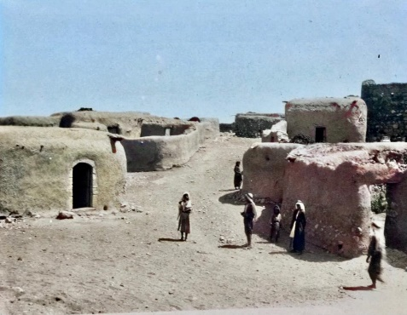

**The villiage of Zarin 1921**

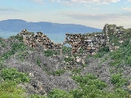

**The village of Zarin 2023**

**The Opening of the Exhibition:**

**"The Library “Since Then and Forever"**

will take place

On Thursday, 30.3.23

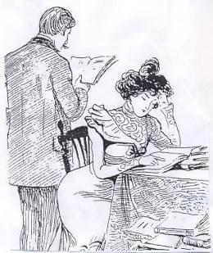at 17:30

followed by Noa Gino's lecture:

I am Gino's daughter.”"

**Reut Shaliv Interviews Chas Broadhurst**

**The English Library on Yizrael**

**Question**: When did you come to live on the Kibbutz?

Neta and I arrived in 1980. We lived on Beit Alfa for four years before moving here. Beit Alpha had a large, nice and lively library. I was a good customer. When I got here, one of the first things I looked for was an English library. Because there were a lot of Anglo-Saxons on Yizrael, I thought there must be a good library here. I discovered that the library was inside the bomb shelter also used by Amen Becker as his artist studio (the bomb shelter in front of the Fink family's house, across the path from Rutie and Amen's house)

It was half a shelter, because the other half “belonged to” Amen. There was a line in the middle, and we were forbidden to cross the line (Reut’s comment: in the exhibition at the library, hangs a picture of Bini, sitting in the same library, right next to the demarcation line). It was very crowded, so that when a new book came in, another book had to be thrown away to make place. I only discovered that later. When I came to Yizrael, the library was under the responsibility of Judy Court and Sharon Franklin, I think. When I arrived Judy wanted out, and because I was a good client, she asked if I would like to take over, which I did. The library was open once a week, in the evening, from seven thirty to nine, I think…. after dinner.

But let's go further back. Judy says that Mrs. Kaplan was in charge of the English library before her (Yehuda Kaplan's mother) (Ruti Mashali’s grandmother, to be precise – Ed) The status of the English library was “tolerated”. That was not an official decision, but the emphasis was on a minimum budget. However, in order to read and enjoy, you need to read in your native language.

Because of the small budget, I looked for books in second-hand stores. I didn't care, because a public library is basically a thrift store. Someone has always read the book before you anyway. I would go once every month or two, to Tel Aviv or Haifa. I went to Allenby Street, where there were many second-hand book shops and at the end of the street there was a large Steimatsky bookshop. I would take books that people had donated that we already had a copy of, and I would exchange them. There were stores that took everything and there were stores with a higher level. The best was Halper's Books. I caught a ride with someone who worked in Tel Aviv, for example: Yossi Piekarski, and I would return by bus with a bag full of books. That's how I got three used books for the price of one new book in Steimatsky.

Back to our bomb shelter - we would open the shelter once a week, usually on Mondays. There were many libraries: English, Hebrew, children's, reference, pedagogical (five libraries!) each opened once a week, each was in a different place. From the very beginning it was clear that if it could be possible to put the libraries together, the same number of people could open the library every day. Chanale Levin was a librarian at the children's library, Mirik Yuval at the Hebrew library, Safta Tova Ben-Dov was in the study room. I can’t remember who was in the in the pedagogic library - someone who left the Kibbutz.

The library in the shelter was in bad shape. There was terrible humidity and it affected the books. I decided to remove the library from there. After we left the bomb shelter it was completely flooded. We got out just in time. About a year later, the shelter of the Hebrew library was also flooded!

Together with Mike Scheiderman and his “Internash” (inverted fork tractor, Massey Ferguson International) we moved to the old dining room.

The building at that time was completely empty. We moved the library to where the old post office of the old dining room had been (where Ron Cohen’s office stands today), the toilets were next to it, so Yossi Abadi, who was then the kibbutz carpenter, built a door for us and that's how we closed off the area.

Suddenly we had an area three times larger than the “half shelter” and there was plenty of room for books. We could bring in new books without throwing out others!

When the renovations eventually started in the old dining room, they wanted that area for the secretaries and it was suggested that we move up to the second floor, into the old dining room itself. Here we had even more space!

We could bring in books on all kinds of subjects. Half of the second floor, the wide-open space of the dining room itself, was the “Tarbut” warehouse and half was the English library. The problem was that the roof of the old dining room slopes inwards, in an unusual ‘V’shape. The gutter was in the middle of the roof. Because the building was neglected, the water outlet in the gutter was always blocked and rain dripped into the building. It was very important that the bookshelves stand slightly to the side and not in the middle. We placed buckets in strategic places, to catch the drops.

Then the 'younger generation' wanted a snooker table, and the ideal place was where the library was. The plan was to move the Tarbut warehouse next to the chicken house (Lul), then move the English library to the other half of the space where the Tarbut warehouse was. Very quickly the younger generation realized that they had to play snooker while holding an umbrella, so the snooker table was taken out. In the meantime, they wanted to build a studio for a home video team. (We had a home channel on TV on which we would broadcast movies that we rented at “Blockbuster” and broadcast homemade programmes. So, we moved back across to the previous half.

In the meantime, we got the Kolbo’s old desk (which became the librarians counter until the current renovation). At that time, the idea of the complex was brewing. Our final (?) move was to the current library complex , which before that, was part of the Yizrael Elementary School buildings -. From the beginning we had a problem. We had to share the space with other libraries and there was too little space for the whole English library. (“There’s a hole in my bucket…” – ED)

The system in the old library was to sort books by author's name, but also by type (genre). We would put a coloured sticker on the book, to identify the genre: thrillers and detectives - red (lots of blood), science fiction - of course dark blue, biographies - brown (bullshit), general literature - green (pastoral), romantic novel - yellow (vomit). Many times I would find books out of place and I had to leave a note, for instance that: Goldfinger does not come under subject of “bondage” or by the author BOND, J.

“All Quiet on the Western Front” by Erich Maria Remarque, does not come under the “Cowboys” section, or …”The Happy Hooker” by Javier Hollander does not belong to the sociological section!

There were pocketbooks, for example, cheap detective novels, that one was not obliged to return. It was customary to take them to army reserve duty and not return them.

Each time we moved the library from one place to another, the shelves also had to be moved. Because there was no budget, we used shelves of any shape or size that came our way. We would often find shelves, but without the bits needed to put them together. We would try to guess which screws could be removed from standing shelves, without them collapsing. Each shelf had a minimum number of screws. Mike and I moved the library to the new complex, and we also helped build the shelves for all the libraries that came into the complex.

**Finally, we could be open every day!**

(Great memories of days gone by and people no longer with us – Ed)

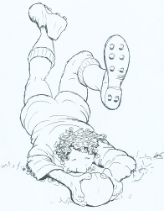**A Pile of Guys on the Grass**

**The Championship is on the Agenda**

This coming Saturday, the rugby league for the 2022-23 season will be decided in a match for the championship on the Yizrael field

As usual and as expected, Yizrael will host ASA Tel Aviv for another final that will decide who will win the championship. Yizrael, the champion of the last three years, will want to make history and win a fourth championship in a row. On the other hand, the Tel Aviv players will aim to return the championship trophy to the centre of the country and spoil the celebrations of the northerners.

The champion players have a big advantage from the first final game (the final is a series of 2 games) that took place at Sportek last Saturday and in which the Yizrael /Gilboa players won 44-21, and gave themselves a 23 point advantage before the decisive game.

The first final game was close for 55 minutes, both teams made 3 free kicks and the result was 22-21 for Yizrael (free kicks by - Tabiso, Abutbul and McMillan). The players fought for every ball and gave everything in defense and attack. But apparently the fitness or the desire of the Jezreel players was greater and in the last 20 minutes of the game, coach Nimrod Kaplan's apprentices managed to take control of the game and place 4 more tries (Yuri, Fabi, Devon Muller, and Adrian Rinstein) and win big, in a difficult away game. The outstanding player of the game was undoubtedly Uri Abutbul who led the team, kicked an excellent goal and dominated the game.

And now - for the deciding game of the season, as mentioned - this coming Saturday, March 18 at 13:00 the final game will begin on Yizrael’s home field

Everyone is invited to encourage and push the team to the championship and history!

Before the final game, from 09:30 to 12:30, there will be children's games for ages 8-10-12 with the participation of the "Hadar" and "Mrar" clubs, as well as teams from "Ramat Tzvi", "Hazorea", "Achuzat Barak" and of course - Yizrael!

You are invited to watch the future generation of Israeli rugby

Of course, throughout the event, drinks, food (hamburgers, hot dogs, meat from the smokehouse). Rugby equipment and more will be sold on the field.

See you on the field - Amir and the Boykies

**Google translate is not that great**

כמובן שלאורך האירוע ימכרו במגרש שתיה, אוכל (המבורגרים, נקניקיות**, בשר מפורק מהמעשנה)**, וציוד ראגבי ועוד.

Of course, throughout the event, drinks, food (hamburgers, hot dogs, **decomposing meat** **from the smokehouse**), will be on sale



**Cheep Cheep Cheap**

**At: “It’s Worthwhile taking a Peek”**

Spring has burst upon us with a storm - the blossoms are so beautiful and smell intoxicating.

The butterflies fly around us as if to say - cheers to everyone! And go enjoy nature’s gift.

And in the second-hand store - summer clothes have taken the place of the winter ones.

The store was emptied of its contents - thanks to everyone who enjoyed visiting, making purchases, or just drinking coffee in good company.

I would be very happy to fill the store with everything possible - footwear, clothing, ornaments, furniture, jewelry, and everything you want to let go of.

Thank you in anticipation!

Have a blooming and happy spring

Ofra Shapira – It’s worth taking a peek

**For Seniors**

**A One Man Play**

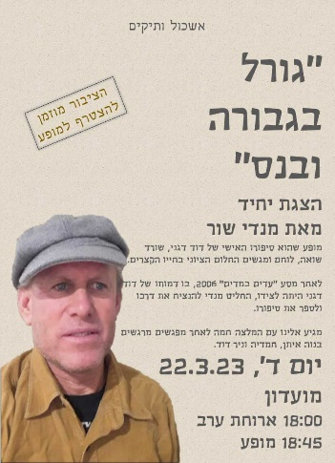**Fate Heroism and Miracle**

A play by Mandy Shur

**The story of a Holocaust survivor**

Wednesday 23.3.23

18:00 in the Moadon

The play will begin at 18:45

**Family trip Saturday 25.3.2023 – To Nahal Yitzpor**



We will leave at 08:00

We'll have breakfast on the Gilboa near the Gilboa Iris trail and maybe we'll get to see some irises.

Then we will trek down Nahal Yitzpor, a beautiful and somewhat challenging route, but suitable for all lovers of hiking.

Estimated return 13:30

It will be fun!

Register today on Kehilanet.

(Good preparation for the Yizrael March the following week – Ed)

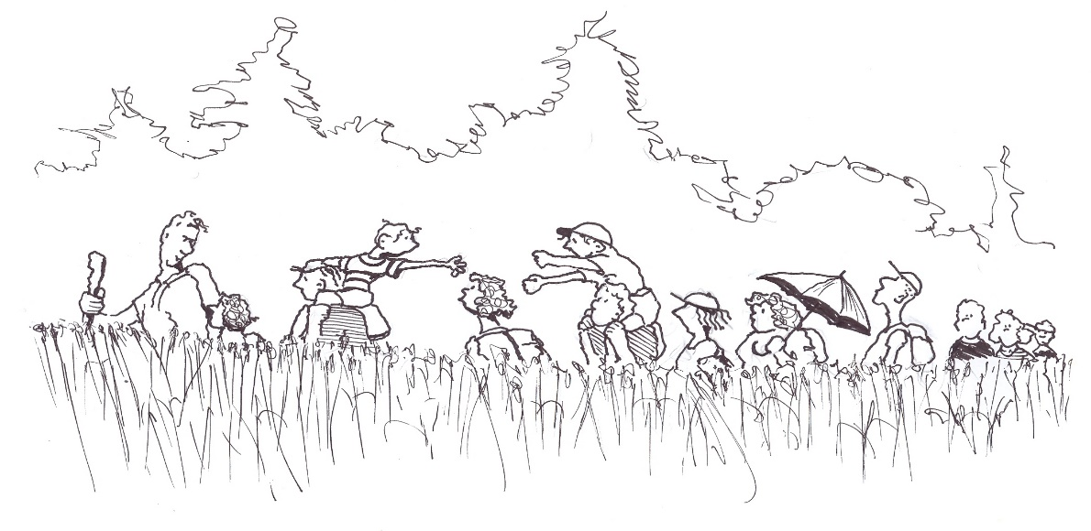



**The 8th Jezreel March**

**Saturday 1/4/2023**

New route! Full of blossoms and new viewing points

Activities and refreshment points will be scattered along the entire route.

The length of the short route: 5.5 km

The length of the long route: 9 km

There will be transportation for those who have difficulty walking.

invite: Please

friends, co-workers and employees from all our work branches

Get ready!!

**English is Fun - with Rahel**

The World According to Student Bloopers: continued

Delegates from the original 13 states formed the Contented Congress. Thomas Jefferson, a Virgin, and Benjamin Franklin were two singers of the Declaration of Independence. Franklin had gone to Boston carrying all his clothes in his pocket and a loaf of bread under each arm. He invented electricity by rubbing two cats backwards and declared, “A horse divided against itself cannot stand.” Franklin died in 1790 and is still dead.

George Washington married Martha Curtis and in due time became the Father of Our Country. His farewell address was Mount Vernon.

Soon the Constitution of the United States was adopted to secure domestic hostility. Under the Constitution the people enjoyed the right to bare arms.

Abraham Lincoln became America’s greatest Precedent. Lincoln’s mother died in infancy, and he was born in a log cabin which he built with his own hands. When Lincoln was president, he wore only a tall silk hat. He said, “In onion there is strength.”

Abraham Lincoln wrote the Gettysburg Address while traveling from Washington to Gettysburg on the back of an envelope. He also freed the slaves by signing the Emasculation Proclamation.

On the night of April 14th, 1865, Lincoln went to the theatre and got shot in his seat by one of the actors in a moving picture show. The believed assinator was John Wilkes Booth, a supposingly insane actor. This ruined Booth’s career.

Meanwhile in Europe, the enlightenment was a reasonable time. Voltaire invented electricity and also wrote a book called *Candy.* Gravity was invented by Isaac Walton. It is chiefly noticeable in the autumn, when the apples are falling off the trees.

Johann Bach wrote a great many musical compositions and had a large number of children. In between, he practiced on an old spinster which he kept up in his attic. Bach died from 1750 to the present. Bach was the most famous composer in the world, and so was Handel. Handel was half German, half Italian and half English. He was very large.

Beethoven wrote music even though he was deaf. He was so deaf he wrote loud music. He took long walks in the forest even when everyone was calling for him. Beethoven expired in 1827 and later died for this.

***……………...more next week***

***concluding this fascinating “History of the World” by Student*** ***Bloopers***