**The Yizraelite - No 2093 Date: 17.2.2023**

**Kibbutz Yizrael**

Translated and edited by Eddie Solow

**Edi-torial**

**Printed on the Shirt at the protest at the Knesset:** We can be sure that the nations of the world will not be able to destroy the State of Israel

We are not sure that we Jews will not bring about our own destruction.

Rabbi Yehuda Amital

Mazel Tov to Ziv and Tomer Chaiyun – On the birth of their daughter - Dor

Granddaughter of Esther and Rafi Ben-Bassat.

Mazel Tov to the families.

Blessings - happiness, joy, laughter and play, humor, patience, health and lots and lots of love...

**Congratulations to Michal and Ishai Levi**, on the birth of their son - Matan

Brother to Hilly. Grandson of Margalit and Danny.

Congratulations to the entire Levy family, the Tzafadiya family and Michal's family.

We wish you - happiness, joy, laughter and play, humor, patience, health and lots and lots of love...



**Thanks to a caring and supportive community**

It's been a long time since I found myself lying under my kalnoit, with broken bones.

Sigal Kaplan, the young angel, found me, rescued me, sat me in a chair. In seconds everything swirling around...

I was lying in an ambulance on the way to the "Emek" hospital, where my family visited me, as well as Shlomo Cohen and Yoni Brauman. I had a fractured pelvis.

From there I went to rehabilitation in Shoham, in Pardes Chana

There my family visited me, Shlomo Cohen, Rinat Chikurel and many from the kibbutz who were interested in my welfare.

Aviva Boitler and Rinat took care of me, and prepared my home for my return to the kibbutz.

My dear children helped me in the various stages after the fall from the Kalnoit.

My dear neighbors welcomed me warmly. The clinic staff took care of everything.

To Jenny the therapist - thank you very much for your great help.

I am happy that I live in a caring, supportive and loving community, which cares for others

Thank you all! 💜 Ilana Shani

***Partnership House – Beit Shutfut***

* You can always book rooms a month in advance for the major holidays - Rosh Hashanah, Passover and Shavuot - registration will close one month before the holiday date.*

* On the closing date - I will assign the rooms. A member who has not received a room in the last three years will have priority over a member who has received a room in the last three years.*

* If there are no "new" reservations (according to the above category), the order of receiving the rooms will be according to the reservation date!*

*Booking rooms for Passover*

Until February 28, 2023 !!

To book rooms or cancel them - send: to WHATSAPP

Rachel Pikarski

**Invitation to a tour of Teldor**

As part of our business partnership with Teldor,

We will go on a factory tour at the Kibbutz Ein Dor site

On Monday, 27/3/23, at 3:45 p.m

Registration will be posted on the bulletin board

You are welcome to register!

Ron Cohen and Kinneret Govrin

**Never doubt that a small group of caring citizens can change the world**

**This is the only thing that has ever brought about change" / Margaret Mead (cultural anthropologist)**

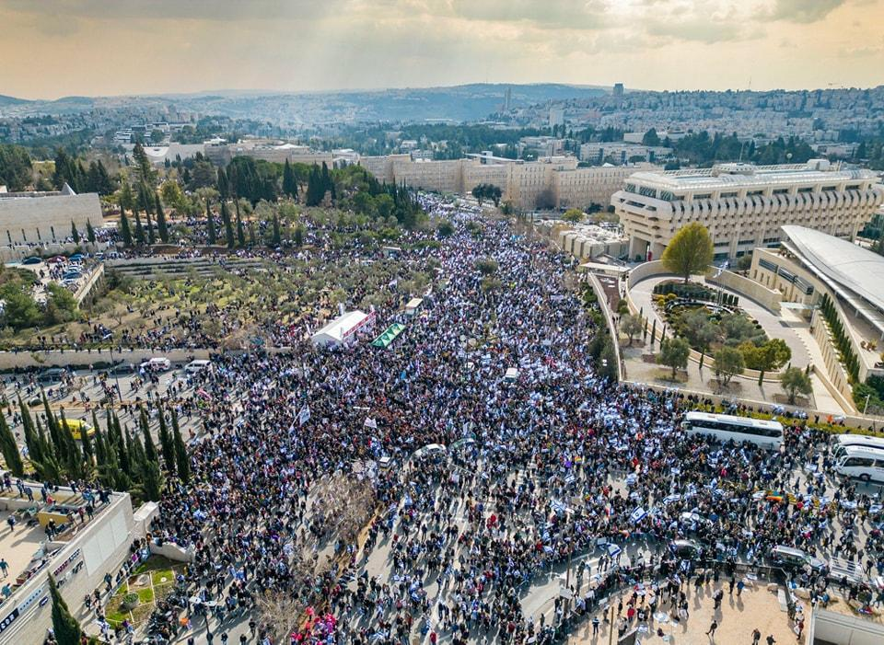



**Printed on the Shirt:** We can be sure that the nations of the world will not be able to destroy the State of Israel

We are not sure that we Jews will not bring about our own destruction.

Rabbi Yehuda Amital

**Ballot Results**

**Congratulations to Neta Blass** on her election as coordinator of the Special Needs Committee.

**In the vote on the subject of attached vehicles**, the decision was made **against** the proposed procedure.

Votes: Against- 128 / In favor - 107 / Abstained - 5.

240 members participated in the vote, which is 80% of those with the right to vote.

**As a result of this vote, the “Status Quo” from 2010 remains in place.**

**Below is the procedure from 2010 (presented verbatim)**

The proposal in its entirety, as received in the voting at the ballot box on the subject: "Car attached to work"

(1) Outside workers who have an attached car for work - will not receive the mobility component of NIS 350 per month* in their budget

(2) Members who have a vehicle of the kibbutz and its corporations** will have a global amount of 700 NIS deducted from their budget every month, which includes: 350 NIS from section 1 + 350 NIS for the partial cost of the time of use during the evening and night hours.

(3) The head of Yizrael Holdings and the NCO will ensure the installation of sensors in all other corporate cars, as well as the upholding of vehicle regulations in agriculture and entrepreneurship. Members who deviate from the established procedures - the rules stated in section 2 will apply to them.

(4) Any amount that will be deducted from the member's budget for a 'car attached to work', will be used for the benefit of improving the vehicle fleet and travel costs for all the members.

_______________________

(*) The mobility component includes the cost of the kilometer + the cost of time.

(**) Members who have a community owned vehicle, vehicles for agriculture, entrepreneurship and small enterprises, as well as outside workers, who use the kibbutz vehicle and who do not leave the vehicle in the parking lot (and/or do not allow the use of the vehicle for the other members).

Yitzhak Peleg – (then) Mazkir.

**(And in everyday English**… Members who work for outside companies will be charged 350 shekels per month. Members who have a car owned by the kibbutz or its corporations will be charged 700 shekels per month. The rest is 1984 Orwellian Newspeak – Ed)



Illustration by **Chaz Broadhurst**

Inspired by Tal Freiman Levy's article

“Saving the donkeys of the Land of Israel”

The sign says: “A vehicle for every worker”

(The man is a genius – Ed)



**Important Update from Community Manager and the Food Branch**

We are updating that after the Ministry of Health ordered the closure of the Pasteurizing Room, due to the lack of a manufacturer's license, and in light of Rabab's resignation after many years of work, as well as in light of the examination of the costs of re-establishing the pasteurization “plant”, **the branch cannot return to operating in its old form.**

The feasibility will be examined in the future, and a separate decision will be made on this.

The building will be renovated and adapted to its new purpose as an extension of the kitchen, and will become a meat preparation area where a variety of meats, poultry and fish will be handled.

We want to thank **Rabab** and all the members who worked there over the years, to supply delicious and high-quality cheeses and dairy products!

Best wishes,

Erez Peleg, community manager / Itzik Schechter, food branch manager



"**Update in the organizational structure"**

Henceforth, the Housing Committee will be part of the Demographic Growth Cluster - Absorption and Young People (Tzemed)

Yifat Assaf, secretary

**Updates from Tzemed cluster**

A) Update in the organizational structure - as part of the changes that were made, the Housing Committee joined into the Tzmed Cluster. This change was made in light of the understanding that the issue of housing has a decisive effect on the absorption of young people and that these areas are related to each other. Also, the union of the three committees under one cluster will strengthen the ties between the committees and improve the decision-making process regarding housing allocation in the kibbutz. As part of the change, Aviva Beutler, coordinator of the housing committee, joined the cluster council.

B) During the month of January, a meeting of the cluster council was held in which we discussed the issue of the 'salaried' track for the younger generation instead of the “grant” track ((מסלול מענק. This route was already approved by the community management a few months ago, but the cluster council asked to reconsider.

In a meeting, the advantages and disadvantages of the new route were examined. The decision that was made, is to apply the salaried track in the agricultural sectors, as it has already been operating successfully for over a year at Maytronics. Regarding the branches of the community, the matter is currently under review and at this stage the “grant” system will remain in place.

The committee went over the work plan for 2022 and marked the execution status of all the planned tasks. Some of the tasks were indeed carried out, some are in the stages of execution and monitoring and some were not carried out and were postponed for this year. In light of this, we wrote the work plan for 2023.

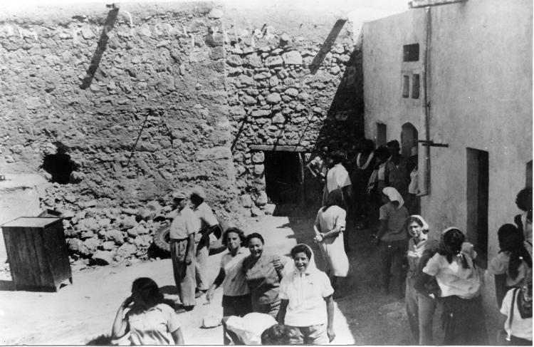

*Members of “Garin Ramat Yochanan” outside their rooms in “Zarin”*

**From Erez's Desk**

**1.** **Prologue** on the subject of the 2023 budget. We are busy summarizing and assessing the performance of last year and approving the budget for the coming year. The community budget was prepared towards the middle of January, but has not yet been approved in all its aspects. However, at this stage, it is important for me to note that the 2023 budget is particularly challenging. This is in the light of the implications of inflation and a significant increase in the price of the services provided by the kibbutz, on the one hand, and on the other hand only a small increase in the community's income. The result is a very tight budget with almost zero freedom of action.

**2**. **Status of projects**

Main roads - this project is almost complete; we are still suffering from the rate of supply of the interlocking stones. We believe that they will arrive by the end of the month, so that we can complete the construction of the sidewalks. During the last week, landscaping works were carried out in the area of the gate and the southern industrial road. The gardening works in this area will be completed after the paving works are finished and the fence will be moved beyond the guardroom.

**3**. **The Cottages** - Work on the houses is in the final stages, and in the coming weeks the work will commence on developing the landscape.

**4. Renovation of Nof - stage 4** - the renovation works are being carried out in full swing and as of now the estimated completion date is July 2023.

**5. Northern neighborhood** - I am happy to report that the building permit for the construction of the neighborhood's infrastructure was received, and the tripartite contract was signed between the kibbutz and the regional council and the council's economic company, which will carry out the project, as a condition for receiving the participation in financing from the Ministry of Housing and Construction.

**6. Youth housing** - the most problematic stage of the building permit – (the approval of the Home Front Command), is behind us and we are moving as fast as possible on obtaining the building permit.

**7. Building of parents' housing** - the construction permit is in the process, and as in the case of the building in the youth housing, the planner is preparing detailed plans for implementation, so that we can approve the budget for the implementation and go out to tender for contractors.

**8. Renewal of the vehicle fleet** - following the approval of the investment budget in the car branch, we bought 4 small cars. These cars will replace 4 old Picantos and we expect to see them in about a month. In addition, we are in the process of closing a deal to purchase another vehicle with 8 seats. We are purchasing a 2019 model vehicle, in good condition. Hopefully we can close the deal within a week.

**9. Maintaining the vehicles**. It is very important for us to create a fleet of new, economical and safe vehicles that are pleasant to drive. This requires effort and money. At the same time, we often see carelessness that causes damage to the vehicles.

When opening the car doors – please be careful not to damage the doors of the adjacent car.

Please drive on appropriate roads and with the required caution.

Safety behavior - the vehicles are designed to allow us to get from place to place. Most of them are not intended for off-road driving or for demonstrating sporting abilities... Improper use is dangerous and impairs the vehicle's usability

**10. Pergola in a young generation housing** - the pergola near the "Rashim" in a young generation, was defined as a dangerous building. The pergola area is fenced off, in order to prevent entry into the area.

We are checking if the building can be restored. At the end of the process, a decision will be made whether to demolish the building or restore it.

**11. We got through "Barbara" safely** - as we witnessed in many places, one of the characteristics of the storm that happened last week is the falling of many trees and branches that endangered the passers-by and caused damage.

Happily, in the kibbutz, with the exception of one branch that fell at the eucalyptus junction, the rest of the trees remained intact. This is evidence of professional and correct maintenance work by the gardening team. Kudos to them for that.

**12. The closing of the Pasteurization plant**– See the update on the closing of the pasteurization plant - see a separate news item above

**13. Stickers on parked cars** - I ask the members who stick: "No parking here" stickers - on illegally parked cars in the kibbutz, in future not to take the law into their own hands.

If you see a car parked in a place that was not intended for that - contact the owner of the car and talk to him (if it is not convenient to talk, you can write...). If after several requests this continues - contact me. Kindly make the distinction between short-term parking for the purpose of unloading/loading equipment and long-term parking.

And … car owners - please make sure to park in the places designated for this. Parking is now plentiful throughout the kibbutz. Even if it means walking a few steps - it only adds to your health. Thank you in anticipation, and let's keep the conversation pleasant, at least in our little Heaven on Earth.

That’s all for now. Erez.

(That’s plenty for now – Ed)

**Report from the Asefa - 8.2.2023**

(Abridged and abbreviated – and still too long - - Ed)

Chairman of the Assembly - Shlomo Cohen / Secretary of the Assembly - Eddie Solow / 42 members present

**On the agenda:**

1. Renovation project of the secretariat building

2. The kitchen and Kolbo renovation project

At the opening of the meeting, Erez explained that the two projects are urgent. He also emphasized that although cost estimates are mentioned, today we are asking for public approval to move forward with the planning of the projects, and that the final approval for the implementation will be received by the Economic Council after the approval of the financing model for both projects.

**(1) Renovation project of the secretariat building** (invited Yoav Kikos - Architects Workshop)

Ron and the planner presented the renovation project of the secretariat building; The need to restore the structure and the functional and historical considerations underlying the program given to the planner.

**Ron** presented examples of similar projects carried out in Kfar Yehoshua and Mishmar Ha'Emek, in which historical buildings were transformed into a functional ones, enabling the proper functioning of the settlement's institutions, while maintaining elements of the original building and its functions in the past. Ron explained that in the last year there has been a significant deterioration in the structural condition of the building, to the point of the immediate evacuation of part of the building and the controlled dismantling of parts of it, in order to stop the deterioration of its condition. As it stands it is an eye-sore and an embarrassment. An extensive renovation of the building is necessary. Ron explained that it is very important to bring the offices of the kibbutz administration into one building thus improving functional efficiency.

The architect Yoav Kissos presented the initial architectural plan.

**The financial estimate for the project is 5.5 million NIS**.

**Nitzan R. Feldman** - Does the plan eliminate the movement room.

**Erez replied** - a solution will be found for it in another location.

**Peter Pizarro** - Rumor has it that we are supposed to get the sports hall back from Maytronics. Has the possibility of using it been considered since it is a building large enough to accommodate both the secretariat and the accounting dept?

**Ron Cohen replied** - this is an real option. At the same time, the current secretariat building will in any case need renovation

**Tal Darom** - it was said that there would be glass walls, but we would not want to sit in a conversation with the secretary with a transparent wall.

**Erez Peleg replied** - it will be planned with these things in mind. Of course, you can close it with a curtain, etc.

**Peter** - I am afraid of the budgetary issue. In a large and complex project like this one needs a large (unpredictable) budget. What is the cost of planning?

**Erez** - You can add the unforeseen costs. With a more detailed plan, the more the accurate the costs will be.

**Ron** - The cost of planning is about 5% of the cost of the project.

**Jeremy Perling** - There are many functions in the kibbutz that were not taken into account regarding the need for meeting rooms. Maybe you should make a list. For example: a reserve fund archive that needs to be kept for 15 years, etc.

**Yifat Assaf** - the temporary secretariat is inadequate. The secretariat building is designed both to provide service to the members of the kibbutz, and is our showcase for those coming from outside. Yizrael deserves a proper showcase.

**2. Renovation project of the kitchen and Kolbo building (invited: Ilan - 'Nachshon Kitchens')**

**Yifat** related the steps taken so far. When Maytronics retracted on the “food Court” idea, we returned to the original renovation plans.

**Background** - the dining hall building was built in 1981 - and has not undergone a significant renovation since then! The building houses the two largest service bodies in the kibbutz - the food branch and the KOLBO, as well as the post office and a member's clubroom.

The Kolbo is currently crowded and inconvenient to use and has structural problems, such as, frequent leaks from above.

**Kitchen** The kitchen today is 335 square meters. It is too small for the amount of food prepared, 800 - 1400 dishes for lunches. The future planning takes into account: the needs of the community as well as the needs of the factories growing inside the kibbutz; Standard requirements and approvals; Correct flow of the food from raw to prepared; Division into separated work sections; Complete separation between storage of raw food and prepared food.

The kitchen is not connected to a fat separator and the fatty waste goes to the sewer, polluting the environment >> The kibbutz pays fines, Unnecessary maintenance expenses. The kitchen equipment is outdated and wasteful.

Replacing the dishwashing system will save between 80 and 150 thousand NIS per year. Buying a new system will pay for itself within two to three years.

**The dining room** (Stage 2 of the project**)** - new interior design of the dining hall (replacement of furniture, ceiling, air conditioning, floor, windows, toilets), pergola in the front - outdoor seating, lobby - toilets, guest room, club entrance for members, parking for scooters (in the care of the planning committee)

**Cooking kitchen** - general renovation

**Execution of the project** - in any case, we will continue to provide the catering and shop services during the entire renovation period! There are several options: continuing to use half of the existing kitchen and renovating the kitchen in two stages / setting up a temporary kitchen in part of the dining room area (the part closest to the dishwashing room), renovating and expanding the rear part of the kitchen. In the second phase, the serving area and the front part of the kitchen will be renovated / a tent can be erected in the front square next to the kitchen - as a temporary kitchen.

We will also consider the full implementation of the entire project all at once/ general closing of the kitchen and receiving food from an external catering company.

**Kolbo:** temporary transfer to another place in the kibbutz/ its temporary transfer to the lobby next to the club or to the club itself/ supply of necessary basic products only. The alternatives will be examined in the detailed planning process and will be presented later.

**The financial estimate for the project: the renovation of the Kolbo and the kitchen, including the renewal of the cooking equipment - approximately 12.5 million NIS**

**Renovation of the dining room an additional NIS 3.7 million +/-**

**In Conclusion:** A project manager will be appointed, who will appoint a team of planners/consultants, who will prepare a contractor file for execution and build an accurate budget for the project; He will plan the phases of the project's implementation, will choose together with the kitchen team how to proceed during the renovation period while examining the budget of the various options, will prepare a multi-phase schedule for the implementation of the project, will manage a tender for the selection of an implementation contractor for the project, will closely manage and supervise the implementation until the completion of the project.

**Discussion**

**Vicky** - asked about the topic of a strong room and the accessibility of the current strong-room in the program. Also asked about plans for an elevator between floors and flexibility of the floor space for the holidays.

**Erez** replied - he intentionally did not include a strongroom and building permits, because this way it is an interior renovation, which does not require them. A renovation that includes building permits will take much longer and be much more expensive. He will check out the Elevator idea.

**Barry Feldman:** Wouldn’t it be cheaper and simpler to build a new building?

**Erez -** in the detailed planning we will refer to all these things.

**Eddie Solow** - every holiday and Friday night there is crowding in the dishwasher room. This also needs to be addressed. (Well said!, Ed)

**Phil Adler** - Must / Need / Want? I think the Kolbo and the dining room are musts. The secretariat is more in the direction of wants. You can also stay in the old clinic building, in the meantime, and maybe use the sports hall. At the moment this is an over ambitious project. I think a financial program is needed. Then Northern housing project is also ahead of us. I don't want to vote without financial information. The intention is to build the dining room next year and I don't know how we will pay for it.

**Erez** - We won’t undertake any project without knowing how to finance it. The whole matter will come the Economic Council.

**A vote was held on both projects:**

T**he renovation of the Kolbo and the kitchen** - approval in principle for the project, final approval will be given by the Economic Council

**For: 96 / Against: 14 / Abstained: 2**

**Renovation of the secretariat building** - approval in principle for the project, final approval will be given by the Economic Council

**For: 73 / Against: 37 / Abstained: 2**

It was decided: to approve both projects in principle. Final approval will be given by the Economic Council.

Concluded: Shlomo Cohen

**Call to elect public representatives to the executive committee**

As published in the previous bulletin, the election of the public representatives to the executive committee will be carried out "as before" only this time through the Kehilanet. We must elect four members, for a two-year term.

The vote will take place from next Sunday, 19/2/23 - at 8:00 / until Monday, 20/2/23 - at 1:00 PM

The vote is called a 'survey' for technical reasons.

Each member will be asked to mark four names of kibbutz members who, in his opinion, are suitable as public representatives on the executive committee. The four members who receive the most votes will sit on the executive committee (on condition they agree).

As you will see in the vote - there is a list of members who may not be elected, because they hold positions or are the spouses of office holders, and are not eligible (members of the committee and their spouses, members of the audit committee and their spouses, members of the community management, the board of Yizrael Holdings and the management of the reserve fund ).

**Reminder:** the management committee is the body that deals with the kibbutz strategy and issues related to the kibbutz regulations (and does not deal with the day-to-day management).

For your convenience, a file containing the names of all the members of the kibbutz will be attached to the vote.

For questions and clarifications - you can contact Tzela Baran Shkolnik, Kinneret Govrin (H.R.) or Yifat Assaf

**Meeting no. 2 "Dror" group**

Preparation program for an easy transition to the younger generation.

Last Sunday we met with 12 boys and girls, in the second meeting in the program "Easy transition for a younger generation" The series continues.

**First aid refresher course for the Emergency Response Teams**

on Thursday 23.2.23 and Wednesday 1.3.23

between 18:00 and 20:30

In the Moadon

Invited from the 11th grade

Intended for those with a first aid background - we will be happy if you come - it's always good to practice!!

Please send me a message if you intent coming

Lilach Ron: 052-3756125



**Emergency Response Committee**

Last Thursday, a meeting was held to prepare for an earthquake event.

Various issues relating to preparedness were discussed.

Following this, Avichai and I met with the education directors and planned the upcoming steps to prepare educators and children

We also met with the veterans at "Beacon ion the Hill" - Feel free to contact us if you feel the need to refine the instructions.

An amazing presentation prepared by Avichai will be shown on channel 900.

Soon, we will distribute to every house on the kibbutz a magnet with important emergency phone numbers and... a whistle.

Lilach Ron.

(And a piece of Kabanos or Polony. If you want an explanation, ask me personally. That way I will know you are actually reading The Yizraelite – Ed).

**The management committee of Outside workers**

**Meeting summary -** February 12, 2023

Participants: Rafi Baum, Erez Peleg, Kinneret Govrin, Shlomo Cohen, Dima Chernichovsky, Maor Persai, Peter Pizarro

Observer: Inbal Pizarro

Invited: Yifat Assaf

Peter reported on the departure of Damian Chicorel from the committee due to the termination of his work as an outside worker. Nicole Emerick also finished her position on the committee in light of her joining the audit committee.

The members of the committee thank Damian Chicurel and Nicole Emerick - for their contribution.

Also, the committee welcomes Kinneret Govrin on her assumption of the position of H.R.

**agenda**:

2) **Review of job percentages in 2022** - Peter presented a new table showing job percentages.

Notes to the table

The "job percentage" should be an average job percentage over all 12 months of 2022.

Kinneret and Peter will meet with outside workers who do not comply with the decisions of the assembly in the work procedure, to find out more details.

It was pointed out again that the application of the procedure in all its aspects (including sanctions) must be concurrent with the application of the same mechanisms for all members of the kibbutz, and not only for outside workers.

Yifat indicated that such a comprehensive move should come to the community's management, before its execution.

The committee congratulates all outside workers for their achievements at work and considers it an extraordinary achievement that there are five members of a kibbutz who earn over 28,000 NIS a month, while the average income of those five is 35,530 NIS!! Well done!

4) Personal insurance through the work – Inbal presented a table of the personal insurances of some of the outside workers which are paid through the pay slip. The issue will be reviewed with the relevant parties (Kobi - special health insurances, Jeremy and the insurance people: life, disability and loss of employment insurances) in order to avoid double insurance.

5) Regulating the transfer of pay slips before reimbursement of expenses to the employee

Failure to transfer slips on time makes it very difficult for the system to operate. It has been recorded that there are situations of delay in receiving the slip from the employer (compared to the money that goes by law by the 9th of the following month), therefore it was decided that anyone who does not hand over the slip by the end of the following month, will not be entitled to reimbursement of expenses (Eshel, km, etc.) . Example: for February's work, the salary is received by March 9. When the February slip is not transferred by the end of April, expenses will not be refunded. (Sometimes you have to be cruel to be kind – Ed)

6) Individual request for reimbursement for an exceptional clause - the clause was discussed and it was decided to adhere to the existing procedure. (And not make an exception – Ed) Peter will convey the decision to the applicant and the relevant parties.

Concluded: Peter

**New English Books in the Library**

Elizabeth Finch - Julian Barnes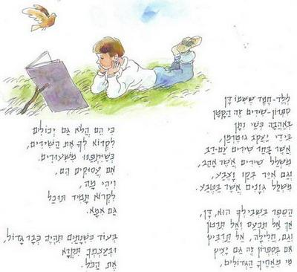

When We Meet Again - Kristin Harmel

A Spark of Light - Jodi Picoult

**childrens’ Books**

Little Miss Chatterbox - Roger Hargreaves

Mr. Clever - Roger Hargreaves

**"Bernie's Cosmos"**

**Art Exhibition – Bernie Fink**



**The Afula Municipal Art Gallery presents**

**Opening: 22.2.2023**

**at 19:00**

**Sunday to Thursday: 10:00 - 15:00 by appointment**

**Sunday + afternoon: 17:00 - 20:00**

**Friday: 10:00 – 13:00**

**Hativa 15 St. / Tel: 05-6595797**

**A journey in the wake of the trees on Yizrael**

Family activity in honor of Tu B’shvet and in honor of the 75th year of the kibbutz.

**On Saturday, February 18, 2023 -** we will joyfully go on a fun activity around the kibbutz

**We will start at 11.00** - in the area of the new plantings near the Arieli family home: there we will all gather for the planting of the 75th Avenue.

At the end of the planting, we will go for a short tour among special trees planted in the kibbutz.

Everyone welcome

Tu B’shvet team: Hamutal, Ella, Limor and Chanan,

**Beit Hamusika Presents**

**Bo Shir Ivri**

**Save the Date**

**25.2.23**

**This year**

**The Songs of Arik Einstein**

**Enlist on the Notice Board**

**Almond Blossom Festival**



**Shabbat 25.2.23**

**Creativity Corner**

**Navigation Run**

**Hay Ride**

**Pita Oven**

**Soup**

**Coffee Corner**

**…and more**

**Google Translate is not so great.**

**(Believe me, It’s not! – Ed)**

. כיום הוא עומד, בחלון הראווה של הקיבוץ, עזוב וחרב.

Today it stands, in the shop window of the kibbutz, abandoned and with a sword.

*********

פרויקט שיפוץ מבנה המטבח והכלבו

Renovation project of the kitchen and **kennel building**

**\*\*\*\*\*\*\*\*\***

המבנה מאכלס את שני גופי השירות הגדולים בקיבוץ – ענף המזון והכלבו

The building houses the two largest service bodies in the kibbutz - the food branch **and the dog shop.**

|  |  |  |  |  |
| --- | --- | --- | --- | --- |
| |  | | --- | |  | |  |  |  |
|  | | |

I can’t understand what they said on  
TV all about Armageddon;  
That bloke from Teheran  
looks a really nice man  
and...ooh, look! A tall cloud with a head on!

**Chazz Broadhurst**

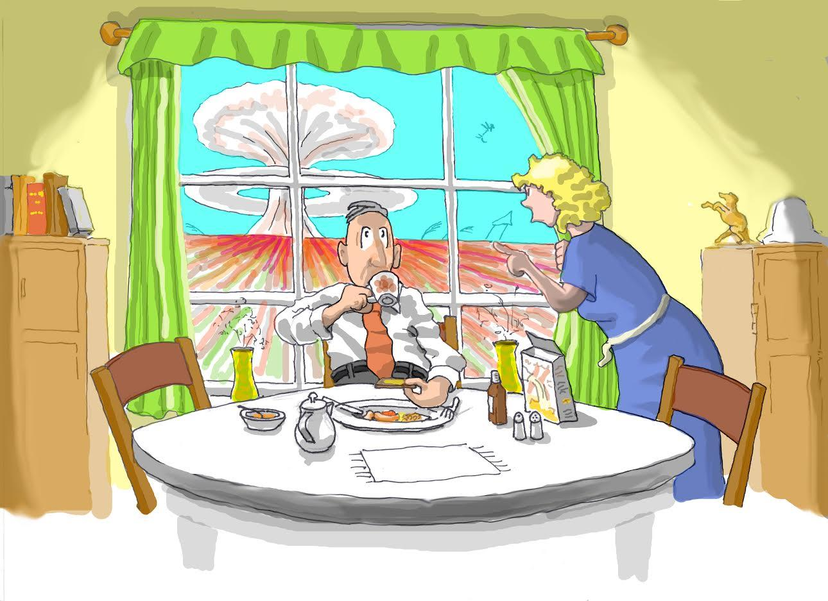

**English is Fun - with Rahel**

In biblical Genesis, we read that God said “Let us make man in our image, after our likeness” and “And out of the ground the Lord God formed every beast of the field, and every fowl of the air; and brought them unto Adam to see what he would call them; and whatsoever Adam called every living creature. And Adam gave names to all cattle, and to the fowl of the air and to every beast of the field.”

The human desire and power to name everything is nowhere better demonstrated than in our ability to label our deepest fears – our phobias. Studies show that the average person possesses three phobias. Count your blessings that you are not the victim of *pantophobia -* the morbid dread of everything.

Humankind is beset with a host of fears and ha managed to name practically every one of them. The two most common human phobias are *acrophobia,* a morbid fear of heights, and *claustrophobia*, a morbid fear of enclosed spaces.

From time immemorial, some of the organisms have inspired fear and even terror in the human breast. Each of these dreads has a label: fear of animals is called *zoophobia,* or birds *ornithophobia,* of fish *ichthyophobia,* of reptiles *herpetophobia,* and of insects *entophobia.*

If you despise eating spinach or broccoli, you are a *lachanophbe.*

For some of us, it is other people who inspire in our hearts the greatest palpitations – *anthropophobia*. If you fear men you are afflicted with *androphobia,* if you fear *women gynephobia.*  If it is your relatives who won’t get off your nerves, you have *syngenescophobia.*

If you are possessed by an irrational aversion to politicians, you have politicophobia, if to thieves, *kleptiphobi*a, if to foreigners, *xenophobia.*

And if you break out into a cold sweat at even the thought of going to the dentist, you have a condition called *dentophobi*a.

Incredible as it may seem, there is even a label for the fear of getting peanut butter stuck to the roof of the mouth. It is called

***arachibutyropobia.***

Enough people fear the number thirteen that many buildings pretend not to have a thirteenth floor. Still, this affliction is assigned a name – *triskaidekaphobia*.

Fear of: *aichurophobua - being touched by pointed objects*

* *alychiphobia - failure*
* *anuptaphobia - staying single*
* *demons and goblins* - *bogyphobia*
* *gamophoba - marriage*
* *lyssiophobia - becoming mad*
* *malieusiophobia - childbirth*
* *phobiphobia - being afraid*
* *coitophobia - sexual intercourse*
* *gephyrophobia - crossing bridges*
* *deipnophobia - dining and dining conversation*
* *chromophobia - colours*
* *catophtrophobia - mirrors*
* *kopophobia - mental or physical examination*

………….more next week