

**The Yizraelite - No 2098 Date: 21.4.2023**

**Kibbutz Yizrael**

Translated and edited by Eddie Solow

**Edi-torial** Dear readers, last week, for some reason beyond my comprehension, there was a reversal of word order in the printed edition. I apologise. It has something to do with the “Format” (I haven’t a clue what that is. We do our best and the computer does the rest - Ed). The version in kehilanet and in the email is the correct one.

I wish you all the best for the upcoming holidays. Let’s hope they pass uneventfully. Most important: THE POOL OPENS ON YOM HA’ATZMAUT!

We do not usually include birthday wishes in our editorial, but this is not an everyday event. **This is a special birthday for a special person. Shirley Markham turned 100 last week. Congratulations Shirley.** May you enjoy many years of reading The Yizraelite in good health!

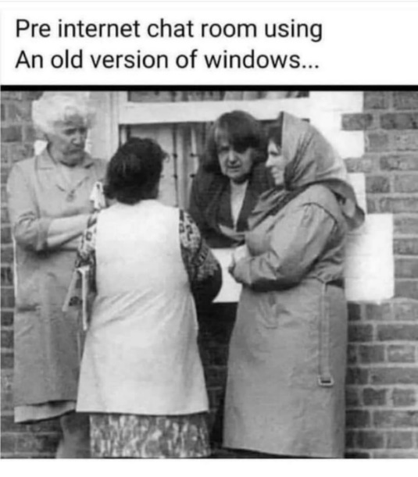Chag Sameach to all our readers!

**THANK YOU**

A week ago, we celebrated our mother / grandmother,

Shirley Markham’s – 100th birthday.

It was a very exciting and special event thanks to a number of lovely people who helped us make it happen.

Thanks to…

**Tami Penn** - for her help, patience, and readiness to answer our every request.

**Itzik Shechter, Adi Laviv, Eyal** and the kitchen team – for their consideration in the construction of the menu and for a wonderful meal.

**Idit Halevi** - for her help and her aesthetic touch in preparing the moadon.

**Momi Cohen** - for volunteering to photograph us and leave us with such a special memory

**Einan Grosser -** for all the technical help and support in preparation (and also in a last-minute mini crisis)

**Haim Nagar -** for the elegant cake and his attention to detail to produce the final product.

**Samdar Yisraeli-Agmon** – for her advice and help with the beautiful potplants, and for her flexibility.

**Shira Levy and Ori Shteiman** - for allowing us to enjoy the event by overseeing the food and drinks.

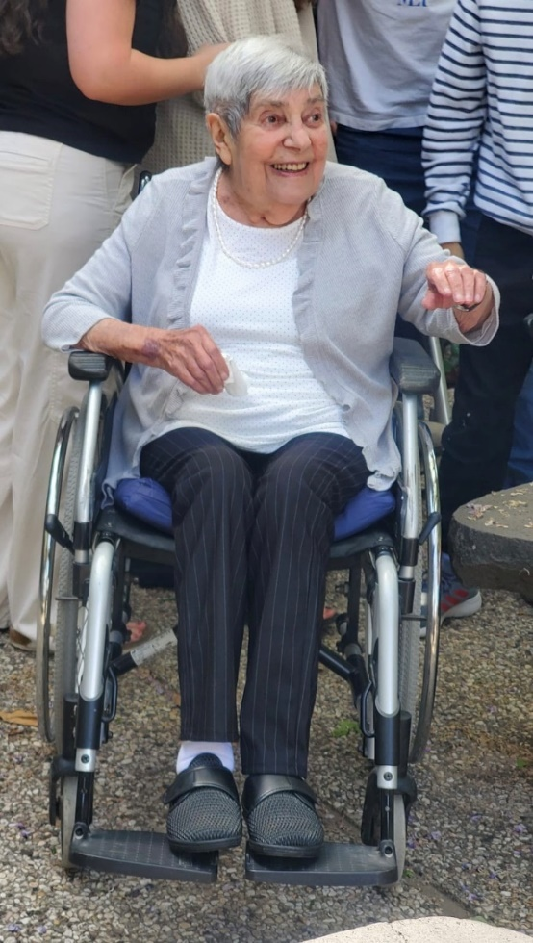Thank you so much.

The family together with mother / grandmother Shirley





**Community Management Meeting Summary 16.4.2023**

Present: Ilana Peleg, Erez Peleg, Yifat Segal, Kinneret Govrin, Limor Griman, Maor Persai, Kobi Levy, Shlomo Levy, Inbal Adler, Stas Gavrilov, Tamir Blass

Absent: Yifat Assaf, Yishai Levy

**1. Presentation of the building branch** **audit report**

(invited: Uri Greenberg, Guy Arad, audit committee - Reut Shaliv, Nicole Emerick)

**Uri Greenberg** - the internal auditor, presented the report summary which concluded that, in general, the building branch is conducted in a professional manner. The audit brought up various issues that need to be improved, based on costing data that was presented during the audit, but resulted from incorrect data that was corrected later. The audit report will be presented to the asefa after a review of the community management and following correction of the incorrect data.

**1. Adaptation of apartments for special needs** (invited: Aviva Beutler - Coordinator of the Housing Committee)

In general, the kibbutz has about 100 members and 20 residents over the age of 70, of which 55 are over the age of 80 (41 members, 14 residents). Another statistic: there are 33 people over the age of 80 without spouses (21 members and 12 residents). The number of people in the kibbutz who need the assistance of a caregiver is increasing, and more and more, there is need to bring nursing workers into the apartments, which are not always adapted for this and require renovating.

Points raised in the discussion:

The number of cases requiring close care already exceeds the number estimated at the end of 2023. Obviously, this also financially affects our health system and creates large unplanned expenses. Our policy is that each member will be allowed to grow old in his own home, and this is also the preference of most members. When it is not possible to have a caregiver living in the member's house, we are forced to use double the number of caregivers, and accordingly the cost is much higher.

In the past, some of the members objected to increasing their house to 110 square meters, or adapting the bathroom, and as the years passed, there was an urgent need to add a room, or make adjustments, to allow an additional room for a nursing assistant.

In order to enlarge the house, (to create an additional bedroom), a building permit is required and, in some cases, the construction of a reinforced security room, at very high costs, and contrary to the existing decision that we do not enter the old neighbourhoods with heavy earthmoving equipment for the purpose of construction.

In the past, in such cases the adults would move to the “Beit Seudi (nursing home) This was much more expensive.

As a general rule in Israel, people age at home and only about 3% are in nursing homes. The decision to close our local nursing home in the kibbutz was based on both this data and the preference of the kibbutz members to age in their own homes. - When looking at the solutions, it is necessary to distinguish between the houses of members and the houses of parents - residents

Several options were raised: The options of moving to a nursing home in the area, or a transfer to another apartment, which allows for an live-in caregiver, were ruled out in light of previous decisions and due to the housing shortage and a reluctance of the elderly couples to change.

An option of bringing a trailer on wheels was considered, to avoid a building permit, and to place it next to the house. The cost of a trailer is about NIS 85,000 even before connecting it to the infrastructure. Also, a trailer on wheels requires annual licensing. In addition, there is difficulty in connecting the trailer to the house, which does not allow supervision by the caregiver.

**Another option that was examined** - to build an adjoining room using lightweight construction, while connecting to the existing house, and under a temporary building permit, which requires the building to be dismantled after a fixed period. The cost of construction of this size is estimated at about 35,000 shekels.

It was noted that this would be less expensive than employing multiple caregivers.

There is a team that deals with the issue of aging/nursing/adapting the houses. The team prepares the issue for management discussion. Decisions concerning parents/residents will be incorporated into the residency procedure being prepared.

**Decision:**

For members - approval of an addition of a room, from light construction, with a temporary permit, which will be dismantled at the end of the period of need. The solution is only possible in urgent health cases and to the extent that the need cannot be solved within the framework of adjustments within the home. The solution that will be given will be according to the planning of the kibbutz only, without the possibility of family intervention.

In the case of parents or residents - The parent/resident will finance the required changes at his own expense and will sign an agreement accordingly.

Summation: Erez Peleg

**Agriculture - Summary of the year 2022**

The main points - this is the first year that the **Gadash (Field Crops)** 'returned home' under the leadership of Ohad Ziv. The team mainly consists of kibbutz members and the younger generation.

We focused on growing and selling crops in the fields. We no longer do the sorting here on the kibbutz.

The year was also good for **almonds**; We went from a loss to a profit following a significant cost reduction of the crop per acre - a plan that Adi Ratzin (the branch manager from Geva) has been promoting for 3 years. Higher yields than usual and good quality fruit.

**The olives** also brought a record amount of 43 tons of oil, at a high price, which brought good results.

In **all fruit and vegetable crops, grains and citrus fruits** - last year was characterised by high and unexpected volatility of fruit and vegetable prices and exchange rates. Price uncertainty - for example: watermelons harvested at the beginning of the season brought a low price, while we, who harvested in the middle of the season, received a relatively high price. Another example: in the almonds we signed a contract early with a guaranteed price and then the price went up significantly.

**Water** - we had good rains, differential pricing of water costs according to areas, a significant reduction in maintenance costs, ledby Ram Alster, which led to a significant decrease in expenses.

**Dairy** - on the one hand we produced 1.2 million litres more than the quota and the income increased accordingly, but on the other hand, we faced an increase in food and grain prices, etc. (NIS 1.9 million), foot and mouth disease, and we still ended up with a profit, thanks to Uri Horowitz and the amazing team. All in all, a great year, with a 3.5 million NIS profit.

**Agricultural debt** - at the urging of Ron Cohen and Shaul Gur, in-depth work was done on the capital structure of agriculture. In the end, the historical debt of agriculture was settled, so that the building of equity and the independence of the corporation would improve, enabling us to take loans and make investments, which should lead to better business results.

**Early summary and BI** - we finished the year's summary early, thanks to the push by the accounting department led by Maor Persai. The BI system gives us, the managers, access to information, and the ability to analyse information clearly and well.

**What next?? How do we progress??**

We are working according to the strategic plan that ended a year ago.

A) Strengthening the existing branches - dairy farming - continue to become more efficient and purchase the feed at good prices. We are currently dealing with a tuberculosis quarantine (currently only one cow was actually found to be sick. We hope that the quarantine will be lifted soon).

b) Consolidation of the dairy branch- we are examining the option of joining our dairy farm with another kibbutz. This is about doubling the quota: 8 million liters. We have checked the economic feasibility and are currently in negotiations with a potential partner. We will update you on the progress.

**c) Orchards** - we are continuing the optimisation plan for the almonds. Next year 2024, more olive trees will be planted, intensive cultivation for oil.

d) Diversification of the crop portfolio – we are checking the introduction of **carob cultivation**, as a complementary crop to almonds and olives. The carob consumes very little water (about 200 cubic meters per dunam), requires less spraying, and the picking is done by the shaker that we already own. We will update you on the progress.

e) **Field Crops** - we are looking at planting and growing in additional areas near the kibbutz, the expansion of activity with the existing marketers - the ones we are satisfied with, of course... in the following areas: carrots / beetroot / onions / spices / corn and more. Market-oriented crops - working with marketers who will provide an added value from marketing as well and not just from growing. Here too we looked at buying a share in a company that markets directly to the home and we decided not to move forward with it.

f) **Smart agriculture -** we checked several options: saffron, cannabis, in the past we also considered mushrooms, today we are focusing on a project of smart greenhouses that allow growth of crops throughout the year: high-quality / premium tomatoes of a uniform size, with the possibility of directing the large quantities to times when prices are higher - holidays and summer, in our country it is difficult to grow tomatoes and there is a big shortage in the market. On the one hand - growing is complex, so you need to check that the high costs of growing really justify the large investment, on the other hand - the price of tomatoes is high and has been rising for 7 years. We examined a number of such projects that exist in central Turkey. We are accompanied by a consultant who was previously the Ministry of Agriculture's national guide for growing strawberries and tomatoes in greenhouses. A serious and thorough person. We will update you on developments.

As with holdings and the community - we are preparing a model for financing, to see how the investments are made (if they are approved).

The year 2023 is still characterized by uncertainty and price volatility - with the opportunities and challenges this brings... In the end, we reached the average amount of water, but with a very complex distribution of rainfall. Very challenging!! And we hope to make correct and timely decisions, which will bring good results next year as well.

In this complex time of memorial and celebration, I want to thank everyone for being so nice, for the advice, the enlightenment and the comments and wish you all Chag Sameach!

Daniel Rosenfeld (Manager of Agriculture)

On this occasion, between Pesach, through Holocaust Day and the Day of Remembrance for the victims of the IDF and terrorism, and the complex Independence Day celebrations, of where we were 3,000 years ago and 80 years ago... about everything we've been through - the memory of the fallen from our best sons and our family and where we celebrate today, our independence. I want to thank everyone for the goodwill, the advice, the constructive comments and wish you Chag Sameach!

Daniel Rosenfeld

** Shirts for the 75th holiday**

After 25 years of not releasing shirts for Kibbutz Yizrael, the fashionable brand is back in a big way!!!

On the occasion of the 75th year, we can all show off the kibbutz shirt again (and look the same, as 25 years ago)

In the next few days, a registration will appear in Kehilanet, in which everyone can choose the shirt size they wish to receive (sizes 2 - XL5)

Please note that the registration will appear in Kehilanet as a survey that you must fill out. The shirts are intended for everyone who lives in the kibbutz (and the younger generation up to age 30 who live outside).

We will distribute the shirts in the second week of May and we would love you to come dressed in them, to the fun day "0-100" planned for 12/5/23.

Because that's how you create Yizraeli pride!!!

The Kibbutz Chag Hameshek team:

Dorit Fink, Hammutal Ben-Amati-Assaf, Tal Wolfson-Darom, Yifat Assaf, Shani Beor, Tamar Sankar

**Executive Committee Protocol - 4/4/2023**

Replacement of public representatives on the committee

**Present:** Jeremy Perling, Ron Cohen, Avner Alterlevi, Yifat Assaf

Outgoing public representatives present: David Mittelberg, Elad Ilan

New public representatives who were present: Sigal Hadar, Tzachi Tsfadiya, Adi Goldstein-Ilan, Natalie Zinenko

**(1) Congratulations** **to the new board members and thanks to the outgoing members** - Jeremy thanked the outgoing members, and noted: "It was a short, but very significant period that established the committee. Without teamwork, the dedication and the common goal, we could not have passed the transition stage to the new organisational structure from secretariat to management committee and community management. You will go down in history as “members of the first management committee in of kibbutz Yizrael."

**(2) Approval of the protocols from 14/2/2023 and 1/3/2023** - the protocols were approved.

**(3) Approval of local committee reports** - it was decided to approve the financial reports of the local committee 2022.

**(4) The management committee of the association, definition of role and responsibility** - Jeremy explained about the role of the management committee, as well as about the commitment and responsibilities associated with it.

**(5) Candidate's statement and confidentiality** **commitment** - the new members signed a confidentiality statement

**(6) Transferring areas of responsibility between the outgoing and incoming committee members** - we went through the list of issues that are currently on the board's agenda, and the status of each issue was updated and the baton was passed from the outgoing members to the incoming ones.

(a) **Examining the kibbutz statutes and updating them** - the team: Jeremy Perling, Eddie Solow, Tzach Sassi, Yitzhak Peleg - the draft is ready to go to the asefa.

**(b) The association's alternative** - the team: Ron Cohen, Shimon Zelas, Vicky Hollander – will be presented to the general meeting in May, to examine whether Yizrael wants to enter into a review process of the matter.

**(c) Pension Goals** - the team: Elad Ilan, Artzi Sankar, Ariel B.D., Yitzhak Peleg, Tzach Sassi - still at work. The team gathered ideas from the public as well as ideas from other cooperative kibbutzim. The next step: working with pension and actuarial professionals, who will come up with a proposal that will give the members a better pension guarantee than there is today, and without harming the reserve fund. Instead of Elad, the team will now be led by Sigal Hadar and Avner Alterlevi.

**(d) Keren Haim B** - The team: Nitzan R-F, Tamir Blas, Ofra Shelef, Hanan Shaliv, Rotem Agmon, Fay Drezner, Yitzhak Peleg. The issue is pending on the recommendation of the kibbutz's legal advisor. Tzachi Tsfadiya will replace Nitzan in leading the team.

**(e) Defining the topics that will define our way of life issues** - the team: Yifat Assaf, Nitzan R-P, Eddie Solow, Talia Arad, Elad Ilan, Yitzhak Peleg. not yet completed. Instead of Nitzan, Adi Goldstein- Ilan will join Yifat in leading the team.

**(f) Building a strategic process in the community** - the team: David Mittelberg, Shlomo Cohen, Tamir Blas, Limor Griman, Keren Kagan. The process has begun, a steering team was established led by Yifat Folkman from the O.D.B company, and overseen by the cluster managers: Yifat, Erez and Jeremy. The idea is to adopt in the community a mechanism of strategic thinking, so that the community will be more planned and be less reactive. The role of the management committee is to ensure that all bodies are synchronised: holdings - community - members. It is important that the community comes prepared for the following key discussions. Jeremy and Yifat will continue to lead the team together with Natalie Zinenko.

**(g) The manner of distribution of profits** - this subject has been shelved at this stage. It will be discussed in the future.

**7)** Miscellaneous - closed section (no report available to public – Ed).

8) A toast to Pesach; (“L’Haim – Ed)

Summarised: Jeremy and Yifat

**From Erez's Desk -21.4.2023**

**1) Traffic changes due road work in progress.**

Work is being carried out to lay infrastructure and restore the northern industrial road, from the Garden Branch headquarters to the western gate. As a result of the work, the road is closed, and we had to allow traffic on the road, between the Music School roundabout and the western road, defining it as a one-way road. Usually, this road section is blocked with barriers and there is little traffic. Now that the traffic in the area is directed to this road, this requires all of us to pay more attention:

It is important to follow the directions of traffic and not drive against the direction, even if this greatly lengthens your way.

This is a road that passes near the childrens’ houses and private residences. It is important to drive very slowly, on this road, paying maximum attention to children who may pop up from the direction of the sidewalks straight into the road. As part of efforts to slow down traffic, additional speedbumps were installed this week. I appeal to those who live near the road to **be more careful** especially when it comes to exiting the sidewalks towards the road.

**The road is not a parking lot. Vehicles should not be parked along the road, and even more so at this time.**

The current traffic arrangements are expected to last for another two and a half months. We apologise for the inconvenience and thank you in advance for your cooperation.

**(2) Execution of private work by employees from the kibbutz in the members' homes**

From time to time, we witness construction works being done privately in the members' homes. These are works such as building a pergola, aluminum work and the like. Before signing a contract, I recommended to consult with Guy Arad - the building manager, mainly to find out if the price offer you received makes sense. It is important to note that the building branch does not provide services and cannot be responsible for work done by contractors who do not work on its behalf.

It is also important to emphasize that **it is forbidden for kibbutz employees to provide private services to members of the kibbutz.**

**(3) Cancellation of breakfasts in the dining room**

Around the Pesach festive event, breakfast was cancelled three times. Twice, on the eve of the holiday as usual. In addition, a notice was published about the cancellation of sitting in the dining room for breakfast after the Mimouna - something that is not usually done in the kibbutz. In the end, this meal took place because everything was set up and ready. The idea of cancelling this meal stemmed from a real fear that the dining room would not be fit to receive diners, due to the Mimouna the previous evening, and also due to a lack of manpower, due to Ramadan. The options were thoroughly weighed up before the decision was made. In the future, before meals are cancelled, all options will be thoroughly examined by the food branch and by myself.

**(4) Opening the pool**

After much hard work, the swimming season opens on Wednesday, Independence Day. All details and hours will be sent by Arnon Matalon. Thanks to Arnon Matalon, Barry Feldman, the gardening team and the building branch - for preparing the pool properly and on time.

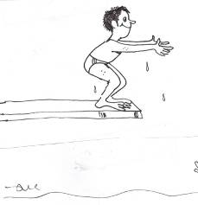That’s all for now. - Erez

**Open Meeting about Toranut**

**On Tuesday 9/5/23 at 20:00**

On Tuesday 9.5.23 there will be an open meeting in the moadon on the subject of toranuyot, led by the toranut team, which has been working on preparing the toranut procedure for the past year.

In the meeting, the principles of the proposed procedure will be presented, and there will be a platform for the multitude of opinions, feelings and ideas on the subject. After the meeting, all points raised will be collected and brought for consideration by the new HR management Committee, and from there to the asefa.

Everyone is invited!!

****The Toranut team: Kinneret Govrin, Sarit Laviv, Tal Darom, Ortal Salzman and Yifat Assaf

**Get ready for the Historic Photo of us all, in Honour of the 75th Anniversary!**

Everyone who lives in the kibbutz today is invited to take part in a kibbutz photo (including members of the younger generation up to the age of 30 who do not live in the kibbutz).

The photos will be of the family and together will be combined into one big collective photo.

For all singles - you can be photographed separately, join another family or organise and be photographed in any way you choose.

The photographs will be taken in the moadon by a team of professional home photographers - on Saturday 6/5/23 and Saturday 13/5/23, **between the hours of 9:00 and 15:00.** Those who cannot come on these dates, are welcome to contact us.

A representative from each family (the one who will receive the messages) will register the family in Kehilanet at the most convenient time for you in the "Family photo in honour of the 75th holiday" calendar (ten minutes per family).

Remember - documentation has an important historical value in the life of the community today, and for the grandchildren and great-grandchildren....

For any question, you can contact Tamar Sankar or Yifat Asaf

**Notice Regarding the Partnership House**

Two rooms in the partnership house were taken due to the needs of the kibbutz and due to the lack of apartments in the kibbutz. There are two rooms available to the public, a large and a small one.

Rahel Piekarski will do her best but nevertheless, the limited situation must be taken into account.

In the hope that we will be able to leave the remaining two rooms available for guest accommodation, and we will not need to use them.

Yifat Assaf - Secretary

**Music School**

**Teachers' Concert - an experience not to be missed!**

As is our custom every year, this year we held a "Teachers' Concert". An "ancient" tradition with us, which began with an extraordinary cultural experience, and continued as a kind of "branch party".

The music teachers (28 in number!) demonstrated their abilities on the various instruments, some in solo performances, and some in interesting ensembles and combinations: when the bassoon teacher and the cello teacher play a piece by Mozart – Mozart turns immediately into chocolate balls! (A joke for music and chocolate connoisseurs alike -Ed)

The singing teacher, an opera singer by profession, shook the walls of the house with classical arias, and a new piano player surprised us all by singing in the style of jazz-rock...

The musical diversity did not stop flowing: the evening opened with the playing of two veteran piano teachers. The audience, who was expecting a classical piece, got to move in their chairs to the sounds of a piece with a jazzy rhythm...

The evening ended with the ensemble of all the teachers, playing the wonderful work of the Lebanese composer Rahbani originally – sung by the singer Firuz. In our case - an instrumental performance (you can guess who did the musical arrangement) The flautist, our new teacher, between breaths mumbling the words in her mother tongue.

Our students, of course, were invited to the concert, so that they could see what heights it is possible to reach... The general public was also invited along with anyone looking for an unadulterated dose of musical pleasure.

(As the headline says: “Teachers' concert - an experience not to be missed!”

**Tender for the Position of Editor of the Newsletter (Hebrew)**

After many years Zimra has expressed her desire to finish editing the Alon.

We publish the tender for the position, with feelings of thanks and appreciation of Zimra. We will find a way to express an organised communal thank you.

Anyone interested is invited to contact Kinneret Govrin, HR.

**Rugby - the end of the senior season - 2022-23**

Last Saturday, our senior team finished the 2022-23 season by winning the state cup and completing a huge double - winning the championship and the cup in one season!

In the cup final we met, of course, our big rival, ASA Tel-Aviv, all that is left for them this season is to fight for the cup and try to beat Yizrael-Gilboa after 4 failed attempts this season.

The Yizrael players came very short staffed to the game, due to injuries and absences of key players, which gave an opportunity to young players and soldiers to play and show what they are worth. Indeed, they all surpassed themselves, gave everything on the field in defense and attack and at the end of a long physical struggle, they came out with the upper hand and a perfect end to a difficult season.

The game started well for Yizrael, when Idan Eisenberg, one of the game's star players, broke through the Tel Aviv defense on the way to the first try. Gilad Vardi added 2 more points (with his successful kick) and Yizrael-Gilboa lead 7-0.

The Tel Aviv players did not give up and continued to put pressure on the Yizrael defense, but the champion players, led by Yahel Rosilio (after returning from Australia) and Devon Muller (our Viking from South Africa), did not let the Tel Aviv players touch down and return to the game. In the 25th minute, after a breakthrough by Devon who made an excellent pass to Gal Ben-Yehuda, who then placed the second try. Vardi added 2 more points and Yizrael was leading 14-0. A little before halftime, the Tel Avivians managed to cross the Yizrael try line and narrow the score to 14-5.

The second half continued with Tel Aviv’s pressure and Yizrael ‘s strong and uncompromising defense. Despite all efforts, Tel Aviv made another try and reduced the score to 14-10.

The game continued and with it the fight for every ball and every metre on the way to the trophy. The second half was the strongest and tightest so far this season – the Yizrael players gave everything, even playing 12 against 15 for a few minutes and for about 20 minutes 13 players against 15 (due to yellow cards). About 10 minutes to the end, the Tel Avivians managed to break through the defense again and lay down a try that gave them the lead 17-14. When push came to shove, the Yizrael players did not give up and returned to the game with a successful penalty kick by Gilad Vardi that tied the score at 17-17, a few minutes to the end.

The game resumed with both teams trying to take the desired trophy - the Yizrael defense managed to keep the ball and earn another penalty, which put the team in the Tel Aviv half of the field. **And then it happened** … **one minute to the final whistle, Vardi picks up the ball, pulls a defender and passes to Omer Levinson the captain, who manages to break through and lay down the winning try (22-17) and ensure a perfect season with a huge double!!!**

Congratulations to coach, Nimrod Kaplan, on an amazing season and to all the players who showed how much heart, soul and “balls” they have. (Not my choice of words – Ed)

We gave everything on the field for the team!!

Outstanding players in the final: Idan Eisenberg and Yahel Rosilio

A perfect and sweet ending to the season.

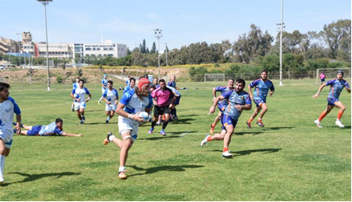

***This coming Saturday – 22.4.23 we will host Slovenia for an* international match – on our field.**

Everyone is invited to an international sports celebration on our home field.

Kick-off at 14:00

From 11:00 – children’s games

Looking forward to seeing everyone in the stands!

Boykies

**Excerpts from the letter published on the 56th Independence Day, 5644 (2004) in Bulletin No. 1119**

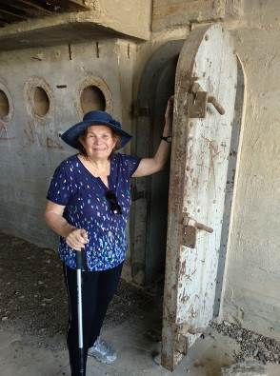**Memories of Captivity**

**Ruth Olami-Becker**

On the morning of May 15, 1948, in Kibbutz Ashdot Ya’akov, a group of children, myself among them, left the shelter where we had stayed all that night, to get some fresh air. Black smoke could be seen from the direction of Naharayim ...

I went to the hill, a place from which there was a view of Lake Naharayim and behind it, the houses. The black smoke formed a cloud over the entire settlement. I noticed how people around looked at me with great compassion.

It was clear to everyone that Naharayim had fallen and that everyone had been killed.

Mum and Dad stayed in Naharayim. My father was the division commander on behalf of the “Haganah” and my mother was a medic. I understood that I no longer had a father and a mother. From now on, the Sprocket family in Ashdot-Ya’akov would be my family for the rest of my life.

A few days later, an enemy plane flew over kibbutz Ashdot Yaakov and bombed it. So it was decided to evacuate all the children to the Haifa area. Three trucks were brought in. The floor and sides of the trucks were lined with mattresses, to protect against bullets. They loaded all the Ashdot-Yaakov children on the trucks, including me, and we set off.

Suddenly we stopped with a thump. I saw some injured children. And the mitapelet was also covered in blood. They ordered us to hurry up and get off the truck and lie down in the drainage ditch on the side of the road. Then we started to hear the noise of the shelling – a kind of strange whistle that gets louder and louder and then suddenly a loud boom! It turned out that the Syrians were shelling the road with canons and our truck had been hit.

For a long time, we continued to lie there until the adults got organised. The shells kept falling near the trucks, so we were told to run to the ditch – when you hear the whistle of an approaching shell – you should lie down, protect your head with your hands and immediately after the explosion get up and keep running...

For about half an hour we ran up the winding road until we were out of range of the shells. [...] After some time we continued on our way to Haifa. When we arrived in Haifa, we were housed, like all the Jordan Valley children, in school classrooms, on the floor.

The next morning, I saw a man I knew and his name was Doenitz. He and his wife Manya were good friends of my parents. When they learned that the children of the Jordan Valley had arrived in Haifa, they looked for us, me and my brother, and took us to their home in Kiryat Hashmal. We lived with them. We went with the family’s children to school in Kiryat Haim. All that time we didn’t know what had happened to mum and dad.

A few days later, news was published in a Jordanian-Arab newspaper about the occupation of Naharayim and that all the people of Naharayim were taken prisoner. The most important thing was that a photo of my mother, drinking a cup of tea on her way to captivity, appeared in the article. Now we knew they were alive and that everything would be fine. After a few weeks, mother was released and arrived in Haifa. The joy was very great.

The Olami family, mother, my brother Ran and I, joined other families from Naharayim, people who arrived in Haifa a few weeks earlier with the evacuation from Naharayim. We were accommodated in a hotel in Haifa.

Again, we moved to a new school and as children do, everything seemed natural, normal and perfectly fine. After a few weeks in the hotel, we got an apartment in the German colony. In the same house and in the one next to it, other Naharayim families lived and so we continued to be with the friends we had known for many years.

That summer of 1948, at the end of the 4th grade, I studied in five schools: in Naharayim, in Ashdot Ya’akov, in Kiryat Haim, in Ironi A and in Amami C in Haifa. Thanks to the high level of the school in Naharayim, there was no problem integrating and succeeding. Then a postcard arrived from captivity, from Dad.

The POW camp was in the desert, in a place called Umm il Jamal, near the town of Mafrak. The Red Cross visited the camp and delivered mail to us. Each of the prisoners was entitled to write a postcard once a month. We also had the right to send one postcard. How much can be written in one postcard? How can we tell him about everything we’ve been through? And what is happening with us? About school? About family and friends? How will we pass the news on to our father about the developments of the war of liberation? After all, they were captured on the day of the declaration of the state and according to the stories of the Arabs – Tel Aviv had fallen, Jerusalem was conquered and all the Jews – in the sea...

Dad told us, in the postcards he sent, about life in captivity, which sounded really fun – they live in tents, they have sleeping bags they received from the Red Cross and all day long they study, draw, and make handicrafts from different materials. Nine months passed and finally the day of liberation came. Dad came back.

Years passed, I grew up and left the house, my parents moved to another apartment, life went on and it did not seem important to keep any objects from home. In 1990, father died, after a few months in 1991, mother passed away.

Some time ago I decided to sort and organise photos and slides and here was a surprise. I found the old tin box that was made in Umm Al Jamal, during the captivity, and inside it there were slides from various trips around the world. And now, after all these years, I received the special box that personifies the whole story of that period and my memories, through the eyes of a child, to whom everything that happened that year seemed natural and understandable.

(What an amazing story. Thank you so much Ruti – Ed)

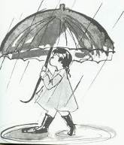**Rainfall from the beginning of April 2022: 59 mm**

**From the beginning of the season: 411 mm**

**Multi-year average to date: 418 mm**

**As compared to the multi-year average to date: -2%**

**Rainfall Table**

|  |  |  |  |  |  |  |  |  |  |
| --- | --- | --- | --- | --- | --- | --- | --- | --- | --- |
| Month | Sep | Oct | Nov | Dec | Jan | Feb | March | Apr | May |
| Total | 0 | 18 | 2 | 44 | 105 | 93 | 40 | **59** |  |
| Average | 0.38 | 16 | 51 | 99 | 111 | 80 | 52 | 19 | 5 |

Daniel Rosenfeld – Manager of Agriculture

**New English Books in the Library**

The Reading List/Sara Nisha Adams

The Little Teashop of Lost and Found/Trisha Ashley

Mercy/David Baldacci

The Paris Library/Janet Skeslien Charles

The Strength of Hope/Abram Goldberg

a Cup of Silver Linings/Karen Hawkins

Book Lovers/Emily Henry

Apples Never Fall/Liane Moriarty

Suspects/Lesley Pearse

The Dictionary of Lost words/Pip Williams

One Hundred Days/Alice Pung



**Childrens’ Theatre**

**22.4.23**

**In the Moadon – 17:00**

**“Perfect”**

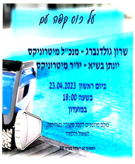**Coffee and a Chat with**

**Sharon Goldenberg – CEO Maytronics**

**Sunday 23.4.23**

**18:00 – 19:30**

All are invited to hear the end of year summary and to ask questions.

**Invitation to the Asefa**

**On Sunday 23/04/2023**

At 19:30

(After the coffee and chat with Sharon Goldenberg, Maytronics)

In the Moadon

Agenda: The staffing committee recommends:

1. **The management Committee of HR**

Coordinator: Kinneret Govrin

Community Manager: Erez Peleg

Secretary: Yifat Assaf

Staffing Committee Coordinator: Nir Segal

Representative of the search team: Irit Shemesh

Coordinator of outside workers: Peter Pezaro

Coordinator of the Education Committee: Momi Cohen

Public representative: Noa Armoza

Public representative: Shlomo Cohen

Public representative: Eddie Solow

**(2) Composition of the Planning Committee**

Coordinator: Axel Levin

Community Manager: Erez Peleg

The committee’s liaison with the public: Zehava Rosilio

Construction Administration Coordinator: Shlomo Levy

Representative of the Environmental Quality Committee: Alita Mor

Real Estate Manager: Vicki Hollander

Gardens representative: Shahar Levy

Housing Committee representative: Matan Elul

Visibility team representative: Revital Zelas

Public representative: Barry Feldman

Public representative: Benny Segal

Public representative: Ofir Griman

**(3) Additional member of the bereavement committee:** Ranit Levy

Asefa Committee and Council

**Invitation to the Economic Council**

**On Thursday, 27.4.23**

**at 20:30**

In the Moadon

Agenda:

(1) Presentation of plans for financing from the housing fund in 2023

(2) Presentation of a building project in parents’ housing area

Budget approval request

Asefa Committee and Council

**Memorial Day Eve Ceremony**

**Mon 24.4.23**

**19:45 (Siren will be sounded at 20:00)**

**Memorial Day Ceremony at the Kibbutz Cemetery**

**Tue 25.4.23**

**10:45**

**Independence Day Celebrations**

**Tue 25.4.23**

**19:45**

**Closing ceremony of Memorial Day and opening of the Independence Day celebrations (with fireworks)**

**followed by a Luna Park for young and old**

**and a live show in the Moadon**

**Wed 26.4.23**

**Opening of the Swimming Pool**

**11:00 – 13:00 Soapy slide on the pool lawn**

**Food will not be served at the pool**

**Brunch in Dining Room**

**(Pool closes at 16:00)**

**The Silver Platter – Natan Alterman**

And the land grows still, the red eye of the sky slowly dimming over smoking frontiers  
  
As the nation arises, torn at heart but breathing, to receive its miracle, the only miracle  
  
As the ceremony draws near, it will rise, standing erect in the moonlight in terror and joy  
  
When across from it will step out a youth and a lass and slowly march toward the nation  
  
Dressed in battle gear, dirty, shoes heavy with grime, they ascend the path quietly  
  
To change garb, to wipe their brow  
They have not yet found time. Still bone weary from days and from nights in the field  
  
Full of endless fatigue and unrested,  
Yet the dew of their youth is still seen on their brows.

Thus they stand at attention, giving no sign of life or death   
  
Then a nation in tears and amazement  
will ask: “Who are you?”

And they will answer quietly, “We are the silver platter on which the Jewish state was given.”  
  
Thus they will say and fall back in shadows  
And the rest will be told in the chronicles of Israel.

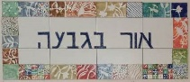

**Or B’Givah 23 – 30 April**

Daily from 08:30 – 12:00 – coffee and cake, chats and board games

Sunday – opening the week – baking with Monica

07:00 Feldenkrais (by appointment) with Ilana Lahav

09:10 – 12:15 – “Seeing the World” – Iceland , Guatemala

Monday – closed

Tuesday – closed

Wednesday – closed

Thursday

07:00 Pedicure (by appointment) with Na’ama

09:00 - coffee and cake, chats and board games

10:00 – Movie

17:15 – Exercises with Michal Sha’anan

**Google Translate is not so great**

**GOOGLE BLOOPERS**

**עינן גרוסר – על כל העזרה הטכנית והמענה בבלת"ם**

Enan Grosser - for all the technical help and support in Bethlehem

**רוצה להודות לכולם על מאור הפנים, העצות, ההארות וההערות ולאחל חג שמח!**

I want to thank everyone for the goodwill, the advice, the constructive comments and wish you a **Merry Christmas!**